NIGERIAN NAVY
CENTRAL PAY OFFICE

PAYROLL SYSTEM
Complete User Manual

A full walkthrough of every screen, for day-to-day users,
administrators, and staff in training
Version 1.0 · August 2026
System supplied by Hicad Systems Limited

Document Control
Item | Detail
Title | Nigerian Navy Payroll System — Complete User Manual
Version | 1.0
Date | August 2026
Covers | The Nigerian Navy Payroll System as deployed at the Central Pay Office: all ten menu groups, 67 chapters and 6 appendices.
Audience | Day-to-day users; administrators and IT staff; trainers and new-staff onboarding.
Screenshots | 94 figures captured from a working installation on 11 August 2026.
Related material | The E-Emolument explainer scripts and process guide, which cover the separate emolument portal (see Chapter 43.2).
Classification | Restricted. Contains personnel and financial data. Not for distribution outside the Service.

How to use this document
The contents list on the following pages is generated by Word. If it appears blank or out of date, click anywhere inside it and press F9, then choose Update entire table.
Chapter and figure cross-references throughout the text are given as chapter numbers — for example “see Chapter 23” — so that they remain accurate however the document is printed or paginated.
Read Chapter 1 first. Readers new to the system should then read Chapters 2 to 5 in order; Chapter 5 in particular is the spine of everything that follows.

Contents

1. About This Manual
Read this chapter first. It explains who the manual is for, how it is arranged, and the small set of conventions used throughout.

1.1 Who this manual is for
This manual covers the Nigerian Navy Payroll System — the application used at the Central Pay Office to hold personnel records, capture payments and deductions, calculate salaries, and produce payslips, bank schedules and statutory returns. It is written for three groups of readers, and each of them can use it differently:
Reader | How to use this manual
Day-to-day users — clerks and operators who enter data, run reports and answer queries. | Work through Part I to learn the screen layout, then read only the chapters covering the menus you are given access to. Every screen is described from a standing start; no prior knowledge is assumed.
Administrators and IT staff — the people who create users, configure reference tables, run month-end and hold the system together. | Read Part I and Part II in full before anything else. Part II describes the settings that everything else depends on. Appendix C lists the errors that come back to you as support calls.
Trainers and new-staff onboarding. | The manual is written in running order: a reader who starts at Chapter 1 and works to the end has covered the full monthly cycle once. Appendix E contains practice exercises keyed to the chapters.

No previous experience of payroll software is assumed. Where a term is specific to this system or to Service pay, it is explained the first time it appears and again in the Glossary (Appendix D).

1.2 How the manual is arranged
The chapters follow the left-hand menu of the application, and the menu itself follows the order of work in a normal month. That is deliberate: if you read the manual front to back you will also have walked through one complete payroll run.
Part | Chapters | Contents
Part I — Getting Started | 1 – 5 | The manual itself; what the system does; signing in; the dashboard and navigation; payroll classes; and the monthly processing cycle that ties every other chapter together.
Part II — Administration | 6 – 13 | Roles and permissions, user accounts, payroll class setup and migration, service-number changes, one-off payments, the company profile, and month-end and year-end processing.
Part III — Personnel Profile | 14 – 16 | Adding personnel one at a time or in bulk, maintaining current records, and handling personnel who have left the Service.
Part IV — Data Input | 17 – 23 | Everything that feeds figures into a pay run: payments and deductions, variations, cumulatives, arrears, allowance uploads and the validation lock.
Part V — File Update | 24 – 28 | The fixed sequence that carries validated input into the master file.
Part VI — Payroll Calculations | 29 – 30 | Running the calculation and reading the calculation reports.
Part VII — Reference Tables | 31 – 42 | The lookup tables the calculation depends on — tax, salary scales, pay elements, banks, commands, states and more.
Part VIII — Utilities | 43 – 47 | Emolument form processing, IPPIS imports, class backup and restore, and consolidated payslips.
Part IX — Reports | 48 – 66 | Every report the system produces, with the options each one offers.
Part X — Audit Trail | 67 | The record of who changed what.
Appendices | A – F | Payroll class reference, pay element codes, troubleshooting, glossary, training exercises, and the figure index.

1.3 Conventions used
The manual uses a small number of consistent devices. They are worth two minutes now because they appear on almost every page.
Convention | Meaning
Bold | The exact wording of something on screen — a button, a menu item, a field label, a tab, or a status. If the manual says press Generate Report, there is a button with precisely that text.
Monospace | Something you type, a file name, a code, or a screen address such as dashboard.html#role-management.
Menu > Item | A path through the left-hand menu. Reference Tables > Bank Details means open the Reference Tables group, then click Bank Details.
Numbered steps | A procedure to be followed in order. Do not skip a step; several screens in this system refuse to open until the step before them has been completed.
Figure 4.2 | A screenshot. The first number is the chapter, the second is the position within it. Every figure has a caption saying what you are looking at.

Three coloured boxes appear throughout:
NOTE
A note adds context — something true about the screen that is not obvious from looking at it.

CAUTION
A caution marks an action that is difficult or impossible to reverse, or that affects live pay. Read these before pressing the button, not after.

GOOD PRACTICE
Good practice is advice drawn from how the system behaves in service. It is not compulsory, but following it will save you work.

1.4 About the screenshots
Every screenshot in this manual was captured from a working installation. The address bar in the images shows localhost:5500, which is the address used on the machine where the captures were taken; your own installation will show the address of your Central Pay Office server instead. Nothing else differs.
The figures show the OFFICERS payroll class, which is why the top right of every screen reads Currently Active In: OFFICERS. When you are working in a different class, that indicator — and the data below it — will change accordingly. See Chapter 4.
CAUTION
Personnel names, service numbers, account numbers and amounts appearing in the figures are drawn from a working data set and must be treated as restricted. Do not reproduce individual screenshots from this manual outside the Service, and do not use live records when training new staff.

2. The System at a Glance
What the application is, who works in it, and what it produces. Read this before you sign in for the first time.

2.1 What the system does
The Nigerian Navy Payroll System holds one record for every member of the Service on the payroll, together with everything needed to work out what that person should be paid this month. Each month the system takes four kinds of information and turns it into pay:
- Standing information about the person — rank, salary group and grade, ship or establishment, bank account, pension fund administrator, tax state. This changes rarely and lives on the personnel record (Part III).
- Reference information that applies to everybody — the salary scales, the tax table, the definitions of each allowance and deduction, and the rules about which allowances cannot be paid together. This is set up once and reviewed when policy changes (Part VII).
- Variable information for this month only — allowances earned, deductions to be taken, arrears, one-off payments. This is captured every cycle (Part IV).
- Cumulative information carried forward — tax to date, gross to date, outstanding loan balances. The system maintains this itself as each month is closed.
From these it calculates the pay run, and from the pay run it produces payslips, bank payment schedules, statutory returns (tax, National Housing Fund, pension), management summaries and reconciliation reports. The complete sequence is set out in Chapter 5, and it is the single most important thing in this manual.

2.2 Who uses it
Access is controlled by role. A role is a named bundle of menu permissions; every user account is given exactly one. The roles supplied with the system are:
Role | Description shown on screen | Typical holder
HICAD | Full system access | System administrator. Can reach every menu including Administration and Audit Trail.
MANAGER | Processor tasks + manage users & payment types | Pay office supervisor. Everything a Processor can do, plus user administration and pay element maintenance.
PROCESSOR | Operator tasks + process payroll + reports | Senior payroll staff. Runs the calculation, the file update and the reports.
OPERATOR | Data entry + input reports + utilities | Payroll clerk. Captures input and prints input-stage reports.
DATA_ENTRY | Handles data input and view all data inputs | Data capture staff. Entry and viewing only.

The roles are cumulative in practice — each one includes roughly what the one below it can do — but they are not hard-coded. An administrator can create additional roles and set their menu access individually (Chapters 6 and 7).

2.3 What you need before you start
- A service number and password issued by your system administrator, and a role appropriate to your duties.
- A modern web browser. The screenshots in this manual were taken in Google Chrome; Microsoft Edge and Mozilla Firefox behave the same way.
- A screen of at least 1366 × 768. The application is responsive and will work on a smaller display, but tables with many columns become awkward to read.
- Network access to the payroll server. The system is not published on the public internet.

2.4 A word about care
This system produces actual pay for serving personnel. Almost every screen in it is capable of being corrected afterwards; a small number are not. Month-end processing cannot be undone. A payroll class migration applied to all personnel cannot be reversed by pressing anything. A restore overwrites live data.
Those screens are marked with a caution box in the chapters that follow. Where you have a choice between checking now and correcting later, check now.

3. Signing In and Finding Your Way Around
The header, the menu, the dashboard, and the handful of controls that appear on every single screen.

3.1 Signing in
- Open your browser and enter the address of the payroll server given to you by your administrator.
- Enter your service number in the first field and your password in the second.
- Press Login. The system checks your credentials, reads your role, and builds a menu containing only the sections that role is permitted to reach.
NOTE
If a menu described in this manual does not appear on your screen, the most likely explanation is that your role has not been given access to it. That is a permissions question for your administrator (Chapter 7), not a fault.

3.2 The dashboard
A successful sign-in lands you on the dashboard. This is the home screen of the system and the place the Dashboard menu item always returns you to.
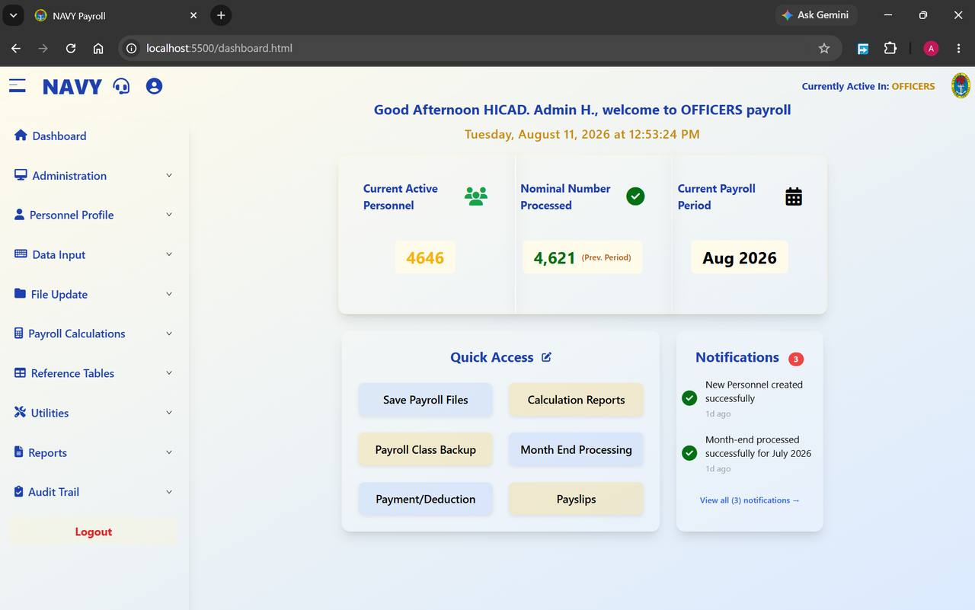
Figure 3.1 The dashboard, showing the greeting, the three headline figures, Quick Access and Notifications. The left-hand menu runs down the side of every screen in the system.

Reading the dashboard
The dashboard is arranged in three bands. The greeting at the top confirms who the system thinks you are and which payroll class you are working in — in the figure, Good Afternoon HICAD. Admin H., welcome to OFFICERS payroll. Beneath it sits the current date and a live clock.
The middle band carries three headline figures:
Field / control | What it is for
Current Active Personnel | How many people are on the payroll in the active class right now. In the figure, 4,646 officers.
Nominal Number Processed | How many records were actually paid in the previous period, shown with the label (Prev. Period). In the figure, 4,621. A gap between this number and the one on its left is normal — it represents joiners, leavers and suspended records — but a large or growing gap is worth investigating.
Current Payroll Period | The month and year the system is currently processing. Everything you enter today is attributed to this period. In the figure, August 2026.

The lower band is split between Quick Access, a set of shortcut buttons to the six most-used screens (Save Payroll Files, Calculation Reports, Payroll Class Backup, Month End Processing, Payment/Deduction and Payslips), and Notifications, a list of recent system events with a count badge. The pencil icon beside Quick Access lets you change which shortcuts appear.
GOOD PRACTICE
Check Current Payroll Period every time you sign in. Entering a month of data into the wrong period is one of the few mistakes in this system that is tedious to unwind.

3.3 The header bar
The dark blue strip across the top of the window is present on every screen. From left to right it carries:
Field / control | What it is for
Hamburger icon (☰) | Collapses and expands the left-hand menu. Collapsing it gives a wider working area on tables with many columns.
NAVY wordmark | Returns you to the dashboard from anywhere.
Headset icon | Opens support. Use this to raise an issue with the system administrator.
Person icon | Your own account — profile and password.
Currently Active In: <CLASS> | The payroll class every screen is currently reading and writing. This is the single most important indicator in the header. See Chapter 4.
Naval crest | Decorative.

3.4 The page header and footer
Below the blue strip, each screen shows its own title on the left — Role Management, Payslips, Bank Details and so on — and, on the right, a green status dot, the signed-in user name, and the current time. The green dot means the browser has a live connection to the server. If it is absent or the time stops advancing, your session has dropped; sign in again before entering anything further.
At the foot of every screen sits a yellow Return button on the left, which takes you back to the previous screen, and the copyright line © 2026 Hicad Systems Limited on the right.

3.5 The left-hand menu
The menu is the spine of the system. It has ten groups; clicking a group expands it to show the screens inside. Only the groups your role permits are shown.
Menu group | What it holds | Covered in
Dashboard | The home screen described above. | Chapter 3
Administration | Roles, users, payroll classes, service numbers, one-off payments, company profile, month-end and year-end. | Part II
Personnel Profile | Adding and maintaining personnel records; old and exited personnel. | Part III
Data Input | Payments and deductions, variations, cumulatives, documentation, arrears, adjustments, validation. | Part IV
File Update | Save payroll files, personnel changes, input variable report, master file update, recall. | Part V
Payroll Calculations | Backup, restore, the calculation itself, and calculation reports. | Part VI
Reference Tables | Overtime, commands, overpayment alarm, tax, salary scales, pay elements, fixed amounts, mutual exclusions, PFAs, banks, departments, states, LGAs. | Part VII
Utilities | Emolument form processing, IPPIS payments, class backup and restore, consolidated payslips. | Part VIII
Reports | The full reporting suite. | Part IX
Audit Trail | The record of changes made in the system. | Part X

Below the groups sits Logout. Use it whenever you leave your desk. The system holds a live session, and anything done from an unattended machine is recorded against your name in the audit trail.

3.6 Controls that behave the same everywhere
The system is consistent, which means a handful of controls are worth learning once:
Control | Behaviour
+ Add New / + Create New / + Add Command (blue) | Opens a blank form, usually directly above the list you are looking at. Fill it in and press Save.
Generate Report (gold) | Produces a printable version of whatever the screen holds. Most report screens let you choose PDF or Excel first.
Edit (green or green text) | Opens the selected row for amendment. Changes are recorded in the audit trail.
Delete (red) | Removes the record. Where a record is referenced elsewhere the system will refuse rather than orphan the reference.
View (blue) | Opens the record read-only. Use this when you only need to check something — it leaves no edit footprint.
Search… | Filters the list below as you type. Most searches accept either a service number or part of a name.
Records per page / 10 per page | Controls page length on long lists, with Previous / Next beneath. The record count — for example Showing 1 to 10 of 4646 records — is always shown.
Clear / Reset Form (grey) | Empties the form without saving. It does not undo anything already saved.
Return (yellow) | Goes back one screen.

4. Payroll Classes
The single concept that most often catches out new users. Five minutes here will save a great deal of confusion later.

4.1 What a payroll class is
Personnel are not held in one undifferentiated list. They are divided into payroll classes — groups that are paid on different scales and processed as separate runs. The classes configured in the system are:
Code | Description | Who it covers
1 | OFFICERS | Commissioned officers.
2 | W/OFFICERS | Warrant officers.
3 | RATE A | Ratings, band A.
4 | RATE B | Ratings, band B.
5 | RATE C | Ratings, band C.
6 | TRAINEE | Personnel under training.

A class is more than a label. Each class carries its own processing month and year, its own payment and deduction records, its own calculation run and its own backup. Two classes can legitimately be in different months at the same time — in Figure 5.1 you will see OFFICERS processing August 2026 while W/OFFICERS is still on July.

4.2 Only one class is active at a time
This is the rule that matters. Every screen in the system reads and writes the active payroll class only, and the active class is shown at the top right of every page as Currently Active In: <CLASS>.
CAUTION
If you enter a deduction while OFFICERS is active, that deduction is attached to the officers' pay run. It will not appear in the ratings' run, and it will not be found by anyone searching the ratings' data. Before entering anything, look at the top right of the screen.
To change the active class, use Administration > Switch Active Payroll Class (Chapter 9). Switching is quick and has no side effects — it simply changes which set of data every screen is pointed at.

4.3 The class statistics
Several screens show a Payroll Class Statistics panel giving the population of each class. It is the fastest way to sanity-check a migration or an upload, and it is reproduced in Figure 9.3.
NOTE
You may see a class labelled Z in the statistics panel. This is a holding class used for records that are not currently attached to a live payroll class — typically personnel in transition. It is not a payroll class you should be processing against.

4.4 Class and role are different things
Two independent controls decide what you can do:
- Your role decides which menus you can open — see Chapters 6 and 7.
- The active payroll class decides which population those menus act on — see Chapter 9.
A user with the HICAD role can reach every screen in the system, but if the active class is TRAINEE they will still see only trainees. Conversely, switching class does not grant any additional permission.

5. The Monthly Payroll Cycle
The order of work. Everything else in this manual is a detail inside this chapter.

5.1 Why the order matters
The system enforces a sequence. Several screens will not open until the screen before them has been completed, and they say so plainly: Personnel Details Report Not Available Yet — this section will become available once the payroll files are saved. These locks are not an obstacle to work around; they are the system making sure that what you are about to calculate is based on data that has been checked and frozen.
If a screen you need is locked, the answer is always the same: go back and finish the step before it. Each locked screen provides a button that takes you straight there.

5.2 The eleven steps
A complete cycle for one payroll class runs as follows.
# | Step | Where | Chapter
1 | Confirm the active class and the processing period | Header · Administration > Switch Active Payroll Class | 4, 9
2 | Bring personnel records up to date — joiners, leavers, transfers, bank changes | Personnel Profile | 14 – 16
3 | Capture this month's payments and deductions | Data Input > Payments/Deductions (and Batch Upload) | 17
4 | Capture variations, arrears, adjustments and one-off payments | Data Input · Administration | 11, 18 – 22
5 | Lock and validate the input | Data Input > Payments/Deductions Validation | 23
6 | Save the payroll files | File Update > Save Payroll Files | 24
7 | Print the changes in personnel data | File Update > Changes in Personnel Data | 25
8 | Print the input variable report | File Update > Input Variable Report | 26
9 | Run the master file update | File Update > Master File Update | 27
10 | Calculate the payroll and read the calculation reports | Payroll Calculations | 29 – 30
11 | Produce the reports, then close the month | Reports · Administration > Month End Processing | 13, 48 – 66

5.3 Step by step

1 · Confirm class and period
Look at Currently Active In in the header and at Current Payroll Period on the dashboard. If either is wrong, correct it before you touch anything else. A month of input captured against the wrong class has to be re-keyed.

2 · Update personnel records
Add anyone who has joined, mark anyone who has left, and correct ranks, salary grades, bank accounts and pension details. This is the point at which standing data should be right; after the master file update it is too late to affect this month's pay.

3 · Capture payments and deductions
Enter the variable amounts for the month. Small numbers of records are keyed directly; larger volumes go in through Batch Upload from a spreadsheet. Every record carries a service number, a payment or deduction type, an amount payable, an amount to date and a pay indicator.

4 · Capture variations, arrears, adjustments and one-offs
Anything that is not a straightforward recurring payment is handled here — a change to a running deduction, back-pay owed on a promotion, a bulk allowance upload from Naval Headquarters, or a one-off payment such as a grant.

5 · Lock and validate
This is the gate between capture and processing. Pressing Lock for Validation freezes the payment and deduction data for the period so that it cannot change underneath you, and opens the verification view. Nothing downstream will run until this is done.
CAUTION
Once the data is locked, further entry for the period is closed. Make sure every source document has been captured before you lock.

6 · Save the payroll files
Save Payroll Files takes a secure copy of the validated data for the record. It is refused while validation is outstanding.

7 · Print the changes in personnel data
This report lists every change made to personnel records since the last cycle. Its purpose is control: somebody other than the person who keyed the changes should read it. It is refused until the payroll files are saved.

8 · Print the input variable report
The companion report to step 7, listing the variable input captured for the period. It is refused until the personnel changes have been printed.

9 · Run the master file update
The master file update writes the validated input into the master records. It is refused until the input variable report has been printed. After this step, the data the calculation will use is fixed.

10 · Calculate
Payroll Calculations works out gross pay, deductions, tax and net pay for every active record in the class, for the stated processing month and year. When it finishes, Calculation Reports unlocks. Read them before going any further — a problem found here costs an hour, the same problem found after month-end costs a great deal more.

11 · Report and close
Produce payslips, bank payment schedules, the payroll register, statutory returns and management summaries. Reconcile. Then run Month End Processing to finalise the period and roll the system forward.
CAUTION
Month-end processing finalises all payroll data for the selected period and cannot be undone. Do not run it until the reports have been read and agreed.

5.4 The exception reports
Between calculation and month-end there is a group of reports whose only purpose is to find mistakes. They take minutes to run and they are the cheapest insurance in the system:
Report | What it finds | Chapter
Salary Reconciliation (filter: Errors Only) | Records where this month's figures do not reconcile against last month's. | 60
Salary Variance Analysis | Personnel whose pay has moved unexpectedly between periods. | 63
Overpayment | Payments that breach the overpayment percentage alarm. | 64
Out-of-Range Payments | Net amounts outside a minimum and maximum you specify. | 66
Duplicate Account Number | Two or more personnel sharing a bank account number. | 65

GOOD PRACTICE
Run all five every month, in that order, before month-end. Duplicate account numbers in particular are worth scanning even in a quiet month — they are the classic signature of a keying error in bank details.

6. Role Management
Administration > Role Management · dashboard.html#role-management
Roles are the bundles of access the system hands out. This screen creates and maintains them; Chapter 7 decides what each one can reach.

6.1 Opening the screen
Open Administration in the left menu and click Role Management. The screen lists the roles that exist, each with the description that will be shown to users and to whoever assigns accounts.
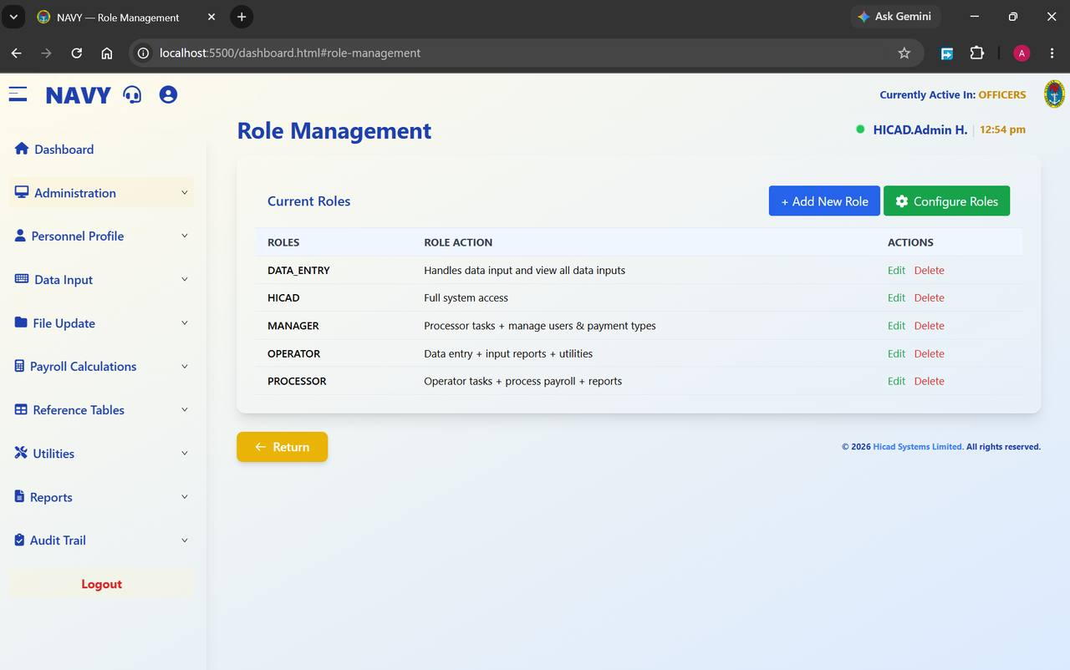
Figure 6.1 Role Management with the five roles supplied as standard. Each row can be edited or deleted; the buttons at the top right add a new role or jump to permissions.

6.2 Reading the list
Field / control | What it is for
ROLES | The role name. Displayed in upper case with underscores, for example DATA_ENTRY. This is the value that appears in the User Role list when an account is created.
ROLE ACTION | A plain-language description of what the role is for. Users see this text, so write it for them: “Data entry + input reports + utilities” is more useful than “Level 2”.
ACTIONS | Edit opens the role for amendment; Delete removes it.

The two buttons at the top right are + Add New Role, which opens the creation form, and Configure Roles, which takes you to the Role Permissions screen described in Chapter 7.

6.3 Creating a role
- Press + Add New Role. A short form opens above the list.
- Enter the Role Name*. Use upper case with underscores in place of spaces, matching the convention of the existing roles.
- Enter the Role Description*. Describe the duties the role covers, not the person who happens to hold it.
- Press Save. The role appears in the list below. Press Cancel to abandon the form.
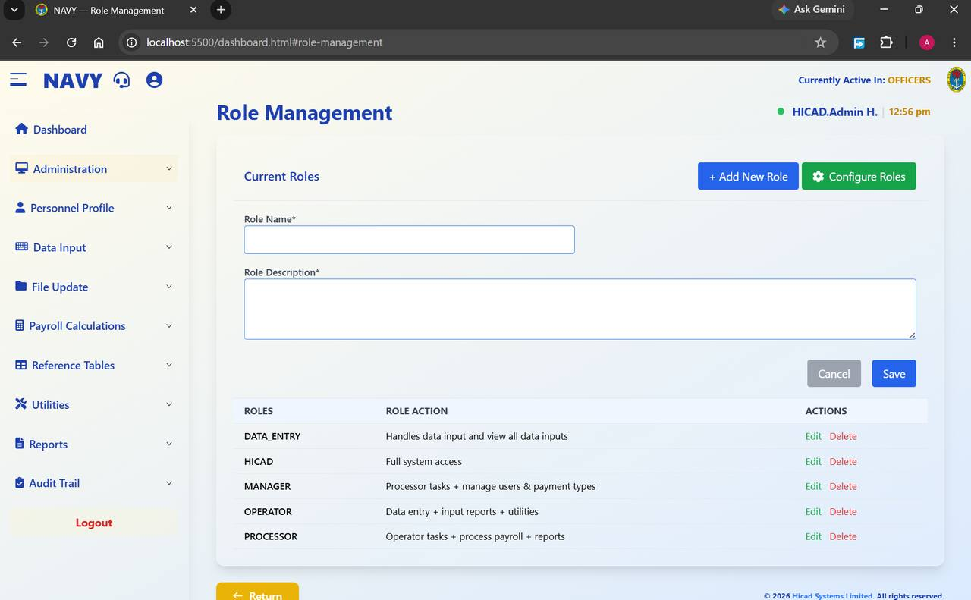
Figure 6.2 The Add New Role form. Both fields are marked with an asterisk and are required.
NOTE
Creating a role gives it no access at all. A new role can sign in and see nothing until you grant it menu access on the Role Permissions screen. Always do the two together.

6.4 Editing and deleting roles
Edit reopens the name and description for amendment. Changing a description is safe at any time. Changing a name affects every account currently holding the role, so check who they are on Control Payroll Users (Chapter 8) first.
CAUTION
Delete removes the role. Do not delete a role while accounts are still assigned to it — move those accounts to another role first, or you will leave users unable to work. The HICAD role should never be deleted; it is the only role with full system access, and removing the last account that can reach Administration locks everybody out of the system's own controls.

6.5 Designing a set of roles
The five supplied roles form a ladder, each including roughly what the one below it can do. If you add roles of your own, keep to the same principle: grant the narrowest access that lets the person do their job, and separate the duties that ought to check one another.
GOOD PRACTICE
Keep data capture and payroll processing in different roles wherever staffing allows. The person who keys a deduction should not also be the person who locks validation and runs month-end — that separation is what makes the control reports in steps 7 and 8 of the cycle meaningful.

7. Role Permissions
Administration > Role Management > Configure Roles · dashboard.html#role-permissions
Deciding, menu by menu, what each role is allowed to open.

7.1 Opening the screen
Press Configure Roles on the Role Management screen. The permissions screen opens with a single instruction — Configure menu access for each role — and an empty role selector.
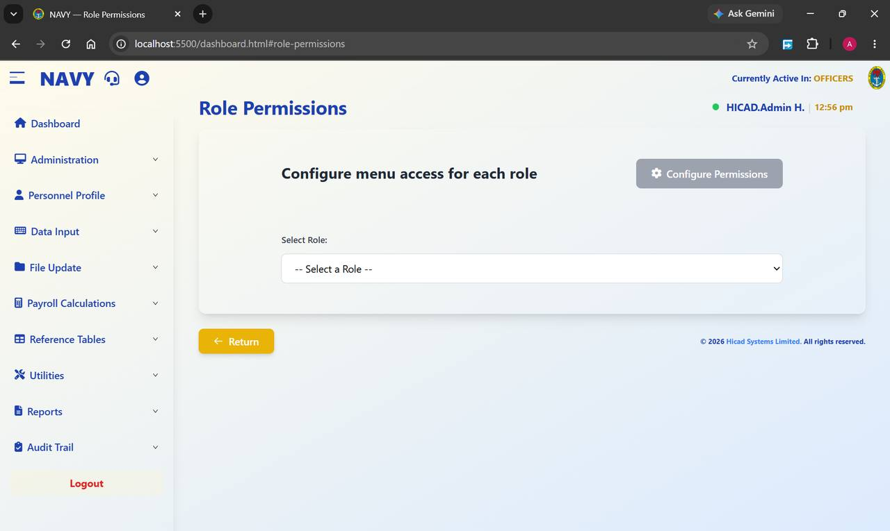
Figure 7.1 Role Permissions before a role is chosen. The Configure Permissions button is greyed out until a selection is made.

7.2 Selecting a role
- Open the Select Role: list. It contains every role defined on the Role Management screen.
- Choose the role you want to work on. The screen immediately shows a confirmation panel giving the role name and its description, with the reminder “Click Configure Permissions to manage menu access”.
- Press Configure Permissions, which is now enabled, to open the menu access grid.
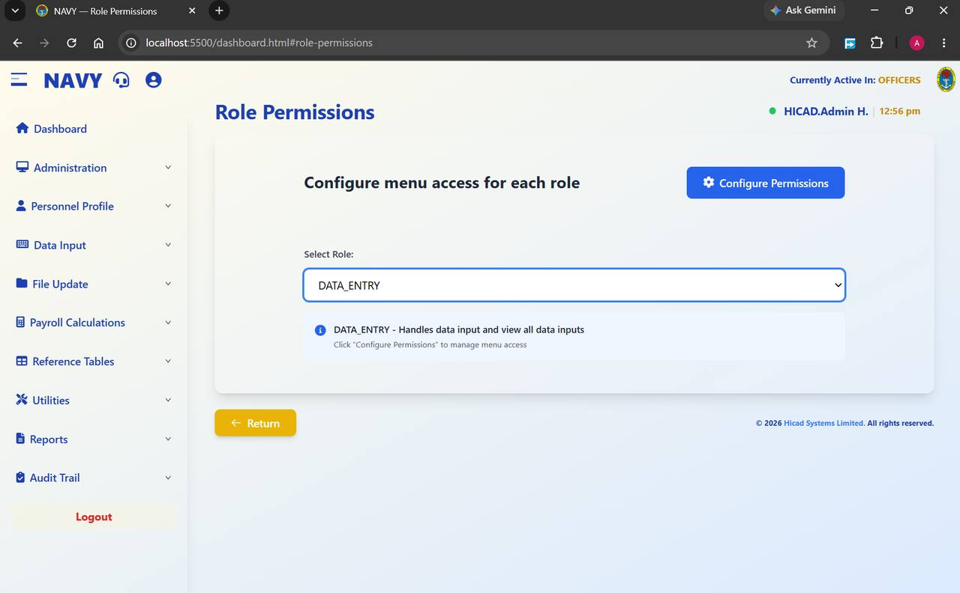
Figure 7.2 DATA_ENTRY selected. The blue information panel repeats the role description so you can confirm you are working on the right one before changing anything.

7.3 The roles in turn
Because it is easy to configure the wrong role by mistake, the confirmation panel is worth reading every time. The five standard roles appear as follows.
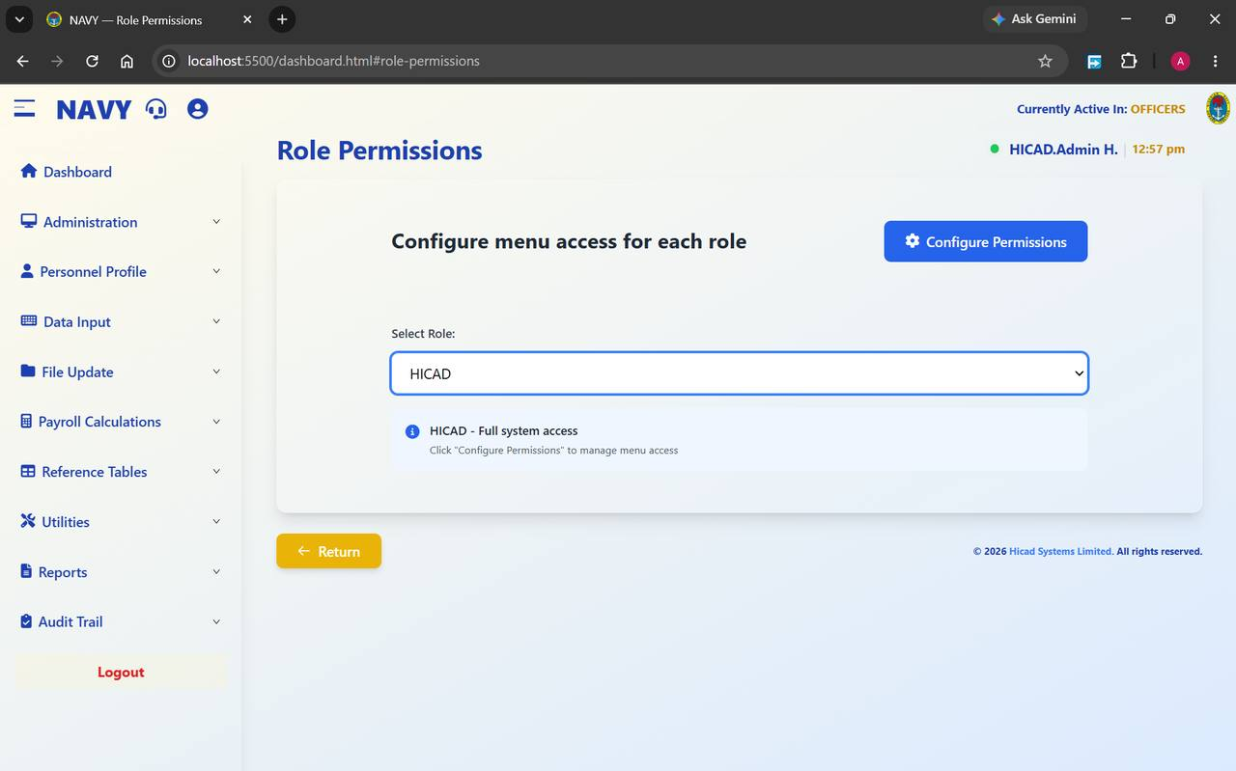
Figure 7.3 HICAD — full system access. This is the administrator role; treat any change to its permissions with particular care.
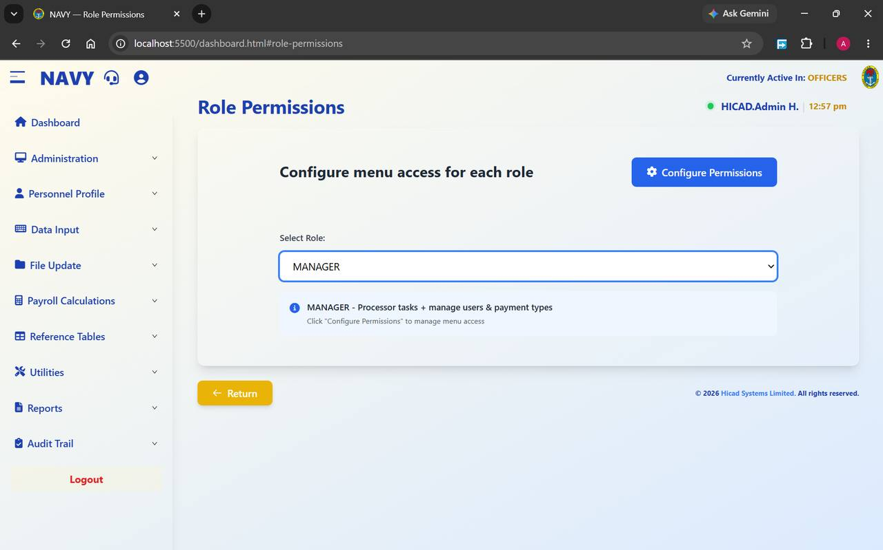
Figure 7.4 MANAGER — processor tasks plus user and payment type management.
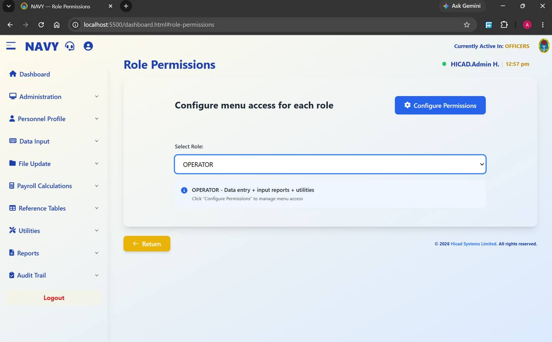
Figure 7.5 OPERATOR — data entry, input reports and utilities.
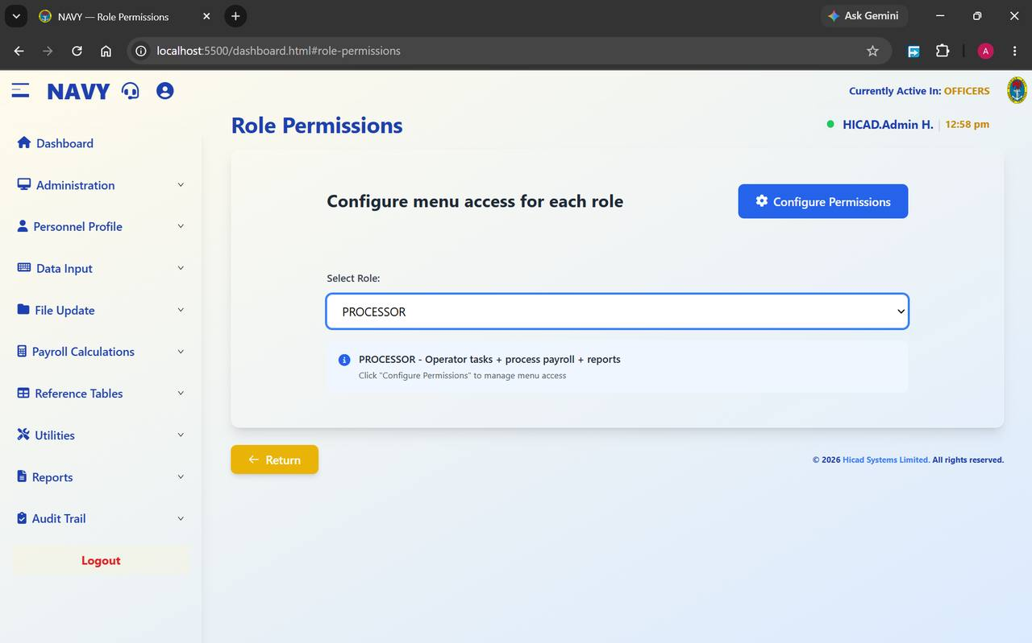
Figure 7.6 PROCESSOR — operator tasks plus payroll processing and reports.

7.4 Granting access
Configure Permissions opens the list of menu sections with a control against each. Switch on the sections the role should be able to open and switch off the rest, then save. The change takes effect the next time a holder of that role signs in.
NOTE
Permissions are granted at menu level, not at button level. A role that can open Payments/Deductions can also add, edit and delete within it. Where you need someone to look without touching, give them a role that reaches the report equivalent rather than the maintenance screen.
CAUTION
Never remove Administration access from the last remaining HICAD account. If you do, nobody can reach Role Management to put it back, and the system will have to be corrected at database level.

7.5 Good practice
- Change permissions for one role at a time, and have the holder sign in and confirm before you move to the next.
- Record why a permission was changed. The audit trail (Chapter 67) captures what changed and who changed it, but not the authority for it.
- Review the whole set once a year, and always after a reorganisation of the pay office.

8. User Accounts
Administration > Create User · dashboard.html#create-user — Administration > Control User · dashboard.html#control-user
Creating accounts, and maintaining the ones that exist.

8.1 Creating a payroll user
Open Administration > Create User. The form creates one account at a time.
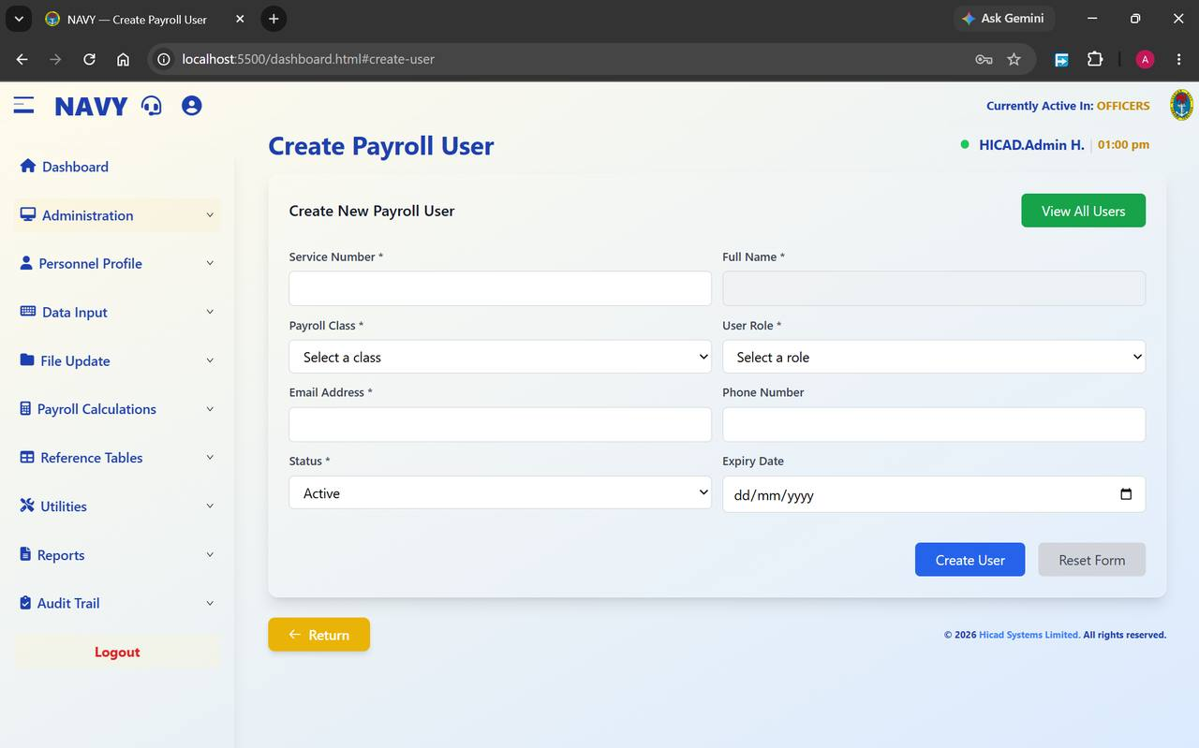
Figure 8.1 Create Payroll User. Fields marked with an asterisk are required; the rest may be left blank.
Field / control | What it is for
Service Number * | The user's service number. This is the identifier they will sign in with, so it must match their Service record exactly.
Full Name * | The user's name as it should appear in the header and in the audit trail.
Payroll Class * | The class the account is associated with. Choose from the classes configured in Chapter 9.
User Role * | The role, and therefore the menu access, this account will carry. The list is drawn from Role Management (Chapter 6).
Email Address * | Used for system correspondence and password recovery. Enter a working address; an account with a wrong address is difficult to recover.
Phone Number | Optional contact number.
Status * | Set to Active for an account that is to be used now. An account can be created in advance and activated later.
Expiry Date | Optional. After this date the account can no longer sign in. Use it for temporary attachments, audit teams and contractors — it is far more reliable than remembering to revoke access by hand.

To create an account
- Complete the required fields, working left to right and top to bottom.
- Choose the User Role carefully. Give the narrowest role that covers the person's duties; it can be raised later if needed.
- Set an Expiry Date if the posting is temporary.
- Press Create User. To empty the form and start again, press Reset Form.
- Confirm the new account appears on Control User, and ask the holder to sign in while you are still available to help.
NOTE
View All Users at the top right is a shortcut to the Control Payroll Users screen described below.

8.2 Controlling existing users
Open Administration > Control User to see every account in the system.
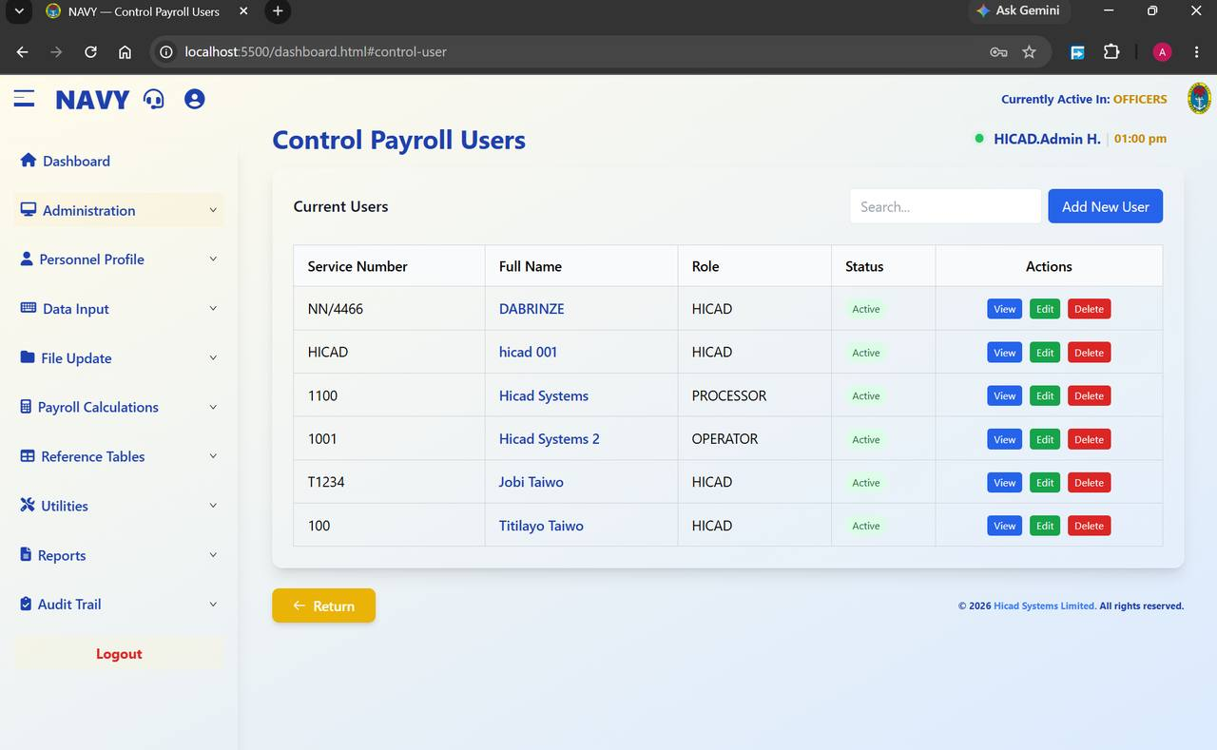
Figure 8.2 Control Payroll Users. Each account shows its service number, name, role and status, with View, Edit and Delete against it.
Field / control | What it is for
Search… | Filters the list by service number or name.
Add New User | Opens the Create Payroll User form described above.
Service Number / Full Name | Identify the account. The name is a link that opens the account.
Role | The role currently assigned. To change it, press Edit.
Status | Active accounts can sign in; inactive ones cannot.
Actions | View opens the account read-only, Edit opens it for amendment, Delete removes it.

Routine account maintenance
- A user changes appointment. Press Edit and change the role to match the new duties. Do not leave the old role in place “just in case”.
- A user leaves the pay office. Set the status so the account can no longer sign in, or delete it. Do not leave a live account behind a departed holder.
- A user has forgotten their password. Confirm their identity by a means other than the system, then reset it from the account.
- A user reports a missing menu. Check the role on this screen against the permissions in Chapter 7 before assuming a fault.
CAUTION
Deleting an account does not delete what that account did. Records created by the user remain, and the audit trail keeps their name against them. That is deliberate — but it also means a deleted account cannot be used to hide activity, and should never be deleted for that purpose.
GOOD PRACTICE
Review the user list every quarter against the current staff of the pay office. Accounts belonging to people who have moved on are the most common finding in an access audit.

9. Payroll Class Setup and Migration
Administration > Payroll Class Setup, Switch Active Payroll Class, Change Payroll Class
Defining the classes, choosing which one you are working in, and moving personnel between them.

9.1 Payroll Class Setup
Open Administration > Payroll Class Setup to see the classes the system knows about and to add new ones.
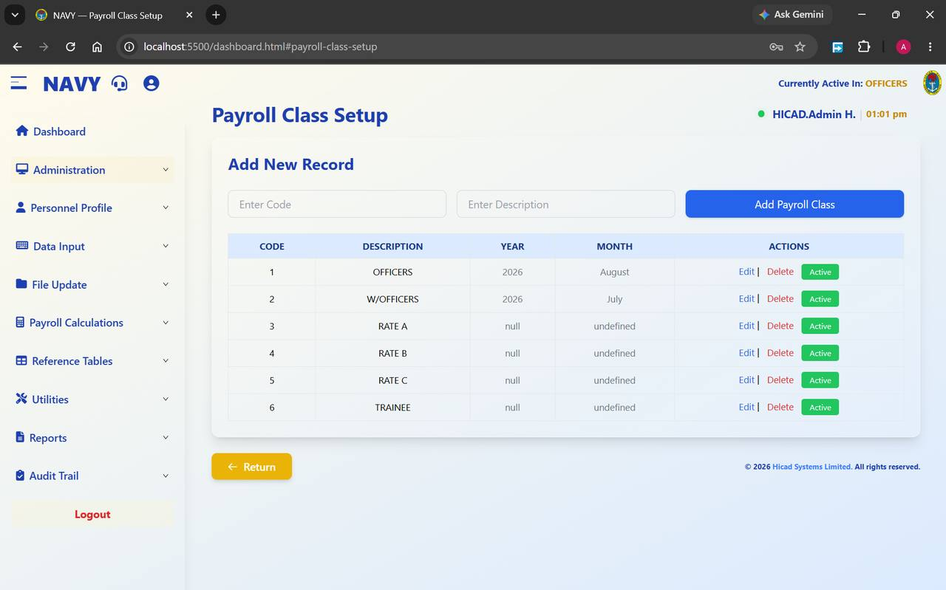
Figure 9.1 Payroll Class Setup. The Add New Record strip creates a class; the table below lists those that exist, with the period each is currently processing.
Field / control | What it is for
Enter Code | A short numeric code for the class. Codes must be unique.
Enter Description | The name users will see — OFFICERS, RATE A and so on. Use upper case, consistent with the existing entries.
Add Payroll Class | Creates the class from the two fields to its left.
CODE / DESCRIPTION | As entered above.
YEAR / MONTH | The period this class is currently processing. A class that has never been processed shows null and undefined — that is expected for a newly created class, and the values populate once the first cycle runs.
ACTIONS | Edit amends the class; Delete removes it. The green Active badge shows the class is available for processing.

NOTE
In Figure 9.1 OFFICERS shows August 2026 while W/OFFICERS shows July 2026. Classes are processed independently, so they may legitimately sit in different months. What matters is that the class you are working in shows the period you intend to work on.
CAUTION
Do not delete a payroll class that has personnel or historical pay data attached to it. Move the personnel to another class first (see below), and keep the class itself for the sake of the history.

9.2 Switching the active class
Open Administration > Switch Active Payroll Class. The screen states the rule at the top: Only one payroll class can be active at a time. Focus on a class to make it active.
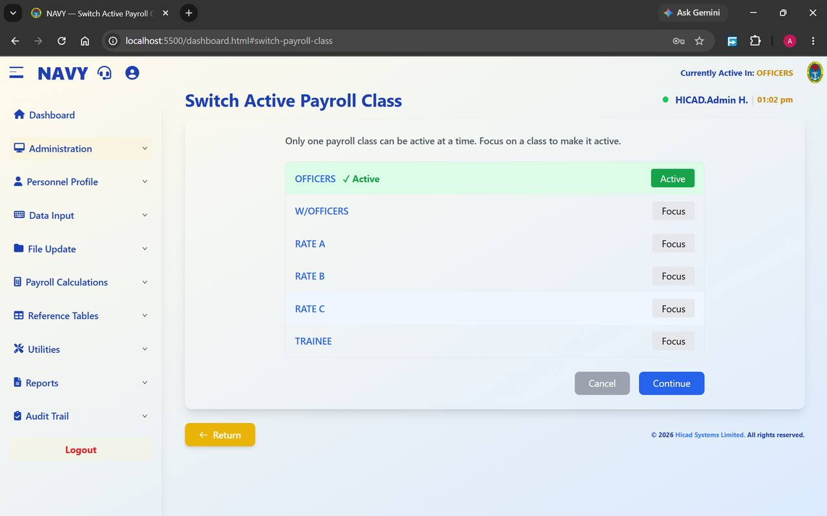
Figure 9.2 Switch Active Payroll Class. OFFICERS is active — shown by the green highlight, the tick and the Active badge. Every other class offers a Focus button.
- Find the class you want to work in.
- Press Focus on its row.
- Press Continue to confirm, or Cancel to stay where you are.
- Check the header. Currently Active In must now read the class you chose.
GOOD PRACTICE
Make this the first thing you do at the start of any piece of work and the last thing you check before entering data. It takes five seconds and it prevents the most common data-entry error in the system.

9.3 Changing a person's payroll class
Open Administration > Change Payroll Class. This screen moves personnel from one class to another — on promotion from rating to warrant officer, for example, or on completion of training. The screen offers three Migration Type options.

All Personnel (Bulk Migration)
Moves every member of the currently active class into a target class in one action.
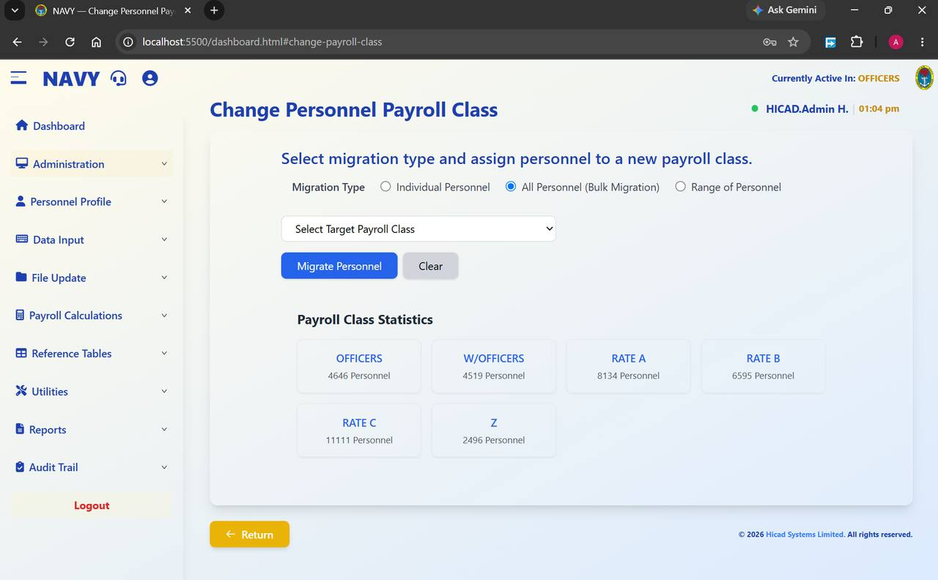
Figure 9.3 Change Personnel Payroll Class set to bulk migration. Only a target class need be chosen; the Payroll Class Statistics panel below shows the population of each class.
CAUTION
Bulk migration affects every person in the active class and there is no undo button. Before pressing Migrate Personnel, note the current figures in Payroll Class Statistics, and take a class backup (Chapter 45). If the migration is wrong, the backup is your route back.

Individual Personnel
Moves one named person. This is the option to use for routine promotions and reclassifications.
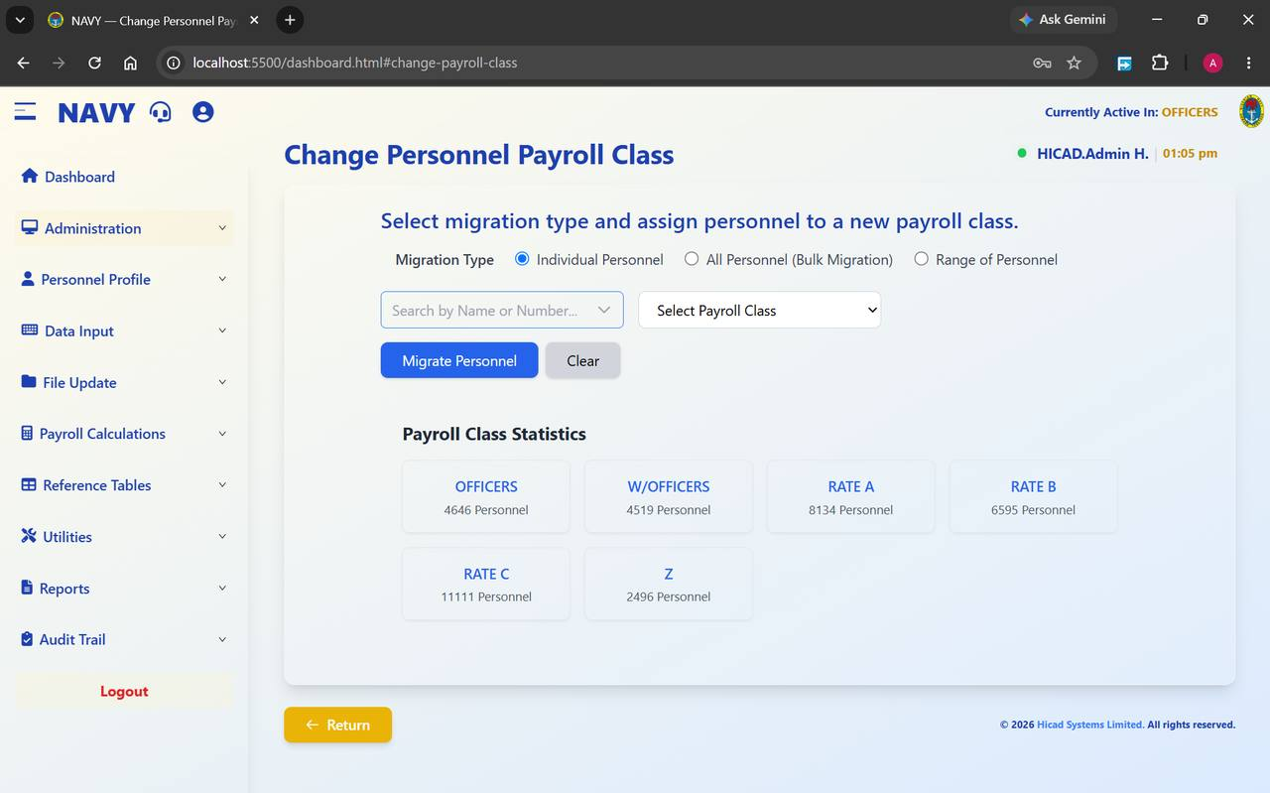
Figure 9.4 Individual migration. Search for the person by name or service number, then choose the class they are moving to.
- Select Individual Personnel.
- Type a name or service number into Search by Name or Number… and pick the person from the results.
- Choose the destination in Select Payroll Class.
- Press Migrate Personnel. Clear empties the form without doing anything.
- Confirm the move by checking the population figures in Payroll Class Statistics below.

Range of Personnel
Moves a contiguous block — useful when a whole intake or draft changes class together.
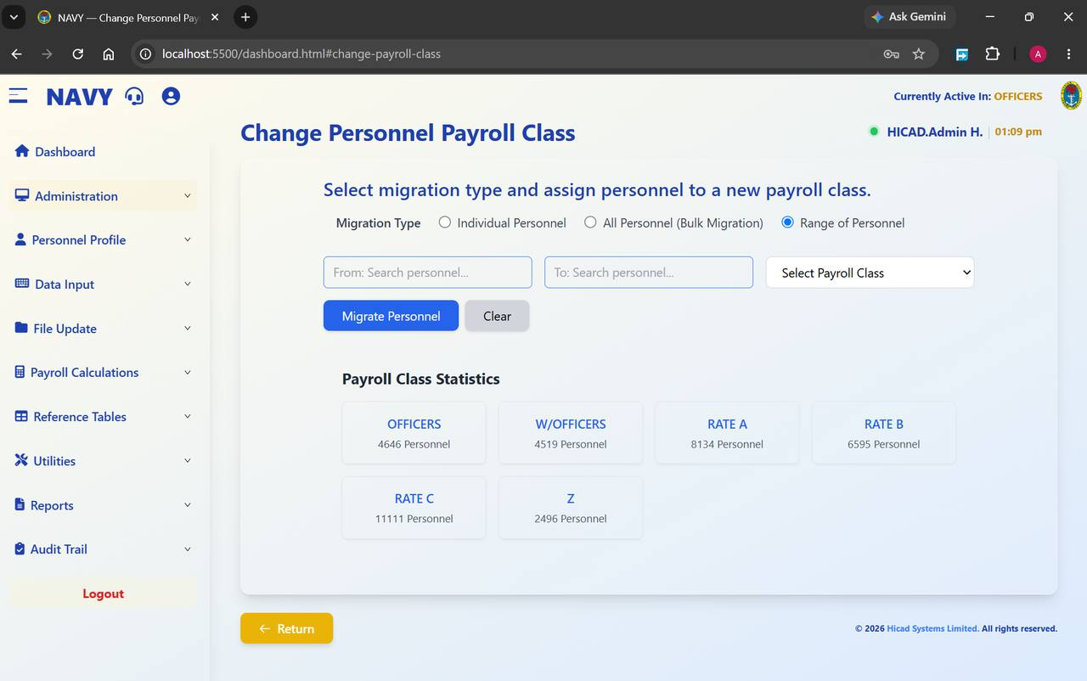
Figure 9.5 Range migration. Set a From and a To personnel record and the system moves everybody in between.
- Select Range of Personnel.
- Set the first record in From: Search personnel….
- Set the last record in To: Search personnel….
- Choose the destination in Select Payroll Class.
- Press Migrate Personnel.
NOTE
A range is worked out on the system's internal ordering of records, which follows service number. Before running a range migration, satisfy yourself that everybody between the two end points really should move — the range will include anyone whose service number falls between them.

9.4 Reading the class statistics
The Payroll Class Statistics panel is shown on all three migration screens and gives a live count for every class. Note the figures before a migration and check them again afterwards: the number leaving one class should equal the number arriving in the other.
The panel also shows the holding class Z, described in Chapter 4. Personnel appearing there are not attached to a live payroll class and will not be paid until they are moved into one.

10. Change Service Number
Administration > Change Registration Number · dashboard.html#change-registration-number
A small screen with large consequences. The service number is the key that ties a person to everything else in the system.

10.1 Why this screen is separate
A service number is not an ordinary field. It links the personnel record to its payments and deductions, its cumulative figures, its salary history, its payslips and its audit entries. Because of that, it cannot be amended on the personnel record itself — it is changed here, deliberately, on a screen of its own.
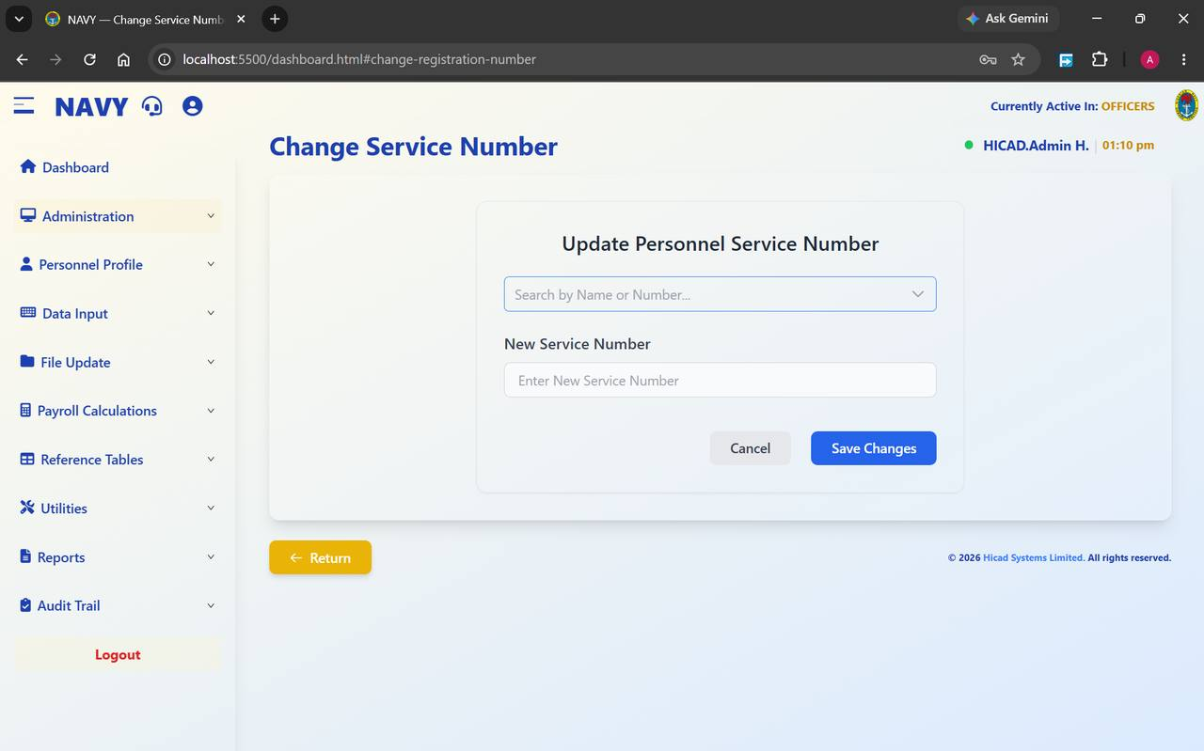
Figure 10.1 Change Service Number. Find the person, enter the new number, save.

10.2 Making a change
- Open Administration > Change Registration Number.
- Use Search by Name or Number… to find the person. Confirm from the result that you have the right individual — check the name in full, not just the number.
- Enter the replacement in New Service Number. Type it, read it back against the source document, and type it again if you are not certain.
- Press Save Changes, or Cancel to abandon.

10.3 Before you change a service number
- Have written authority. A service number change should be traceable to a Service document, not to a telephone call.
- Check the new number is not already in use. Two personnel sharing a service number will produce misdirected pay.
- Do it between cycles where possible — after month-end and before the next month's input. Changing the key part-way through a live cycle is the point at which things go wrong.
- Tell the person. They sign in with this number.
CAUTION
The change propagates through the system. Historical records follow the person to the new number, which is what you want — but it also means that a service number entered in error will move somebody else's pay history onto the wrong record. Check twice before saving.
NOTE
The change is recorded in the audit trail (Chapter 67) with the old value, the new value, your name and the time. If a query arises months later, that is where the answer will be.

11. One-Off Payments
Administration > One-Off Requirement Setup · One-Off Fixed Amount by Rank · Individual One-Off Payment Input · One-Off Calculations · One-Off Reports
Payments made outside the normal recurring cycle: grants, subsidies, arrears settlements and special allowances.

11.1 How one-off processing works
One-off payments run as a small cycle of their own, sitting alongside the main monthly run. There are four stages, and they must be taken in order:
Stage | Screen | What happens
1 · Define | One-Off Requirement Setup | Declare which payment types are to be treated as one-off this cycle, and how each is to be worked out.
2 · Rate | One-Off Fixed Amount by Rank | For payments calculated by rank, set the amount for each rank.
3 · Capture | Individual One-Off Payment Input | Record the payment against individual personnel where it is not calculated automatically.
4 · Calculate & report | One-Off Calculations, One-Off Reports | Run the calculation, then produce bank reports, remittance advice, payment analysis or a summary.

11.2 One-Off Requirement Setup
Open Administration > One-Off Requirement Setup. The screen lists the payment types configured for one-off processing.
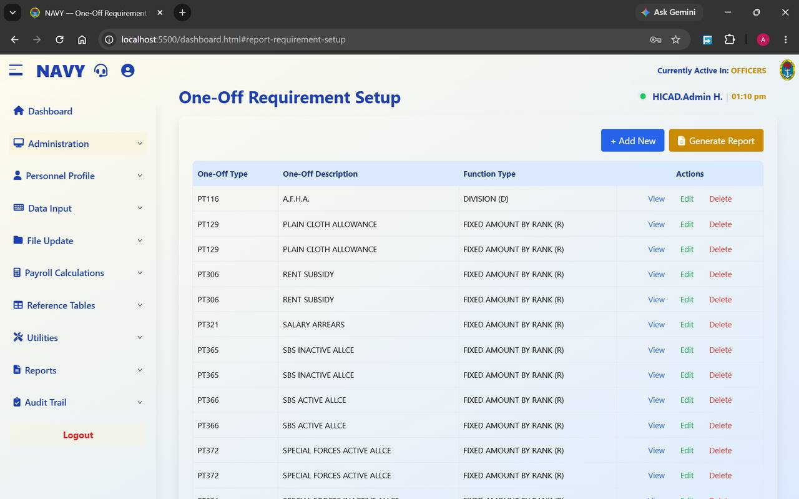
Figure 11.1 One-Off Requirement Setup. Each row pairs a payment type with the function used to calculate it.
Field / control | What it is for
One-Off Type | The payment type code, for example PT306. These codes are defined on Pay Element Description (Chapter 36).
One-Off Description | The plain-language name — RENT SUBSIDY, SALARY ARREARS, SBS ACTIVE ALLCE, SPECIAL FORCES ACTIVE ALLCE.
Function Type | How the amount is arrived at. FIXED AMOUNT BY RANK (R) takes the amount from the rank table in Chapter 11.2; DIVISION (D) derives it by division.
Actions | View, Edit and Delete against each row.
+ Add New | Adds a payment type to the one-off list.
Generate Report | Prints the setup for the record.

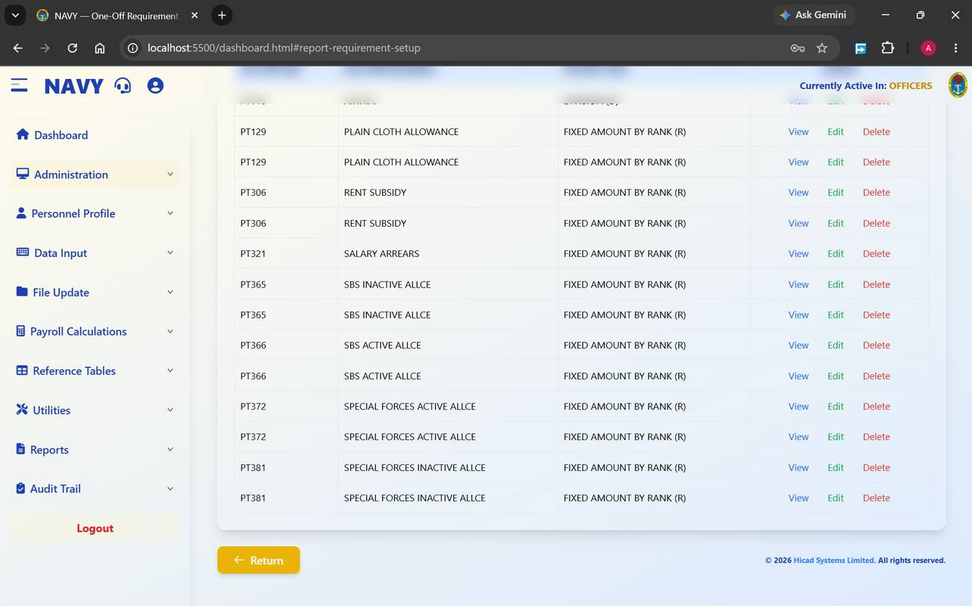
Figure 11.2 The same screen scrolled down. The list is longer than one screen; scroll to review every entry before running a calculation.
CAUTION
Some payment types appear twice in the list. Duplicated entries can produce a duplicated payment. Scroll the whole list and remove any repetition before running the one-off calculation.

11.3 One-Off Fixed Amount by Rank
Open Administration > One-Off Fixed Amount. This screen holds the amount payable at each rank for every payment type whose function is FIXED AMOUNT BY RANK (R).
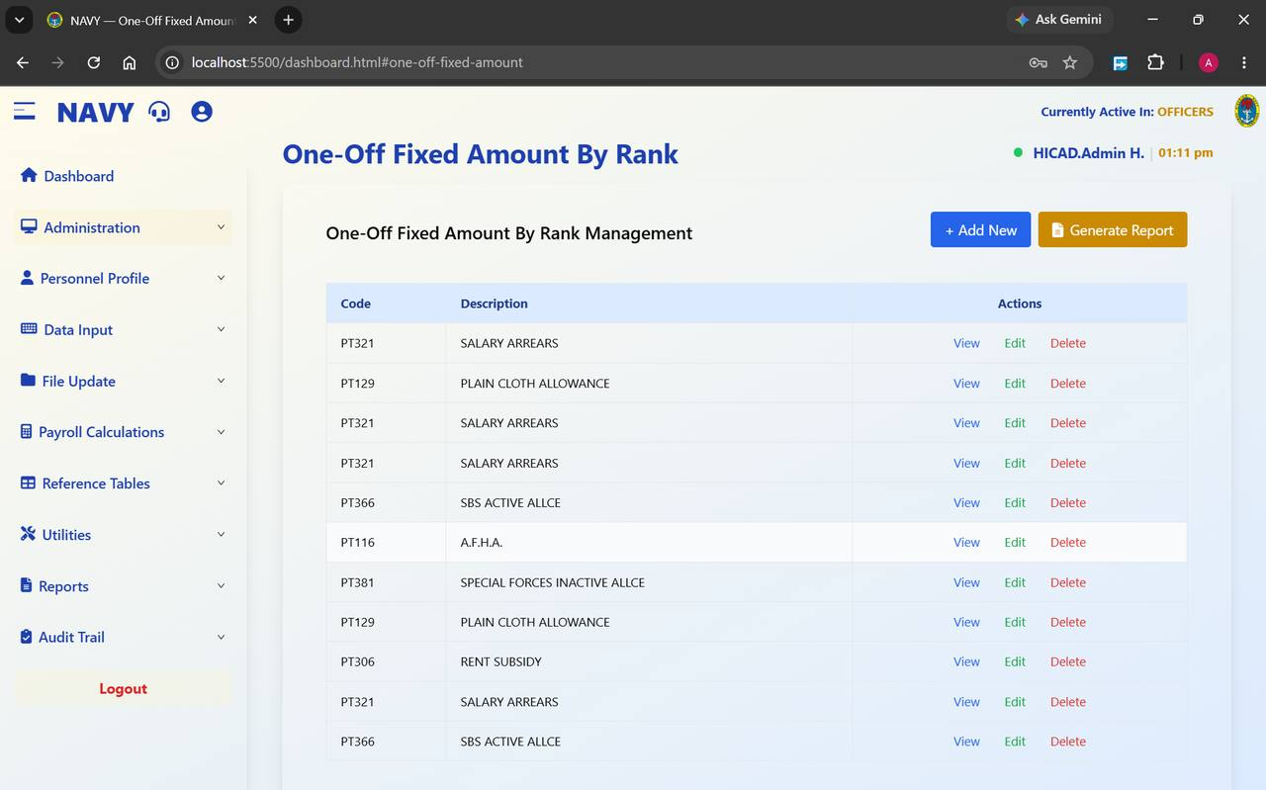
Figure 11.3 One-Off Fixed Amount By Rank Management. Each code is opened with View or Edit to reach the rank-by-rank amounts.
- Find the payment type in the list, or press + Add New to add one.
- Press Edit to open the rank schedule.
- Enter the amount payable at each rank. Where a rank is not entitled, leave it at zero rather than deleting the row.
- Save, then press Generate Report and check the printed schedule against the authority for the payment.
GOOD PRACTICE
Print the schedule and have it signed off before the calculation runs. The rank table is the point at which a single mistyped figure multiplies across every holder of that rank.

11.4 Individual One-Off Payment Input
Open Administration > Individual Payment Input to record one-off payments against named personnel.
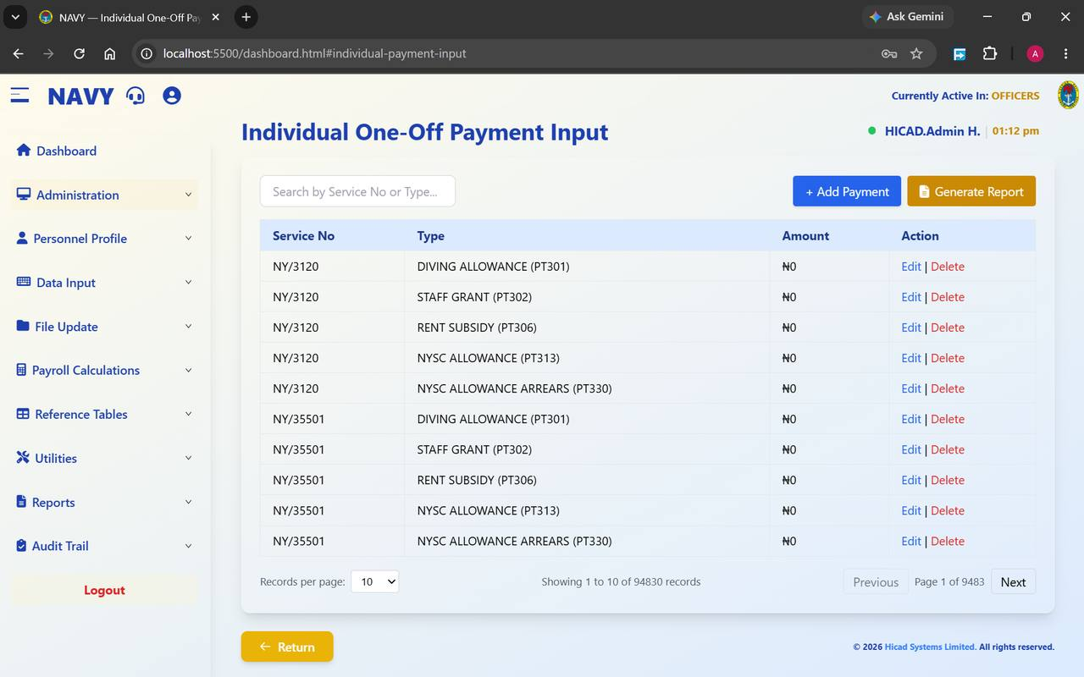
Figure 11.4 Individual One-Off Payment Input, showing entries against two service numbers. The record count at the foot shows how large this table becomes in a live system.
Field / control | What it is for
Search by Service No or Type… | Filters the list. Search by service number to see everything held against one person, or by type to see everyone receiving a given payment.
Service No | The person the payment belongs to.
Type | The payment, with its code — for example DIVING ALLOWANCE (PT301), STAFF GRANT (PT302), NYSC ALLOWANCE ARREARS (PT330).
Amount | The figure payable, in naira. A zero here means the payment is defined for that person but no amount has yet been set.
Action | Edit amends the entry; Delete removes it.
+ Add Payment | Records a new one-off payment against a person.
Generate Report | Prints the input for checking.
Records per page / Previous / Next | Paging controls. The figure shows 94,830 records across 9,483 pages — always search rather than paging when you are looking for something specific.

11.5 One-Off Calculations
Open Administration > Irregular One-Off Calculations to work out the payments defined in the previous three screens.
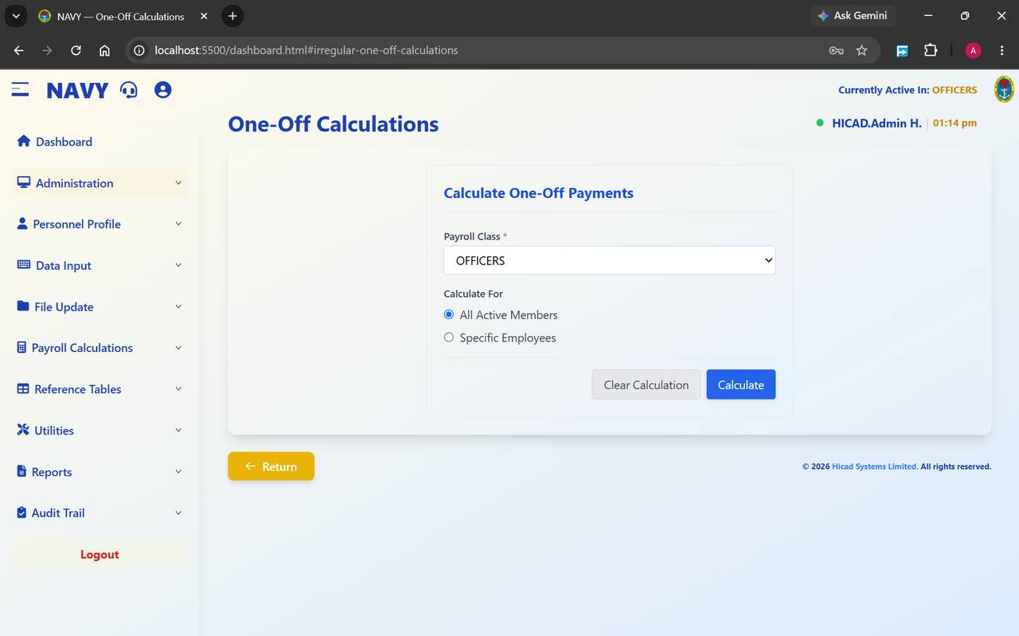
Figure 11.5 One-Off Calculations. Choose the payroll class, decide whether to calculate for everybody or for named personnel, and press Calculate.
- Confirm the Payroll Class*. It defaults to the active class.
- Under Calculate For, choose All Active Members to process the whole class, or Specific Employees to name individuals.
- Press Calculate.
- If you need to start again, Clear Calculation removes the results so that the calculation can be re-run.
NOTE
Clear Calculation discards calculated one-off results; it does not remove the underlying input from Individual One-Off Payment Input. That is what makes it safe to re-run after correcting a rate.

11.6 One-Off Reports
Open Administration > Irregular One-Off Reports to print the outcome.
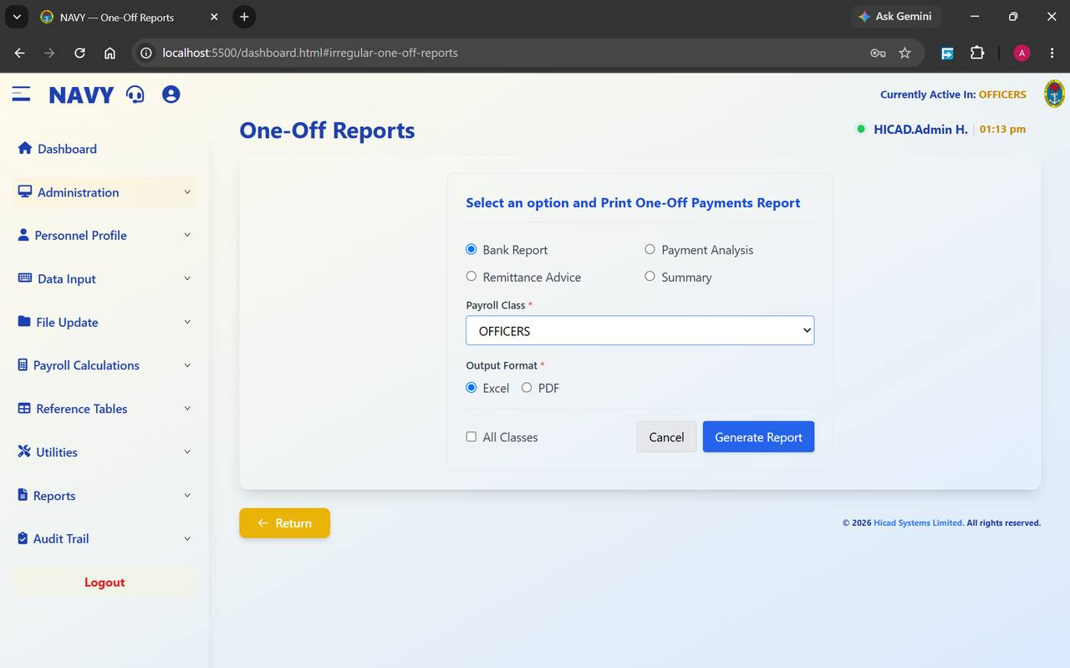
Figure 11.6 One-Off Reports. Four report types, a payroll class, an output format, and an option to cover all classes at once.
Field / control | What it is for
Bank Report | The schedule of payments by bank, for transmission to the banks.
Payment Analysis | An analysis of what was paid and to whom.
Remittance Advice | Advice notes for the payments made.
Summary | A one-page total by payment type.
Payroll Class * | The class to report on.
Output Format * | Excel for further analysis, PDF for a fixed record or for signature.
All Classes | Ticks through every class in one report instead of the single class chosen above.
Generate Report | Produces the report. Cancel abandons.

GOOD PRACTICE
Produce the Summary first and check the totals against your authority. Only when those agree should you produce the Bank Report — that is the one that moves money.

12. Company Profile
Administration > Company Profile · dashboard.html#company-profile
The organisation's own details, and a small number of settings that change how the payroll behaves.

12.1 What is held here
This screen holds the identity of the paying organisation — the Nigerian Navy, Naval Headquarters — together with the addresses and switches that the rest of the system reads. It is set up at installation and changed rarely.
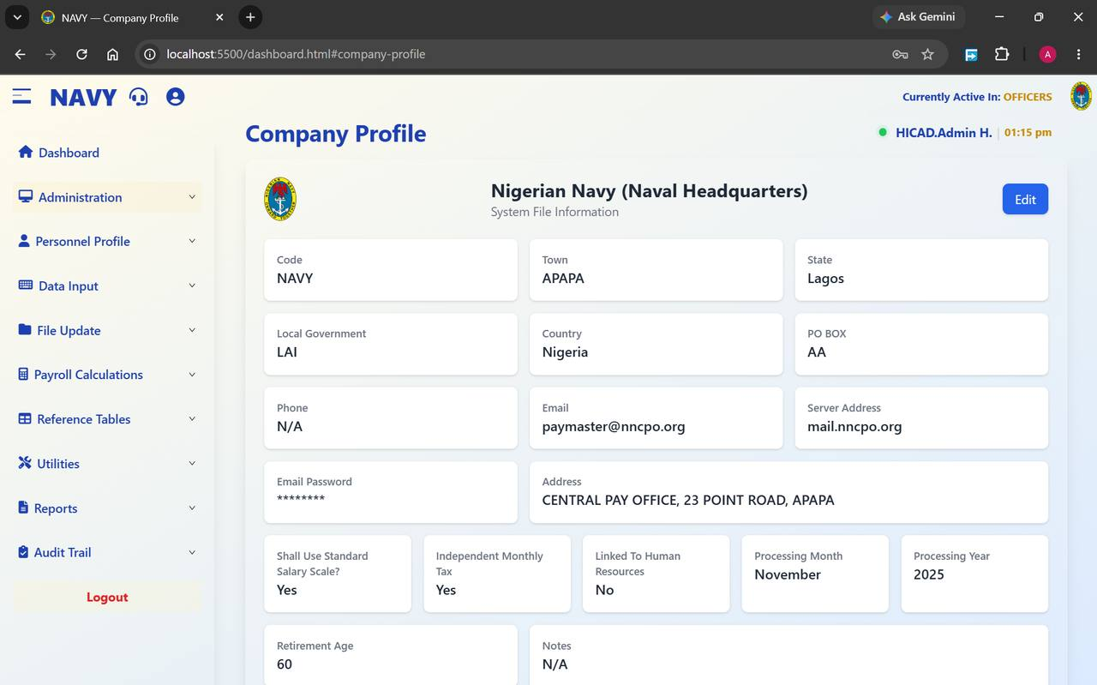
Figure 12.1 Company Profile. The Edit button at the top right opens every field for amendment.

Identity and address
Field / control | What it is for
Code | The short identifier for the organisation — NAVY.
Town, State, Local Government, Country, PO BOX, Address | The postal identity of the pay office. The address appears on documents the system produces, so keep it accurate: CENTRAL PAY OFFICE, 23 POINT ROAD, APAPA.
Phone, Email | Contact details. The email address shown, paymaster@nncpo.org, is the account the system sends from.
Server Address, Email Password | The mail server the system uses to send documents. The password is masked. Changing these stops or starts outbound email — do not change them without your administrator.

Processing settings
Field / control | What it is for
Shall Use Standard Salary Scale? | When Yes, the calculation reads salaries from the salary scale table (Chapter 35) rather than from amounts held on individual records.
Independent Monthly Tax | When Yes, tax is worked out month by month rather than cumulatively across the year.
Linked To Human Resources | Whether the payroll is fed from a separate HR system. No here means personnel data is maintained in this system, as described in Part III.
Processing Month / Processing Year | The period the system considers current at organisation level.
Retirement Age | Used in personnel and pension reporting. Shown as 60.
Notes | Free text for anything that needs recording about the configuration.

CAUTION
The three processing settings change the arithmetic of the payroll. Altering Shall Use Standard Salary Scale? or Independent Monthly Tax part-way through a year will produce a discontinuity between one month and the next that is difficult to explain to an auditor. Change them only between years, and only with written authority.

12.2 Editing the profile
- Press Edit at the top right.
- Amend the fields you need to change.
- Save.
- Confirm by opening the screen again and reading the values back.
NOTE
Because this screen affects every payroll class, restrict access to it. In a normal configuration only the HICAD role should be able to reach Company Profile.

13. Month-End and Year-End Processing
Administration > Monthly/Yearly Processing · Administration > Yearly Processing
Closing the period. These are the two screens in the system that most reward a slow, careful reading before the button is pressed.

13.1 Month-End Processing
Month-end finalises the payroll for the period and rolls the system forward. Open Administration > Monthly/Yearly Processing.
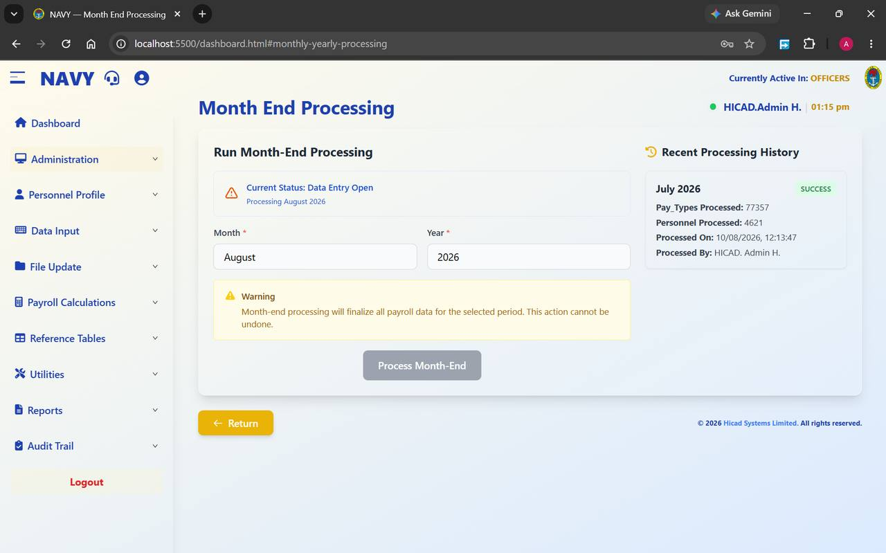
Figure 13.1 Month End Processing. The current status, the period to be processed, an explicit warning, and — on the right — the history of previous runs.

Reading the screen
Field / control | What it is for
Current Status | Where the period stands. Data Entry Open with Processing August 2026 beneath it means input is still being accepted for August.
Month *, Year * | The period to be closed. These are pre-filled from the current processing period; check them.
Warning | “Month-end processing will finalize all payroll data for the selected period. This action cannot be undone.” The system means it.
Process Month-End | Runs the close. The button is greyed until the preceding steps of the cycle are complete.
Recent Processing History | The last close, with the number of pay types processed, the number of personnel processed, when it ran and who ran it. In the figure: July 2026, 77,357 pay types, 4,621 personnel, run by HICAD. Admin H.

Before you press the button
Work through this list. Every item on it is cheaper to check now than to correct afterwards.
- The payroll calculation has completed for the period (Chapter 29).
- The calculation reports have been read and agreed (Chapter 30).
- The five exception reports listed in Chapter 5.4 have been run and any findings resolved.
- The payroll register and bank payment schedules have been produced and reconciled.
- Payslips have been generated.
- A payroll class backup has been taken (Chapter 45).
- The Month and Year on this screen are the period you actually intend to close.
CAUTION
There is no reversal. If a period is closed in error, the only route back is a restore from the backup taken before the run — which is why the backup is on the checklist above and not merely recommended.

Running the close
- Confirm Month and Year.
- Press Process Month-End.
- Wait for the run to finish. It processes tens of thousands of pay type records; do not navigate away.
- Read the new entry in Recent Processing History and check the personnel count against what you expected.
- Confirm on the dashboard that Current Payroll Period has moved to the next month.
NOTE
Month-end is run for each payroll class in turn. Closing OFFICERS does not close W/OFFICERS. Switch class (Chapter 9) and repeat.

13.2 Year-End Processing
Year-end closes the payroll year, resets the annual cumulative figures and prepares the system for the new one. Open Administration > Yearly Processing.
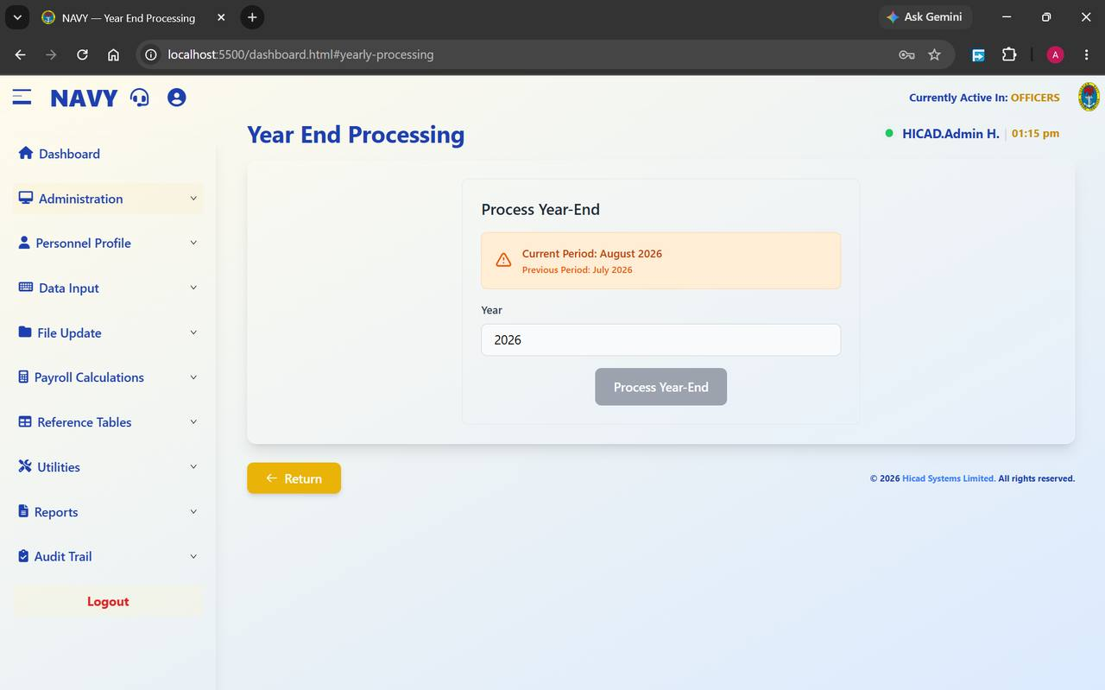
Figure 13.2 Year End Processing. The panel confirms the current and previous periods before the year is closed.
Field / control | What it is for
Current Period / Previous Period | Confirmation of where the system stands. In the figure, August 2026 current and July 2026 previous.
Year | The year being closed.
Process Year-End | Runs the close. Greyed until the year's final month-end has been completed.

- Confirm that the final month of the year has been closed by month-end processing for every payroll class.
- Produce and file the annual statutory returns — tax by state (Chapter 55), National Housing Fund (Chapter 57) and pension (Chapter 58).
- Take a backup of every payroll class.
- Confirm the Year.
- Press Process Year-End.
CAUTION
Year-end resets annual cumulative figures — tax to date, gross to date and the rest. Any statutory return not produced before the year is closed becomes materially harder to produce afterwards. Print first, close second.

14. Adding New Personnel
Personnel Profile > Add New Personnel · dashboard.html#add-personnel
The longest form in the system, taken three steps at a time — plus next of kin, children, and bulk upload.

14.1 How the form is organised
A personnel record is built from five pieces. Three yellow-and-blue step buttons run across the top of the form for the person's own details, and three tabs at the top right switch between the person, their next of kin and their children.
Control | Holds
Step 1: Basic Details | Identity, origin, contact details and photograph.
Step 2: Official Info | Service dates, tax, pension, salary and bank details.
Step 3: Additional Info | Seniority, ship, branch, command, specialisation and entitlements.
Personnel / NOK / Children tabs | Switch between the person's own record, their next of kin, and their children.
Batch Upload | Loads many personnel at once from a spreadsheet instead of keying them.
Current Personnel | Leaves the form and opens the list of existing personnel.

NOTE
The step buttons are navigation, not a wizard. You can move between them freely, and Submit at the foot of any step saves the record as a whole.

14.2 Step 1 — Basic Details
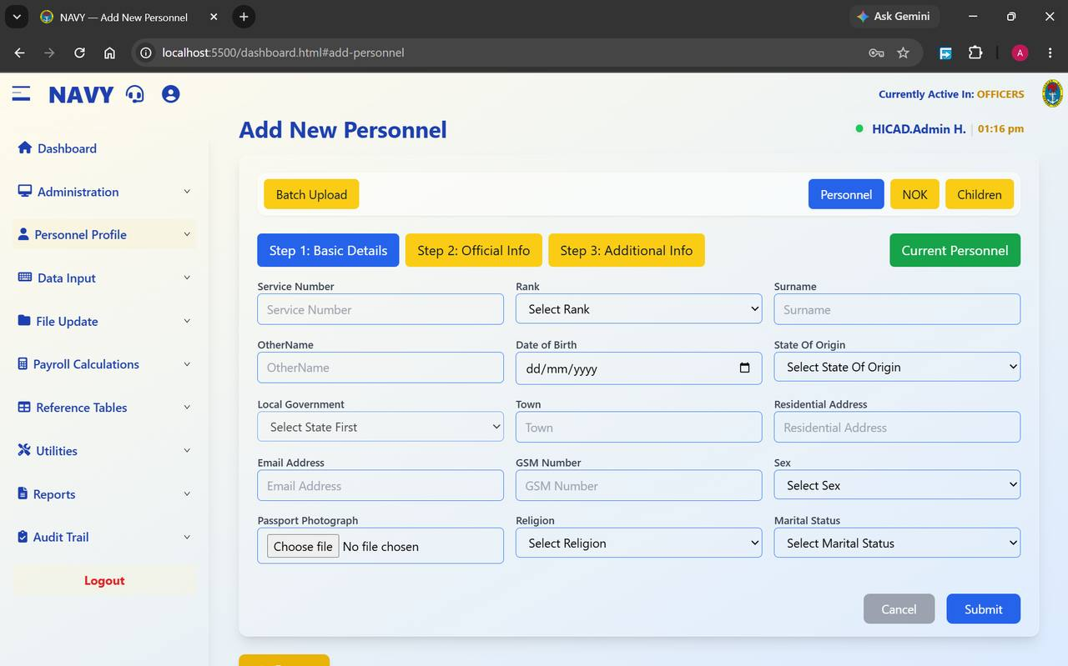
Figure 14.1 Add New Personnel, Step 1. The three step buttons run across the top; the record tabs sit at the top right.
Field / control | What it is for
Service Number | The person's service number. This is the key to the whole record — see Chapter 10 — so enter it from the source document and read it back.
Rank | Chosen from the list. Rank drives entitlement to several allowances.
Surname, OtherName | The person's name. Enter it as it appears on their Service documents; this is what will be printed on the payslip and sent to the bank.
Date of Birth | Entered as dd/mm/yyyy. Used for retirement projection against the retirement age in Company Profile.
State Of Origin | Chosen from the list maintained in Chapter 41.
Local Government | Populates only after a state has been chosen — the field reads Select State First until then. Maintained in Chapter 42.
Town, Residential Address | Home address.
Email Address, GSM Number | Contact details.
Sex, Religion, Marital Status | Chosen from lists.
Passport Photograph | Press Choose file and select a recent photograph on a plain background.

14.3 Step 2 — Official Info
The second step holds the service and financial data on which pay depends. This is the step to take slowly.
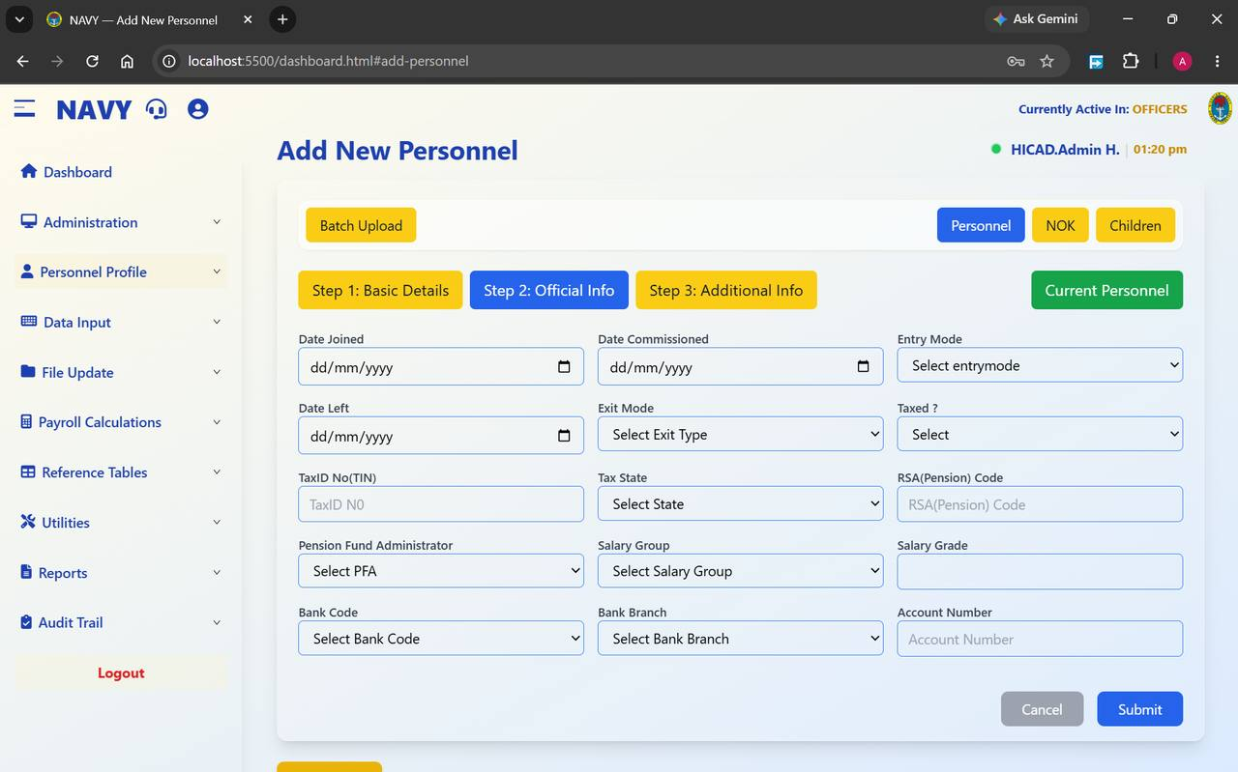
Figure 14.2 Add New Personnel, Step 2. Service dates on the left, tax and pension in the middle, salary and bank details on the right.
Field / control | What it is for
Date Joined | Date of entry into the Service. Used for seniority and long-service entitlements.
Date Commissioned | For officers. Leave blank where it does not apply.
Entry Mode | How the person entered the Service.
Date Left, Exit Mode | Completed only when the person leaves. See Chapter 16.
Taxed ? | Whether the person is subject to PAYE. Only change this from the normal setting where there is a specific authority.
TaxID No(TIN) | Tax identification number.
Tax State | The state to which tax is remitted. This drives the Tax Payments By State return in Chapter 55 — a wrong entry here sends money to the wrong state internal revenue service.
RSA(Pension) Code | The Retirement Savings Account number.
Pension Fund Administrator | The PFA holding that account, from the list in Chapter 38.
Salary Group | The salary scale the person is paid on, from Chapter 35 — for example AFSS2012.
Salary Grade | The grade and step within that group, for example 0103.
Bank Code, Bank Branch | The bank and branch the salary is paid to, from the list in Chapter 39.
Account Number | The salary account.

CAUTION
Account Number is the field most likely to cause a personal hardship if it is wrong. Enter it, read it back digit by digit against the source document, and — where the person is present — have them confirm it. After the record is saved, run Duplicate Account Number (Chapter 65) to make sure the account has not been keyed against somebody else as well.

14.4 Step 3 — Additional Info
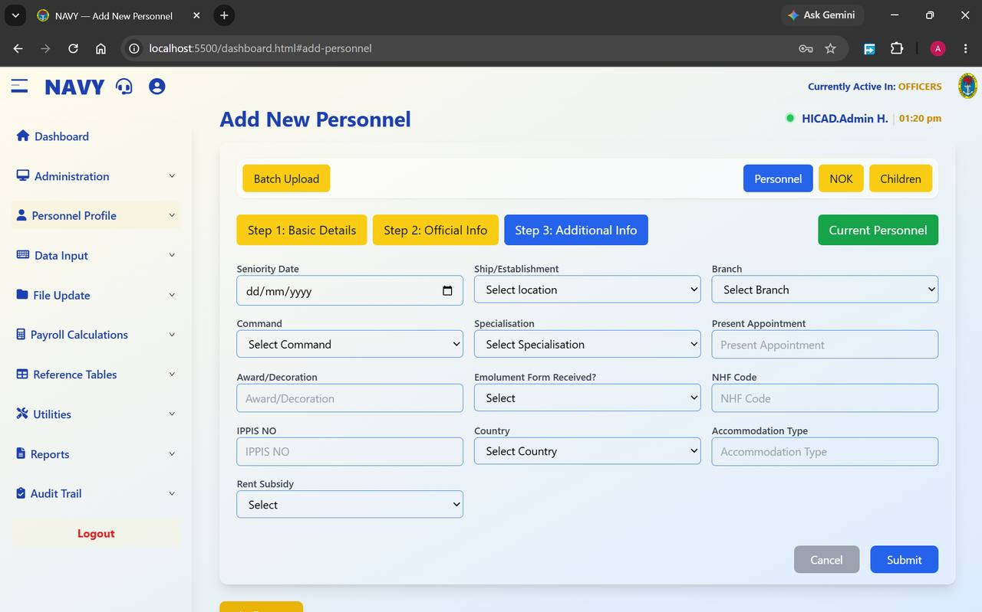
Figure 14.3 Add New Personnel, Step 3. Posting, branch, specialisation and entitlement fields.
Field / control | What it is for
Seniority Date | Date of seniority in current rank.
Ship/Establishment | Where the person is serving, from the location list in Chapter 40.
Branch | Their branch, from Chapter 40.
Command | The command the ship or establishment falls under, from Chapter 32.
Specialisation | Trade or specialisation.
Present Appointment | Current appointment, entered as free text.
Award/Decoration | Awards held.
Emolument Form Received? | Whether the person's emolument form has been returned. This is the link between the payroll and the emolument exercise, and it drives the Emolument Form scope on the personnel report in Chapter 15.3.
NHF Code | National Housing Fund number. Feeds the return in Chapter 57.
IPPIS NO | The person's number on the Integrated Personnel and Payroll Information System, used when reconciling against IPPIS data (Chapter 44).
Country | Country of posting.
Accommodation Type, Rent Subsidy | Accommodation status and whether rent subsidy is payable. These determine entitlement to the rent subsidy allowance.

When all three steps are complete, press Submit. Cancel abandons the record.

14.5 Next of kin
Switch to the NOK tab to record next of kin.
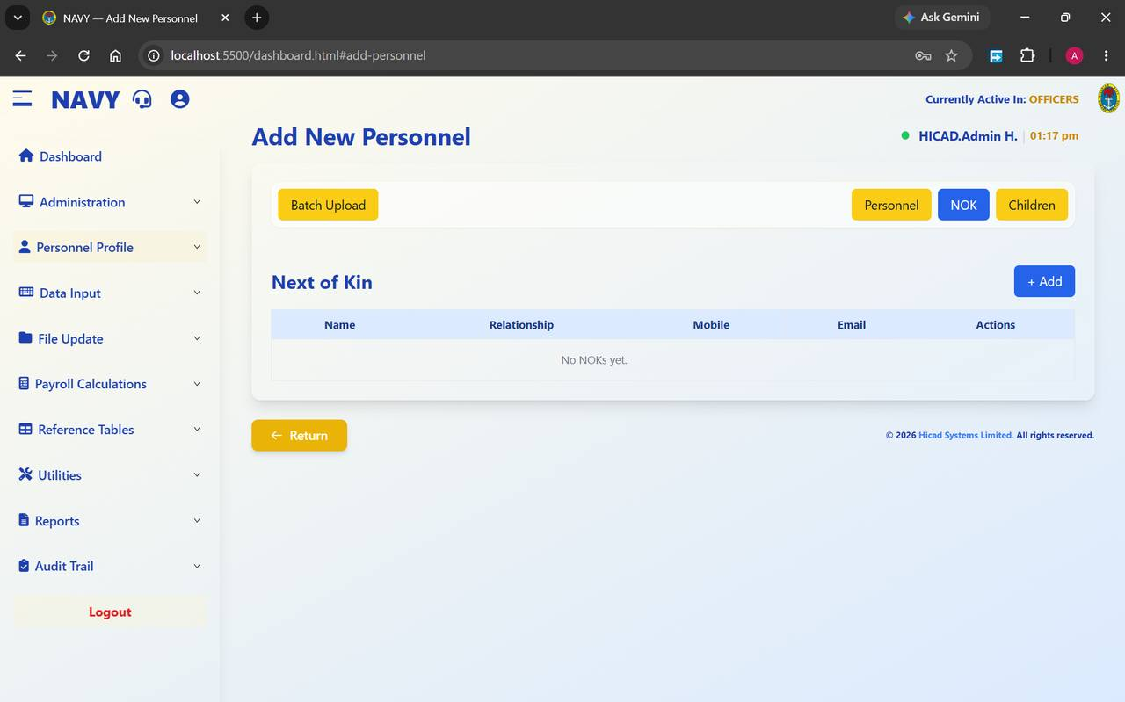
Figure 14.4 The Next of Kin tab on a new record, before any next of kin has been added.
- Press + Add.
- Enter the Name, Relationship, Mobile and Email.
- Save. The entry appears in the table, with actions to amend or remove it.
- Repeat for any additional next of kin.
GOOD PRACTICE
Next of kin details are the ones nobody checks until they are needed urgently. Review them whenever a person's own contact details are updated.

14.6 Children
Switch to the Children tab to record children.
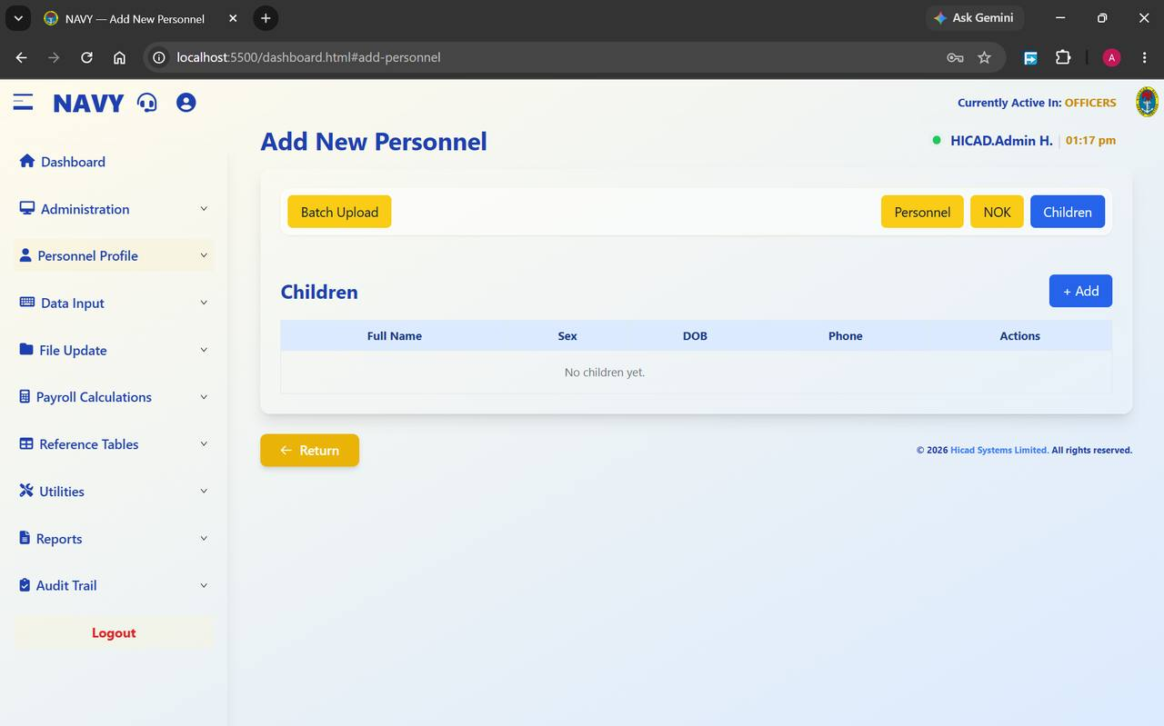
Figure 14.5 The Children tab, showing the empty state before any child is added.
Press + Add and record the Full Name, Sex, DOB and Phone for each child. The entries appear in the table with actions against them.

14.7 Batch Upload
Where a whole intake is being enrolled, keying each record is not practical. Batch Upload loads them from a spreadsheet.
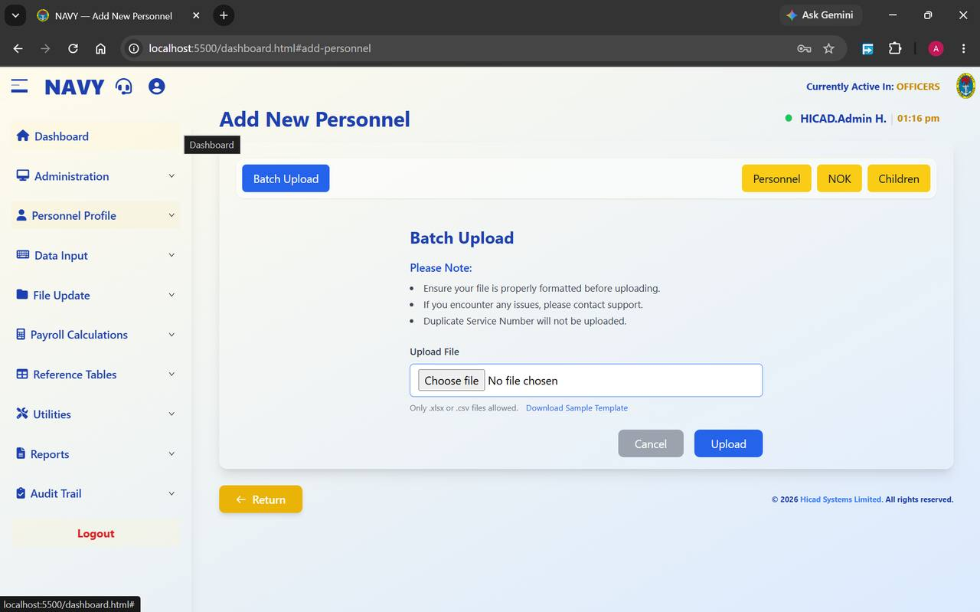
Figure 14.6 The Batch Upload panel, reached from the button at the top left of the Add New Personnel screen.
- Press Batch Upload.
- Press Download Sample Template and use it. The template carries the column headings the system expects; a file built from scratch will be rejected or, worse, loaded into the wrong columns.
- Complete the template. Only .xlsx and .csv files are accepted.
- Press Choose file and select it.
- Press Upload. Cancel abandons.
- Open Current Personnel and confirm the record count has risen by the number of rows you loaded.
NOTE
The on-screen notes are worth taking literally: ensure the file is properly formatted before uploading, and duplicate service numbers will not be uploaded. A row silently missing after an upload is almost always a service number that already exists.
CAUTION
A batch upload writes many records in one action. Load a small test file of two or three rows first, check the result, and only then load the full file.

15. Current Personnel
Personnel Profile > Current Personnel · dashboard.html#current-personnel
The working list of everybody on the payroll in the active class.

15.1 The list
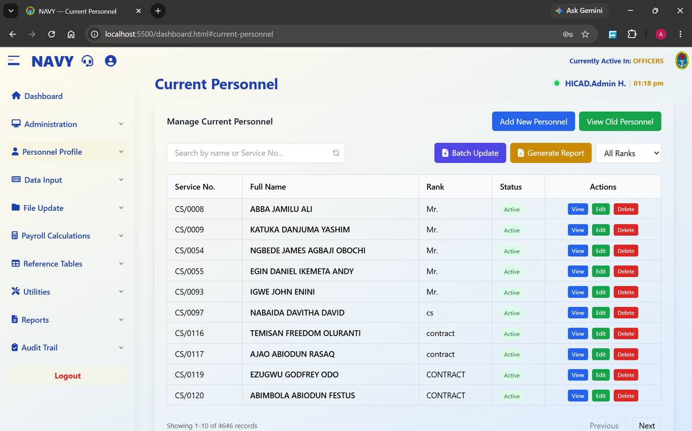
Figure 15.1 Current Personnel. The list is filtered to the active payroll class; the record count at the foot shows 4,646 officers.
Field / control | What it is for
Search by name or Service No… | Filters the list as you type. The circular arrow beside it clears the search.
Batch Update | Applies a change to many records at once from a spreadsheet.
Generate Report | Opens the Current Personnel Reports screen described below.
All Ranks | Filters the list to a single rank.
Add New Personnel | Opens the form described in Chapter 14.
View Old Personnel | Switches to the list of personnel who have left (Chapter 16).
Service No., Full Name, Rank, Status | The record. Active in the status column means the person is on the live payroll.
Actions | View opens the record read-only, Edit opens it for amendment, Delete removes it.

NOTE
The rank column reflects exactly what is on each record. Entries such as cs, contract and CONTRACT in Figure 15.1 show what happens when rank is keyed inconsistently over time. Where you find them, correct them to the standard rank list — inconsistent ranks break the By Rank scope on every personnel report.

15.2 Maintaining a record
- Find the person using the search box.
- Press View first and read the record. If nothing needs to change, close it — a view leaves no edit footprint.
- If a change is needed, press Edit.
- Amend only the fields covered by your source document.
- Save, then re-open the record and read the changed values back.
CAUTION
Delete removes the personnel record. Where somebody has left the Service, do not delete them — record the Date Left and Exit Mode on Step 2 of their record instead, so that they move to Old Personnel and their history is preserved (Chapter 16).

15.3 Batch Update
Batch Update applies the same kind of change to many records at once — a salary scale revision, a bank branch merger, a mass posting. It works in the same way as the batch upload in Chapter 14.7: download the template, complete it, upload it.
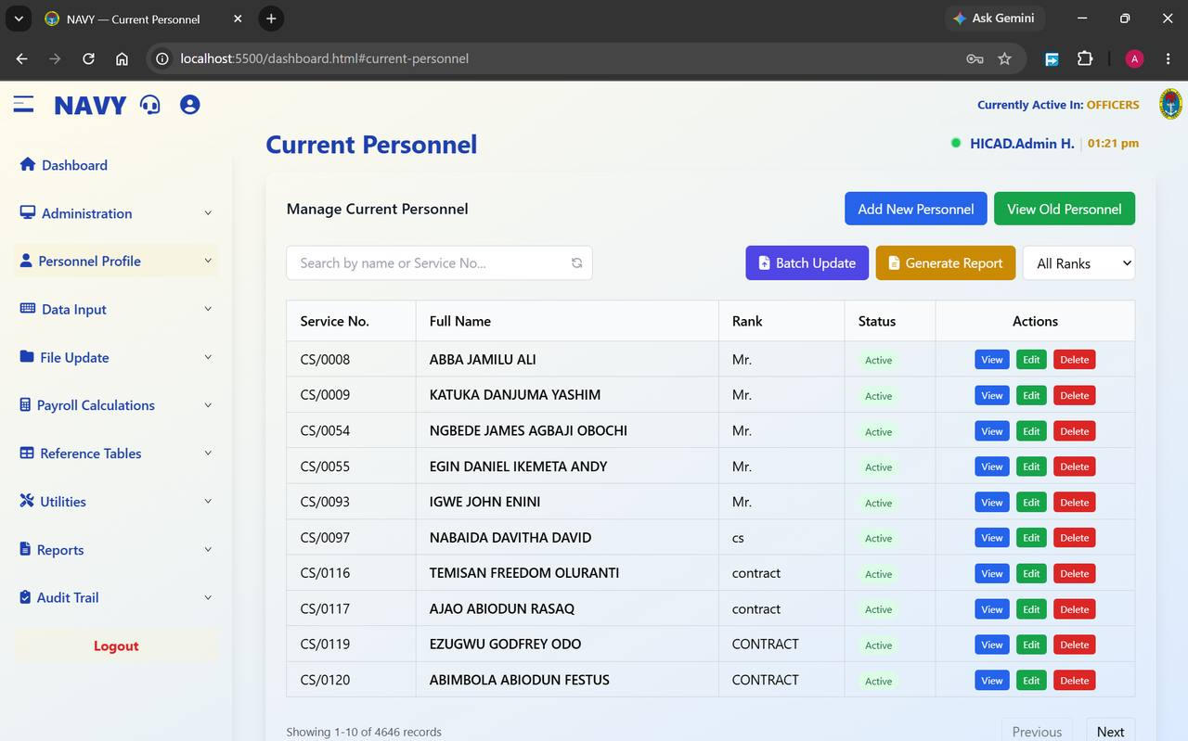
Figure 15.2 Current Personnel, from which Batch Update and Generate Report are launched. Always note the record count before a batch operation and check it again afterwards.
CAUTION
A batch update can change thousands of records in one action and there is no undo. Take a payroll class backup first (Chapter 45), test with a handful of rows, and check the result before loading the full file.

15.4 Current Personnel Reports
Generate Report opens a screen offering eleven different views of the personnel population.
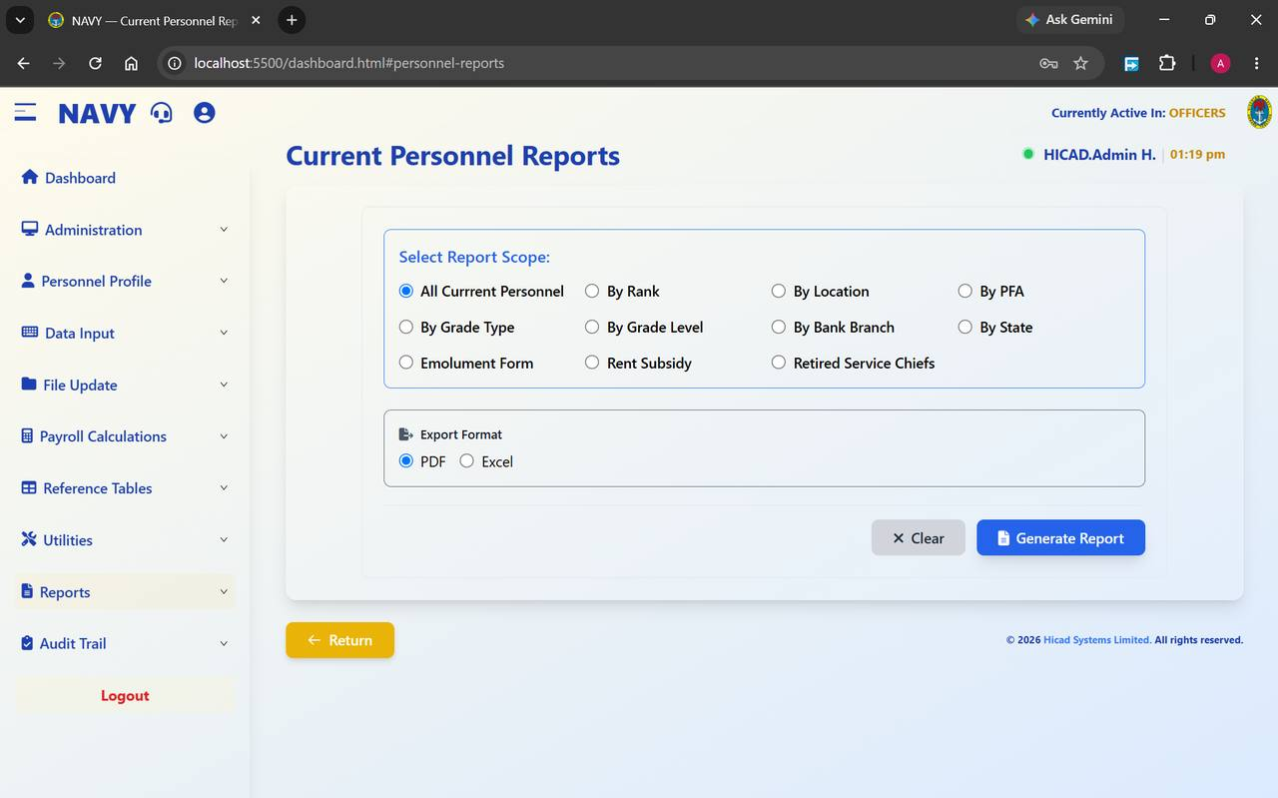
Figure 15.3 Current Personnel Reports. Choose a scope, choose PDF or Excel, and generate.
Scope | Produces
All Current Personnel | Everybody in the active class.
By Rank | Grouped by rank — the standard establishment return.
By Location | Grouped by ship or establishment.
By PFA | Grouped by pension fund administrator. Use this when reconciling with a PFA.
By Grade Type / By Grade Level | Grouped by salary grade type or level.
By Bank Branch | Grouped by paying branch. Useful before a bank reconciliation.
By State | Grouped by state of origin.
Emolument Form | Personnel by whether their emolument form has been received — the chasing list for the emolument exercise.
Rent Subsidy | Personnel in receipt of rent subsidy.
Retired Service Chiefs | A standing return for retired service chiefs.

Choose PDF for a fixed record or a document for signature, or Excel where the figures are to be analysed further. Press Generate Report, or Clear to reset the choices.

16. Old and Exited Personnel
Personnel Profile > Old Personnel · Reports > List of Exited Members
Where personnel go when they leave, and how to report on them.

16.1 Old Personnel
When a Date Left and Exit Mode are recorded on a personnel record, the person moves out of Current Personnel and into Old Personnel. They stop being paid; their history remains.
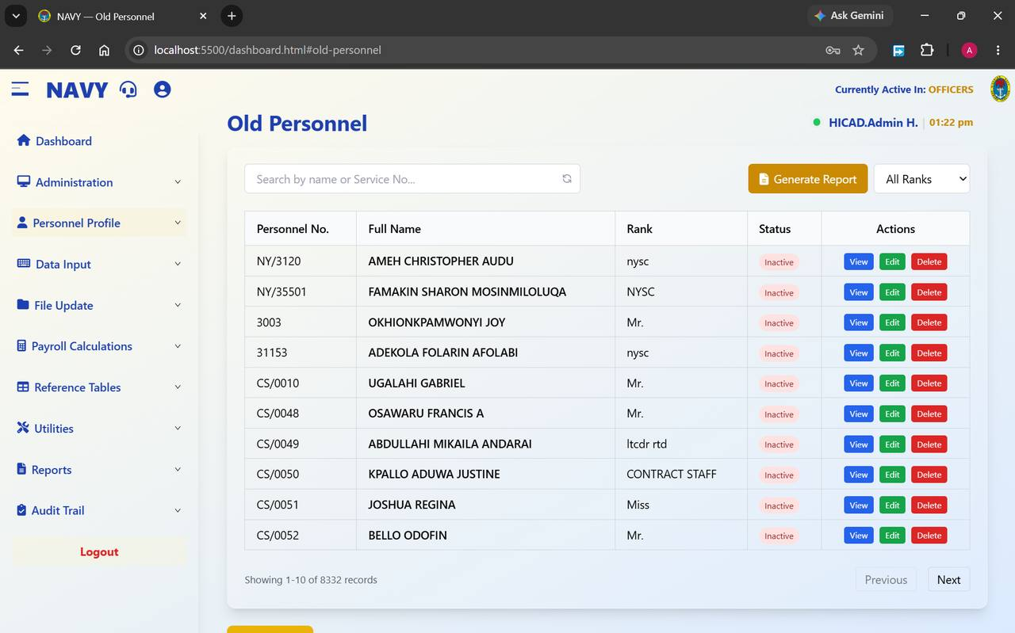
Figure 16.1 Old Personnel. Every record shows Inactive; the list runs to 8,332 records in this installation.
Field / control | What it is for
Search by name or Service No… | Filters the list.
All Ranks | Filters to a single rank.
Generate Report | Opens the exited members report described below.
Personnel No., Full Name, Rank | The record.
Status | Always Inactive on this screen.
Actions | View, Edit and Delete.

CAUTION
Resist the temptation to delete old records. They are the evidence behind any later query on a pension, a gratuity or a historical payment, and they cost nothing to keep.

16.2 Exited Members report
Generate Report opens a report screen with eight scopes.
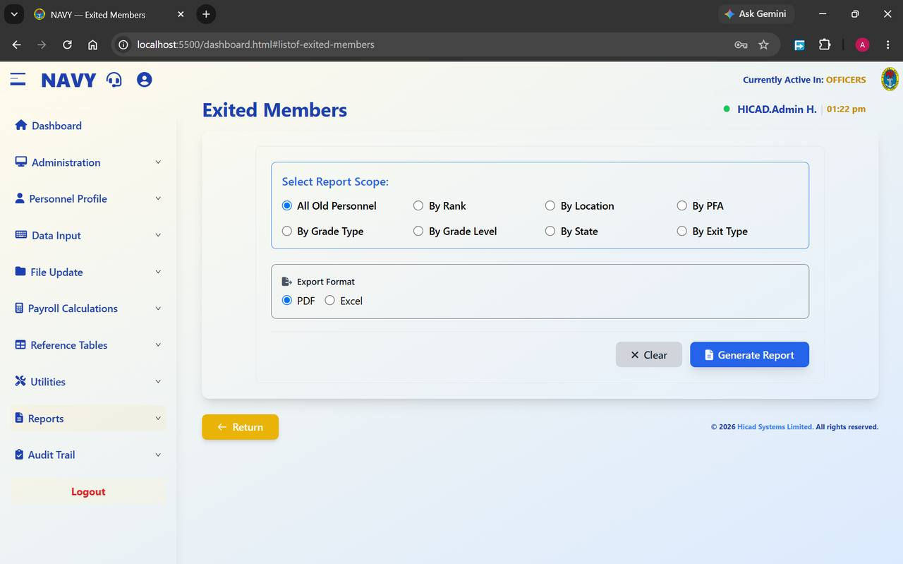
Figure 16.2 Exited Members. The scopes mirror the current personnel report, with By Exit Type added.
Scope | Produces
All Old Personnel | Everybody who has left.
By Rank | Grouped by rank held on departure.
By Location | Grouped by last ship or establishment.
By PFA | Grouped by pension fund administrator — the list to send a PFA when reconciling leavers.
By Grade Type / By Grade Level | Grouped by salary grade.
By State | Grouped by state of origin.
By Exit Type | Grouped by how the person left — retirement, resignation, discharge and so on. This is the most useful scope for wastage analysis.

Choose PDF or Excel and press Generate Report.
GOOD PRACTICE
Run By Exit Type at the end of each year alongside the year-end returns. It is the quickest evidence that leavers have been correctly recorded and removed from the live payroll.

17. Payments and Deductions
Data Input > Payments/Deductions · Data Input > Payments/Deductions (Batch Upload)
The heart of monthly data capture. Everything variable that a person is to be paid, or is to have taken from them, is entered here.

17.1 The screen
Open Data Input > Payments/Deductions. The screen lists the payment and deduction records held for the current period in the active class.
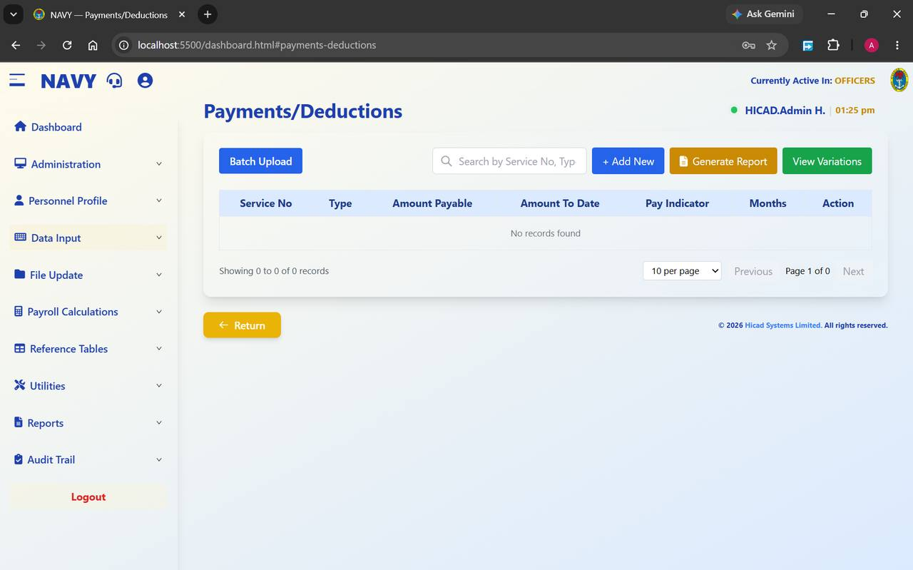
Figure 17.1 Payments/Deductions at the start of a period, before any records have been captured.
Field / control | What it is for
Batch Upload | Switches to the bulk upload screen described in 17.3.
Search by Service No, Type… | Filters the list by person or by payment type.
+ Add New | Opens the form to capture one record.
Generate Report | Prints the captured input for checking.
View Variations | Opens the Variation to Payments/Deductions screen (Chapter 18).
Service No | The person the record belongs to.
Type | The payment or deduction, from the pay elements defined in Chapter 36.
Amount Payable | The amount for this period.
Amount To Date | The cumulative amount paid or deducted so far. For a loan or a recovery this is what makes it possible to see how much remains.
Pay Indicator | Governs how the record behaves — whether it recurs, and how it is treated by the calculation.
Months | How many months the record runs for. Used for instalment deductions.
Action | Edit or delete the record.

17.2 Capturing a record
- Confirm the active payroll class in the header and the processing period on the dashboard.
- Press + Add New.
- Enter the Service No. Confirm the name the system returns is the person you intend.
- Choose the Type.
- Enter the Amount Payable.
- Where the record is an instalment arrangement, set Months and check Amount To Date.
- Set the Pay Indicator according to the nature of the payment.
- Save, and confirm the record appears in the list.
NOTE
Showing 0 to 0 of 0 records at the start of a period is normal — the table is empty until capture begins. It is also a useful check: if it is not empty when you expect it to be, you may be looking at the wrong period or the wrong class.

17.3 Batch upload
For volume, use Data Input > Payments/Deductions Upload.
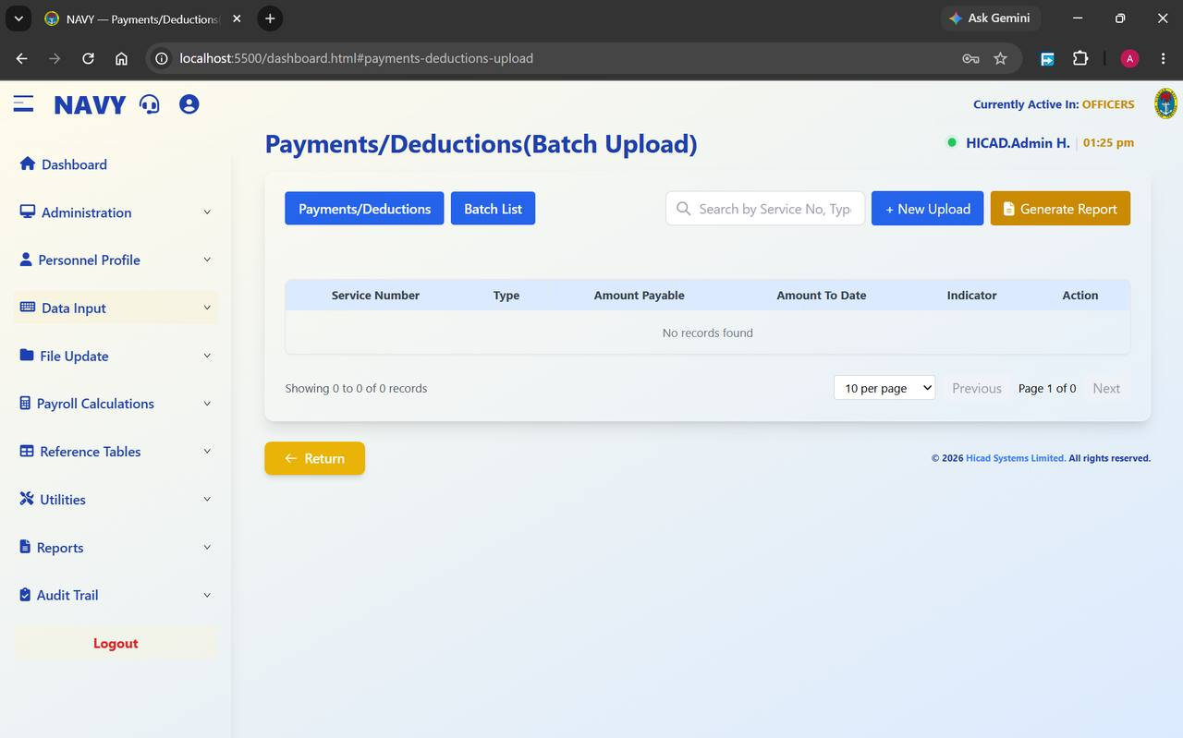
Figure 17.2 Payments/Deductions (Batch Upload). The Batch List tab keeps a record of previous uploads.
Field / control | What it is for
Payments/Deductions | Returns to the single-record screen.
Batch List | Shows previous uploads, so you can see what was loaded and when.
+ New Upload | Starts an upload.
Generate Report | Prints what has been uploaded.
Search by Service No, Type… | Filters the uploaded records.

- Press + New Upload.
- Download and use the template offered.
- Complete one row per payment or deduction, with the service number, type, amount payable, amount to date and indicator.
- Upload the file.
- Check the record count, then use Generate Report and reconcile the total against your source document.
GOOD PRACTICE
Reconcile the uploaded total against the authority for the payment before you go anywhere near validation. A batch that is out by one row is easy to correct now and hard to explain after month-end.

18. Variation to Payments and Deductions
Data Input > Variation Payments · dashboard.html#variation-payments
Changing a payment or deduction that is already running, without disturbing its history.
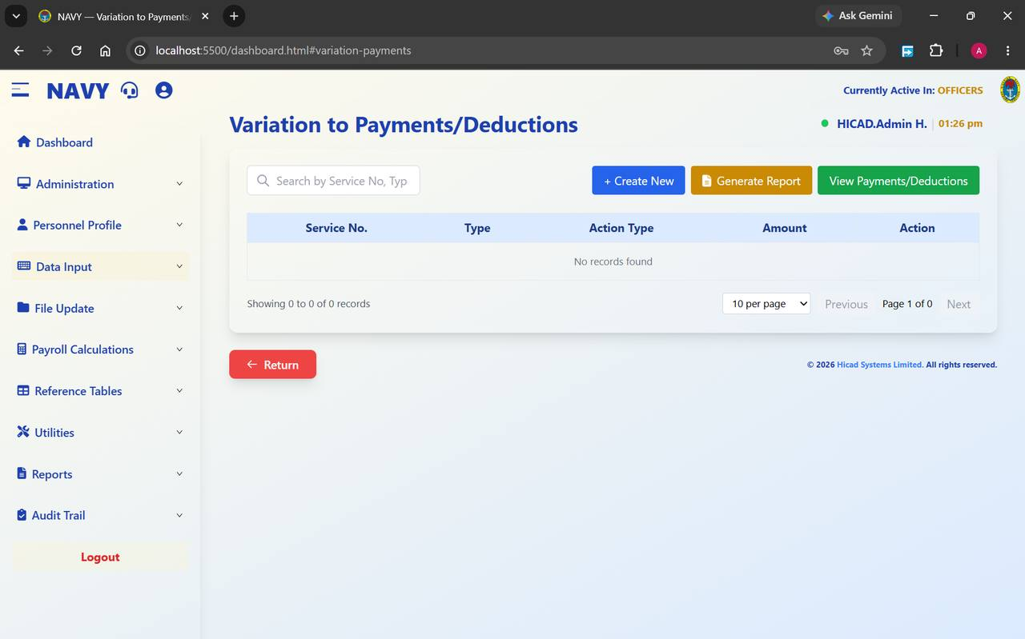
Figure 18.1 Variation to Payments/Deductions, before any variation has been recorded.
A variation records a change to an existing arrangement — increasing a deduction, suspending an allowance, altering an instalment. It is kept separate from the original record so that both the original and the change remain visible.
Field / control | What it is for
Search by Service No, Type… | Finds existing variations.
+ Create New | Records a variation.
Generate Report | Prints the variations captured for the period.
View Payments/Deductions | Returns to the main capture screen (Chapter 17).
Service No. | The person affected.
Type | The payment or deduction being varied.
Action Type | What is being done to it — the nature of the variation.
Amount | The revised figure.

- Press + Create New.
- Identify the person and the payment or deduction being varied.
- Choose the Action Type.
- Enter the revised Amount.
- Save, then press Generate Report and check the variation reads as you intended.
NOTE
Variations are listed separately on the Variation Input Listings report (Chapter 62), which can be produced by pay element, by employee or by operator. That report is the natural control document for this screen.

19. Cumulative Payroll Transfer
Data Input > Cumulative Payroll · dashboard.html#cumulative-payroll
Carrying year-to-date figures into the system — normally only when a payroll is first brought on, or when somebody transfers in mid-year.
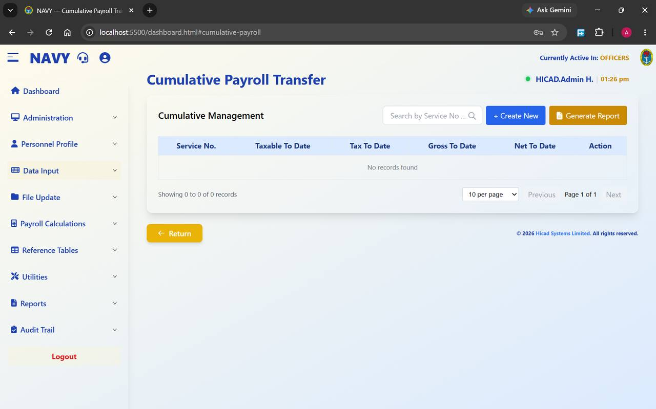
Figure 19.1 Cumulative Payroll Transfer, showing the four year-to-date figures the system holds.
Field / control | What it is for
Service No. | The person the cumulative figures belong to.
Taxable To Date | Taxable pay for the year so far.
Tax To Date | Tax deducted for the year so far.
Gross To Date | Gross pay for the year so far.
Net To Date | Net pay for the year so far.
+ Create New | Records cumulative figures for a person.
Generate Report | Prints the cumulatives held.

In normal running the system maintains these figures itself as each month-end is processed. You will only need this screen in two situations: when the payroll is first loaded part-way through a year, and when a person transfers in from another payroll carrying year-to-date figures with them.
CAUTION
Cumulative figures drive the tax calculation. An incorrect Taxable To Date or Tax To Date will produce a wrong tax deduction for every remaining month of the year. Enter these only from a formal statement of pay, and have them checked by a second person.

20. Input Documentation
Data Input > Input Documentation · dashboard.html#input-documentation
The per-person input form: what has been captured against one individual this period.
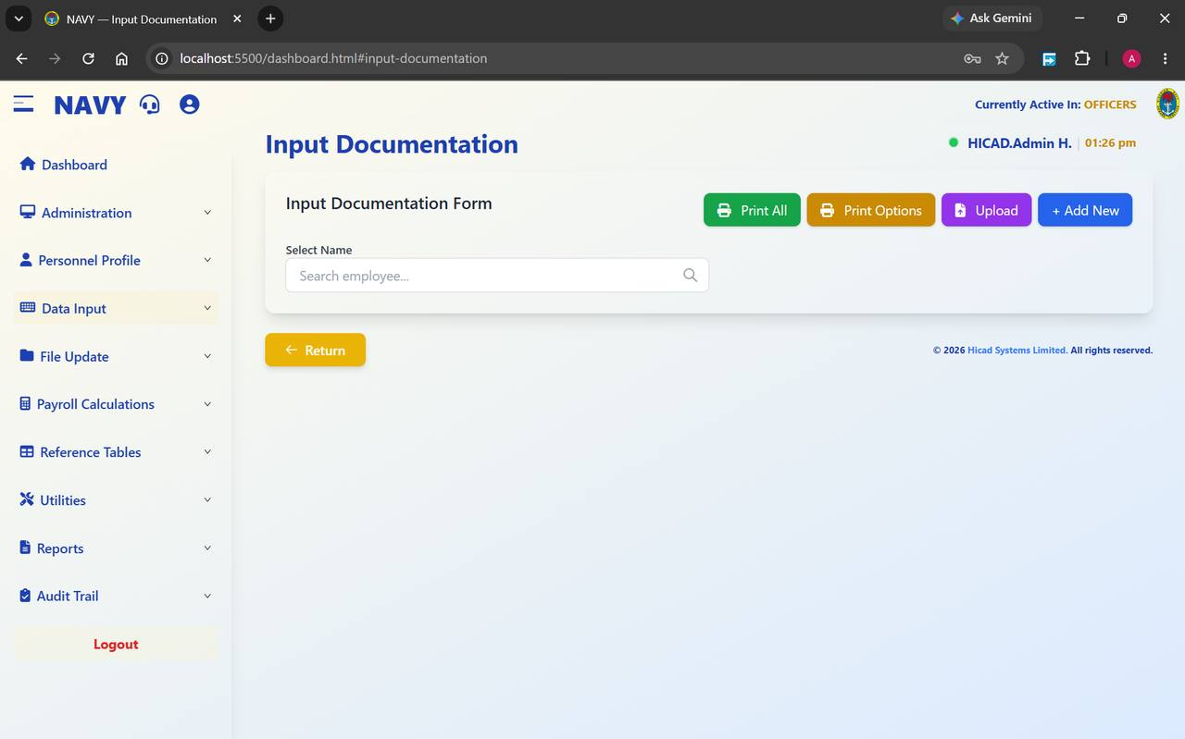
Figure 20.1 Input Documentation. Search for a person to see and print their input form.
Field / control | What it is for
Select Name / Search employee… | Find the person whose input you want to see.
Print All | Prints input documentation for everybody.
Print Options | Sets what the printed form contains.
Upload | Loads input documentation from a file.
+ Add New | Adds an input documentation record.

This screen is the natural answer to the question “what have we actually put through for this person this month?”. It is worth using whenever a query arrives, before opening any of the maintenance screens.
GOOD PRACTICE
Print the input documentation for anybody whose pay is queried, and file it with the query. It is a single sheet that shows exactly what was captured, and it usually settles the matter.

21. Arrears Calculations
Data Input > Arrears Calculations · dashboard.html#arrears-calculations
Working out back pay owed when a change of grade or of rate is applied retrospectively.
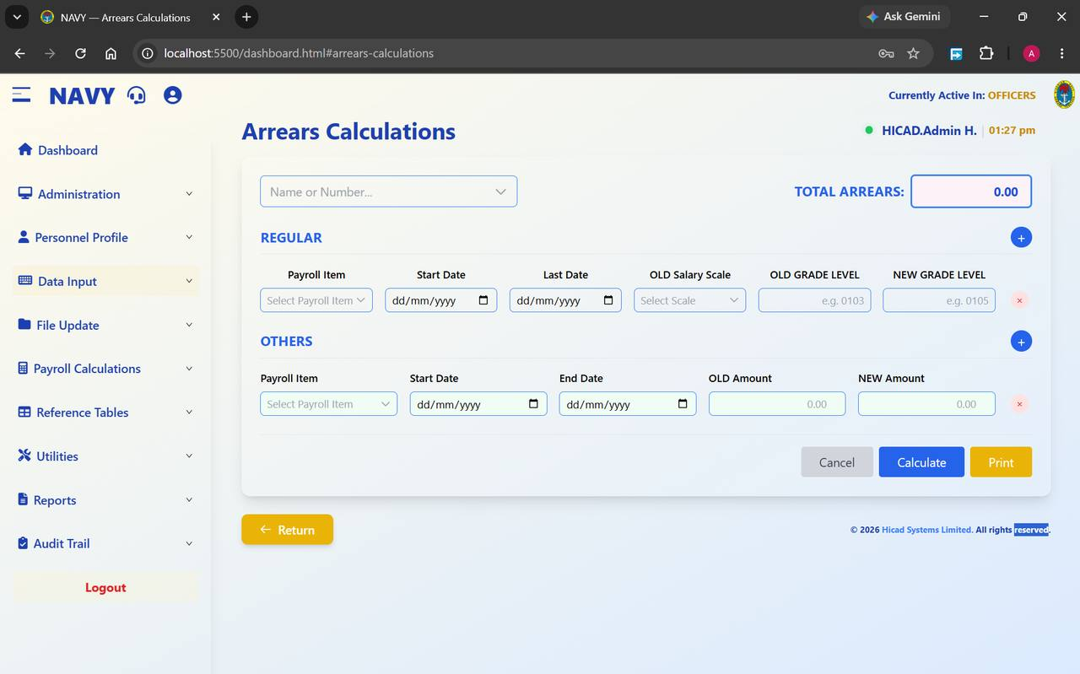
Figure 21.1 Arrears Calculations. The REGULAR block handles grade changes; the OTHERS block handles any other retrospective difference. The running total sits at the top right.

21.1 The two blocks

REGULAR — arrears arising from a grade change
Field / control | What it is for
Payroll Item | The element the arrears relate to.
Start Date / Last Date | The period the arrears cover.
OLD Salary Scale | The scale in force before the change.
OLD GRADE LEVEL / NEW GRADE LEVEL | The grade before and after, entered in the form shown on screen — for example 0103 and 0105.
+ (blue) | Adds another line, where more than one change falls in the period.
× (red) | Removes a line.

OTHERS — any other retrospective difference
Field / control | What it is for
Payroll Item | The element concerned.
Start Date / End Date | The period covered.
OLD Amount / NEW Amount | The figures before and after. The system works out the difference across the period.

21.2 Producing an arrears calculation
- Find the person in Name or Number….
- Add a line in REGULAR for each grade change, or in OTHERS for each rate change.
- Set the dates carefully. The period boundaries are what determine the number of months in the calculation, and a date out by one day can be a month out in the answer.
- Press Calculate. TOTAL ARREARS at the top right updates.
- Press Print and check the calculation line by line against the authority.
- Enter the agreed total as a payment on Payments/Deductions (Chapter 17), or through the one-off route in Chapter 11 where it is being paid as a one-off.
CAUTION
Arrears are paid retrospectively and are frequently large. Have the printed calculation checked and signed by somebody other than the person who prepared it before the figure is entered for payment.

22. NHQ Allowances
Data Input > Adjustments · dashboard.html#adjustments
Bulk loading of allowances authorised at Naval Headquarters.
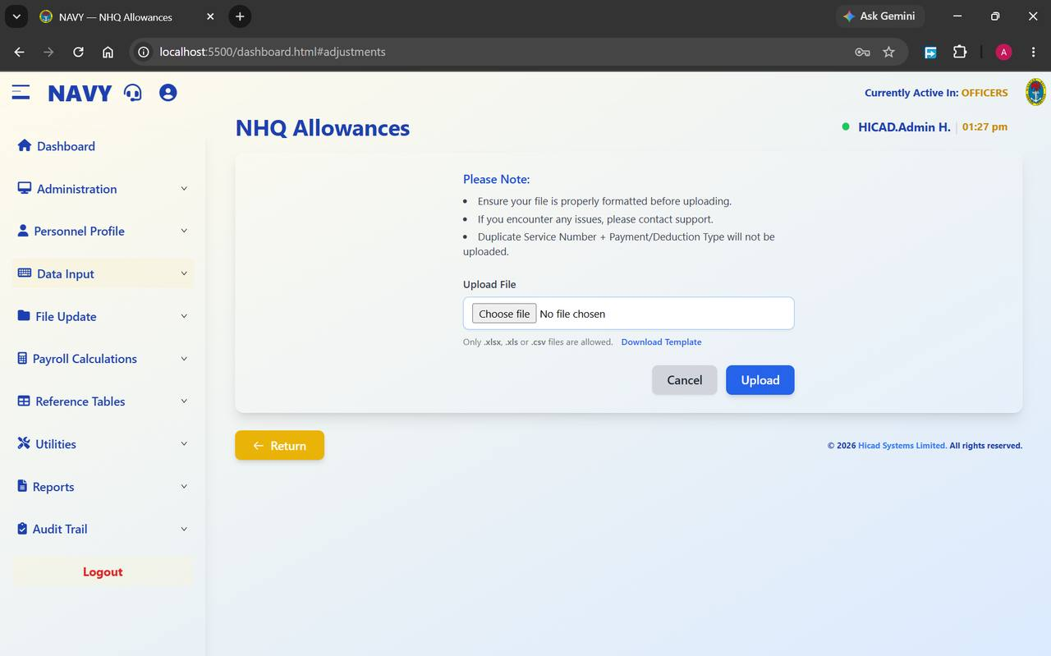
Figure 22.1 NHQ Allowances. A single upload panel, with the rules stated above it.
Field / control | What it is for
Upload File / Choose file | Select the file to load. Only .xlsx, .xls and .csv are accepted.
Download Template | The template with the column headings the system expects. Always start from this.
Upload | Loads the file. Cancel abandons.

The three rules printed on the screen are worth repeating:
- Ensure your file is properly formatted before uploading.
- If you encounter any issues, contact support.
- Duplicate Service Number + Payment/Deduction Type will not be uploaded. The system treats that pair as unique — so a person cannot receive the same allowance twice from one file.
NOTE
The third rule is a protection, not a limitation. If a row is missing after an upload, the usual cause is that the same person and allowance combination already exists — check the Payments/Deductions list before assuming the upload failed.
GOOD PRACTICE
Keep the authorising signal or letter with the uploaded file. When the allowance appears on a payslip three months later and is queried, that pairing is the answer.

23. Payments and Deductions Validation
Data Input > PayDed Validation · dashboard.html#payded-validation
The gate between capture and processing. Nothing downstream runs until this is done.
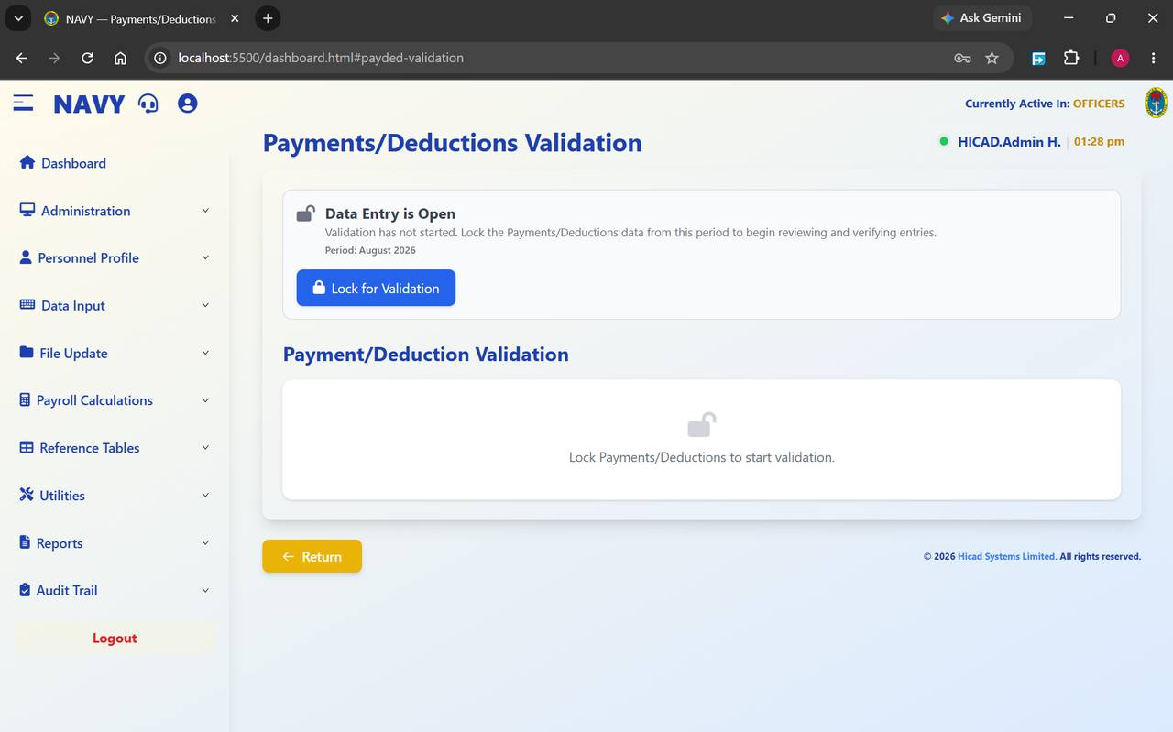
Figure 23.1 Payments/Deductions Validation with data entry still open. The lower panel stays empty until the data is locked.

23.1 What the screen does
While capture is in progress the screen shows an open padlock and the message Data Entry is Open — validation has not started. Lock the Payments/Deductions data from this period to begin reviewing and verifying entries. The period concerned is stated beneath it.
Pressing Lock for Validation freezes the payment and deduction data for the period so that it cannot change while it is being checked, and opens the Payment/Deduction Validation panel below for review and verification.

23.2 The procedure
- Confirm that every source document for the period has been captured or uploaded. Once locked, entry for the period is closed.
- Confirm the Period shown on the screen is the one you intend to lock.
- Press Lock for Validation.
- Work through the validation panel, verifying the entries.
- When validation is complete, move on to Save Payroll Files (Chapter 24).
CAUTION
Locking closes data entry for the period. Anything found afterwards has to be handled as a correction rather than as an entry, which is more work and leaves a more complicated trail. Check that capture is genuinely finished first.
NOTE
This screen is the reason the File Update chapters open with a locked message. If Save Payroll Files tells you validation is required, this is the screen it is sending you to.

24. Save Payroll Files
File Update > Save Payroll Files · dashboard.html#save-payroll-files
Step 6 of the cycle: take a secure copy of the validated data.
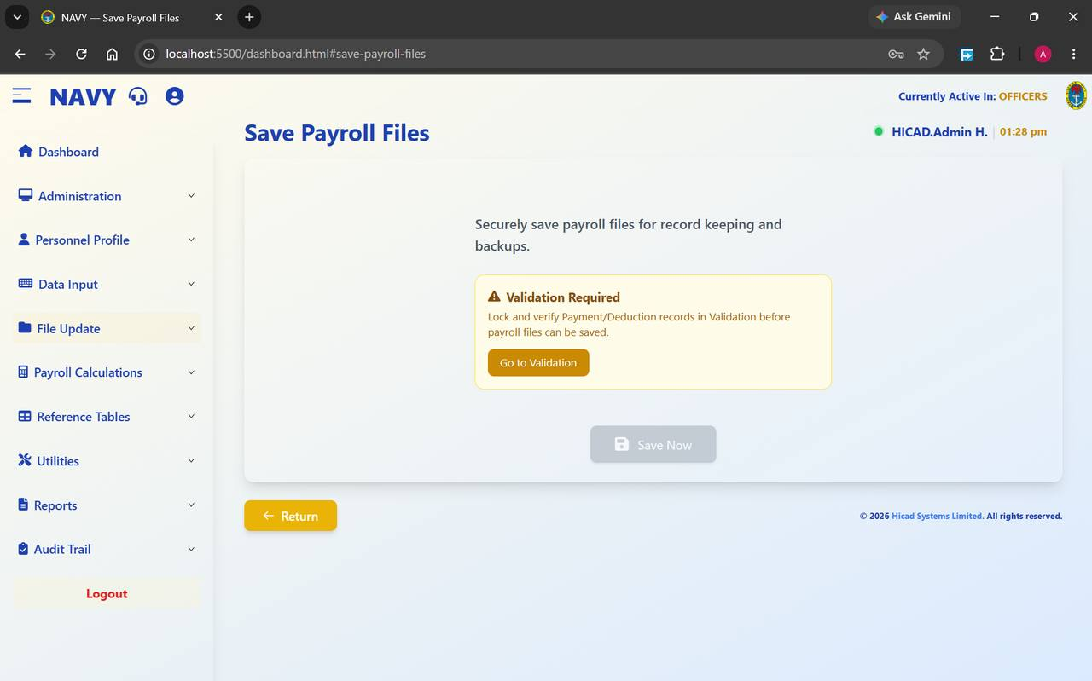
Figure 24.1 Save Payroll Files, refused because validation has not been completed. The Go to Validation button takes you straight to the screen that will release it.
The purpose of this screen is stated on it: securely save payroll files for record keeping and backups. It is the point at which the validated input for the period is committed to the record.

24.1 The lock
Until validation is complete the screen shows Validation Required — lock and verify Payment/Deduction records in Validation before payroll files can be saved, the Save Now button is greyed, and a Go to Validation button is offered instead.
- If the warning is shown, press Go to Validation and complete Chapter 23.
- Return to Save Payroll Files.
- Press Save Now.
- Confirm the save has completed before moving to Chapter 25.
NOTE
This is the first of four screens that unlock in sequence. Save Payroll Files releases Changes in Personnel Data, which releases the Input Variable Report, which releases the Master File Update. Work down the File Update menu in order and each screen will open as you reach it.

25. Changes in Personnel Data
File Update > Changes Personnel Data · dashboard.html#changes-personnel-data
Step 7: the control report listing every change made to personnel records.
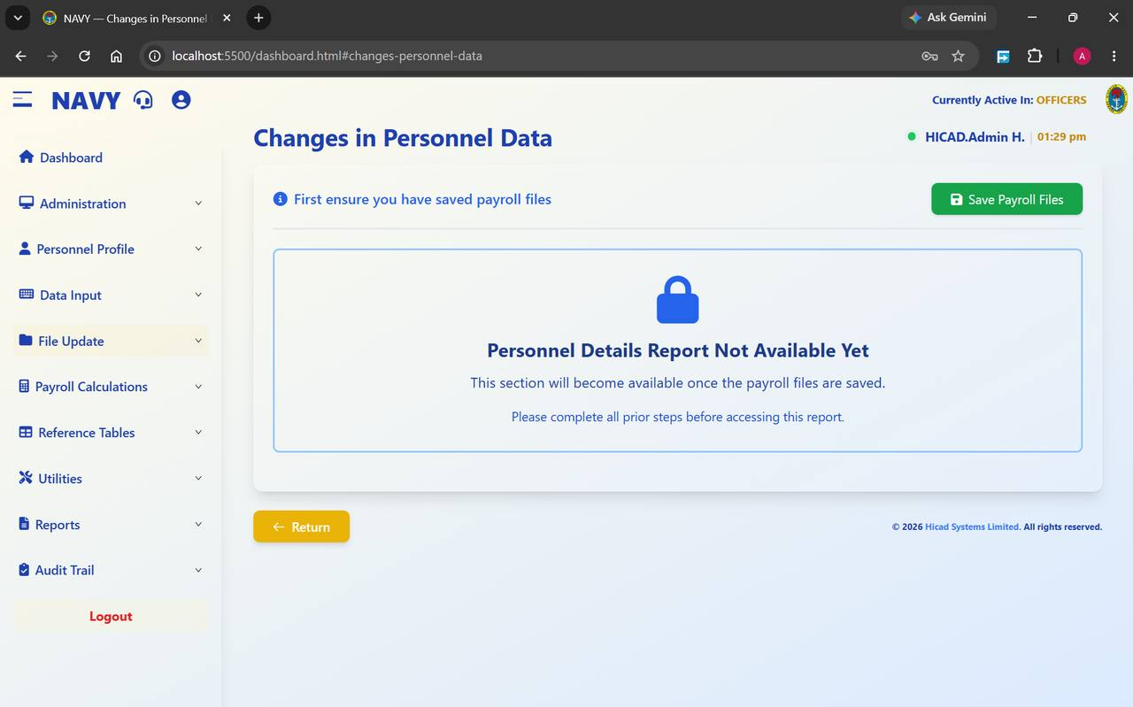
Figure 25.1 Changes in Personnel Data, locked until the payroll files have been saved. The button at the top right takes you back to do it.
This report lists the amendments made to personnel records since the previous cycle — new records, changed ranks, changed bank details, changed salary grades. It exists so that somebody other than the person who keyed the changes can read them before they affect pay.

25.1 The lock
Until the payroll files are saved the screen shows Personnel Details Report Not Available Yet — this section will become available once the payroll files are saved, with the instruction first ensure you have saved payroll files and a Save Payroll Files button at the top right.

25.2 Using the report
- Complete Save Payroll Files (Chapter 24).
- Return here and produce the report.
- Read it against the source documents for the period. Every change should be traceable to an authority.
- Have it checked and signed by a supervisor.
- File it. It is the evidence that standing data was reviewed before pay was calculated.
GOOD PRACTICE
Pay particular attention to changed bank account numbers and changed salary grades. Those two categories account for most of the corrections that arise after a pay run.

26. Input Variable Report
File Update > Input Variable Report · dashboard.html#input-variable-report
Step 8: the control report listing the variable input captured for the period.
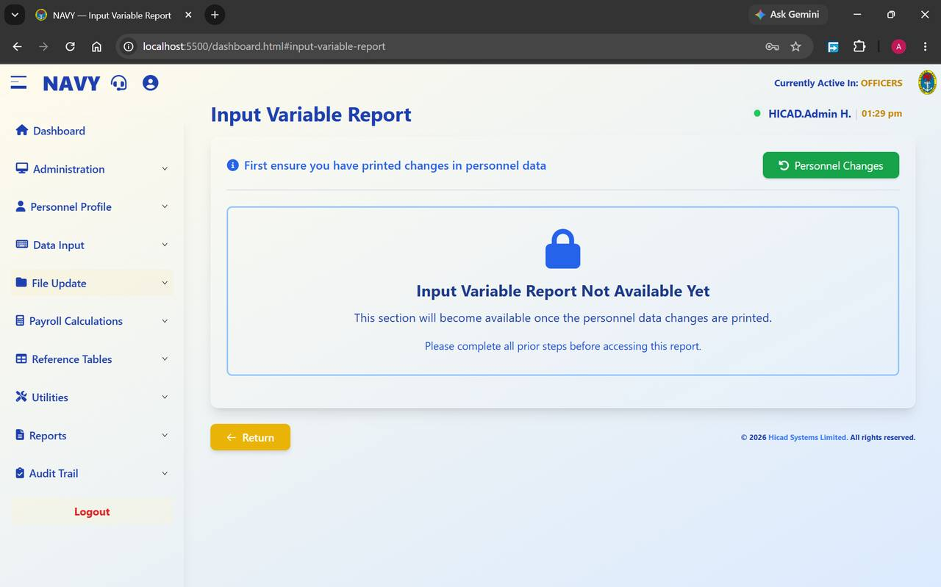
Figure 26.1 Input Variable Report, locked until the personnel data changes have been printed.
Where Chapter 25 covers changes to standing data, this report covers the variable input for the period — the payments, deductions, variations and adjustments captured in Part IV. Together, the two reports account for everything that can move a person's pay this month.

26.1 The lock
The screen shows Input Variable Report Not Available Yet — this section will become available once the personnel data changes are printed, with the instruction first ensure you have printed changes in personnel data and a Personnel Changes button at the top right.

26.2 Using the report
- Complete Changes in Personnel Data (Chapter 25).
- Return here and produce the report.
- Reconcile the totals against the source documents and the batch upload totals from Chapter 17.
- Investigate anything that does not reconcile before running the master file update. After that point the figures are committed.
- Have the report checked and signed, and file it with the personnel changes report.

27. Master File Update
File Update > Master File Update · dashboard.html#master-file-update
Step 9: writing the validated input into the master records.
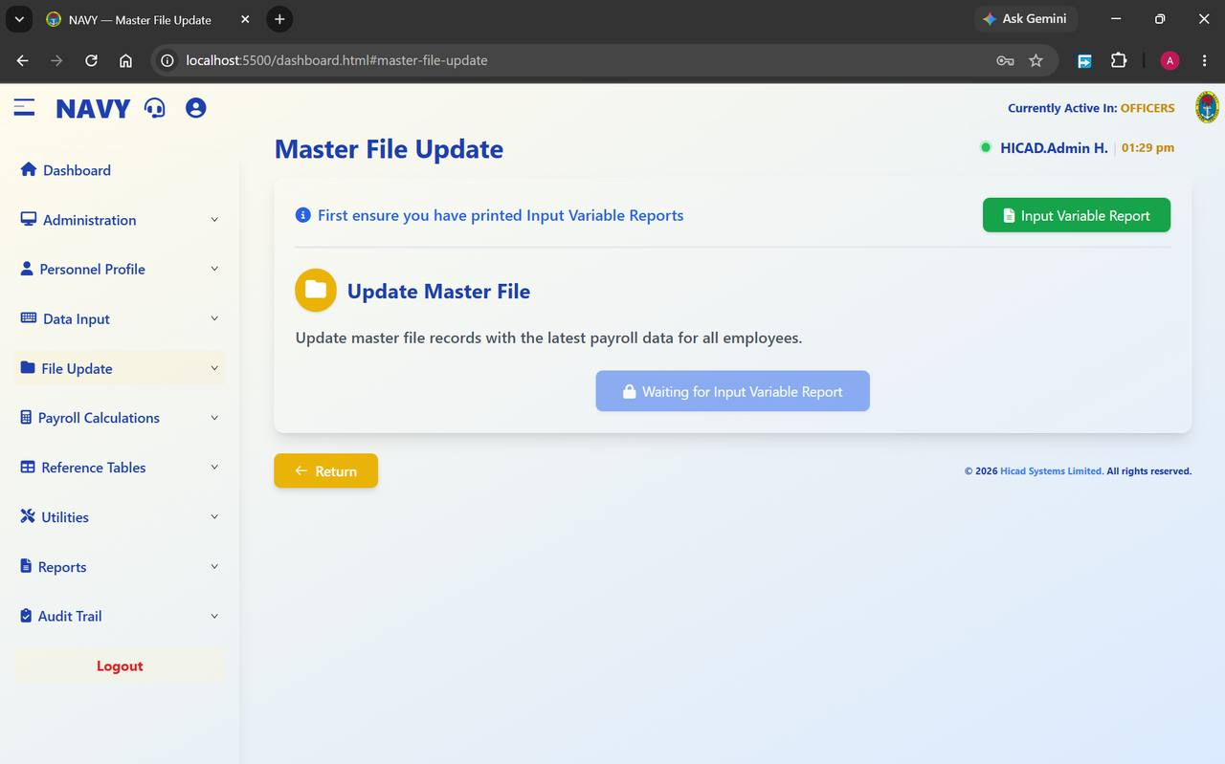
Figure 27.1 Master File Update, waiting on the Input Variable Report. The button reads Waiting for Input Variable Report until the previous step is complete.
The master file update takes the validated, reported input and writes it into the master records, ready for the calculation. Its purpose is given on the screen: update master file records with the latest payroll data for all employees.

27.1 The lock
Until the input variable report has been printed, the screen shows first ensure you have printed Input Variable Reports, offers an Input Variable Report button at the top right, and the action button is disabled and labelled Waiting for Input Variable Report.

27.2 Running the update
- Complete Input Variable Report (Chapter 26).
- Return here. The button becomes available.
- Press it and wait for the update to complete.
- Move on to Payroll Calculations (Chapter 29).
CAUTION
After the master file update, the data the calculation will use is fixed. Corrections found after this point must be handled as adjustments in the following period, or by unwinding the cycle. Read the two control reports properly before you get here — that is what they are for.

28. Recall Payment Files
File Update > Recall Payment Files · dashboard.html#recall-payment-files
Bringing a previously saved payment file back for review or adjustment.
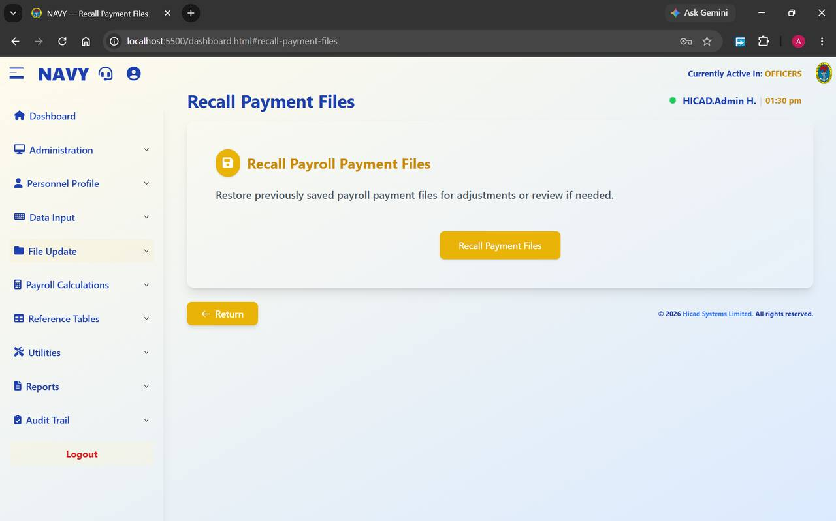
Figure 28.1 Recall Payment Files. A single action, described plainly on the screen.
The screen restores previously saved payroll payment files for adjustments or review if needed. It is the counterpart to Save Payroll Files in Chapter 24, and it is used in two situations: when a saved file needs to be examined in support of a query, and when an error found after saving has to be corrected before the calculation runs.
- Open File Update > Recall Payment Files.
- Press Recall Payment Files.
- Review or adjust the recalled data.
- Where you have adjusted anything, work down the File Update sequence again from the point you changed.
CAUTION
Recalling a payment file part-way through a cycle puts the sequence out of step. If you recall, expect to repeat Chapters 24 to 27 before calculating, and note on the file why the recall was necessary.

29. Payroll Calculations
Payroll Calculations > Payroll Calculations · dashboard.html#payroll-calculations
Step 10: the calculation itself.
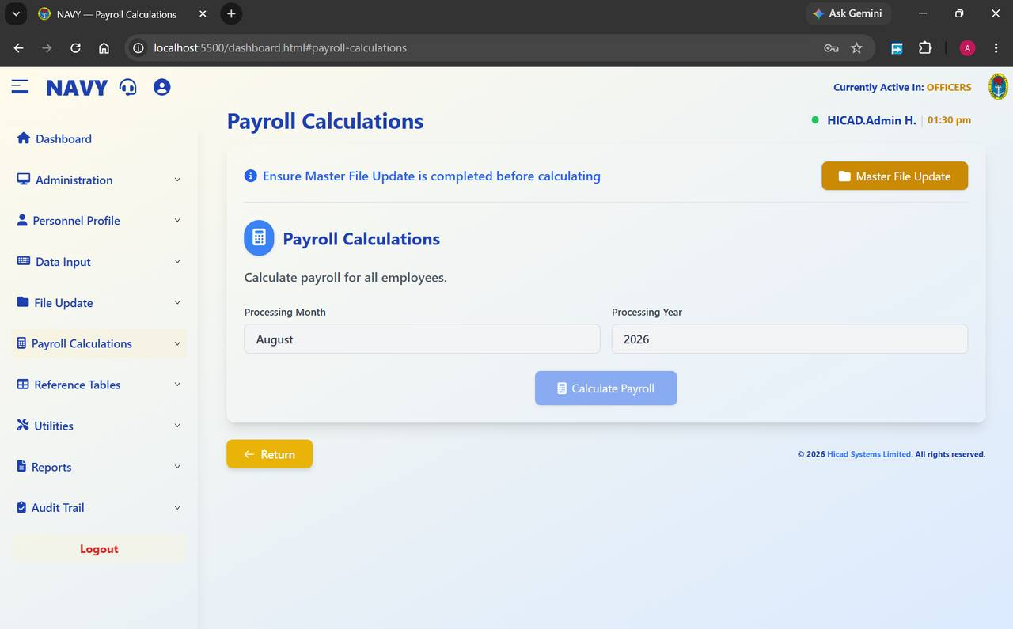
Figure 29.1 Payroll Calculations. The month and year are shown for confirmation; the button is greyed until the master file update is complete.
This screen calculates pay for every active record in the active payroll class. Its scope is stated on the screen: calculate payroll for all employees.
Field / control | What it is for
Ensure Master File Update is completed before calculating | The prerequisite, with a Master File Update button at the top right that takes you to it.
Processing Month | The month being calculated. Read it.
Processing Year | The year being calculated. Read it too.
Calculate Payroll | Runs the calculation. Disabled until the master file update has been done.

29.1 Running the calculation
- Confirm the active payroll class in the header.
- Confirm Processing Month and Processing Year.
- Press Calculate Payroll.
- Wait. The calculation covers thousands of records; do not navigate away from the screen while it runs.
- When it completes, open Calculation Reports (Chapter 30) and read them before doing anything else.
NOTE
The calculation is run separately for each payroll class. Complete a class, then switch class (Chapter 9) and repeat.
GOOD PRACTICE
Take a payroll class backup (Chapter 45) immediately before calculating. It is the cheapest possible insurance and takes less than a minute.

30. Calculation Reports
Payroll Calculations > Calculation Reports · dashboard.html#calculation-reports
Reading the result before anybody is paid.
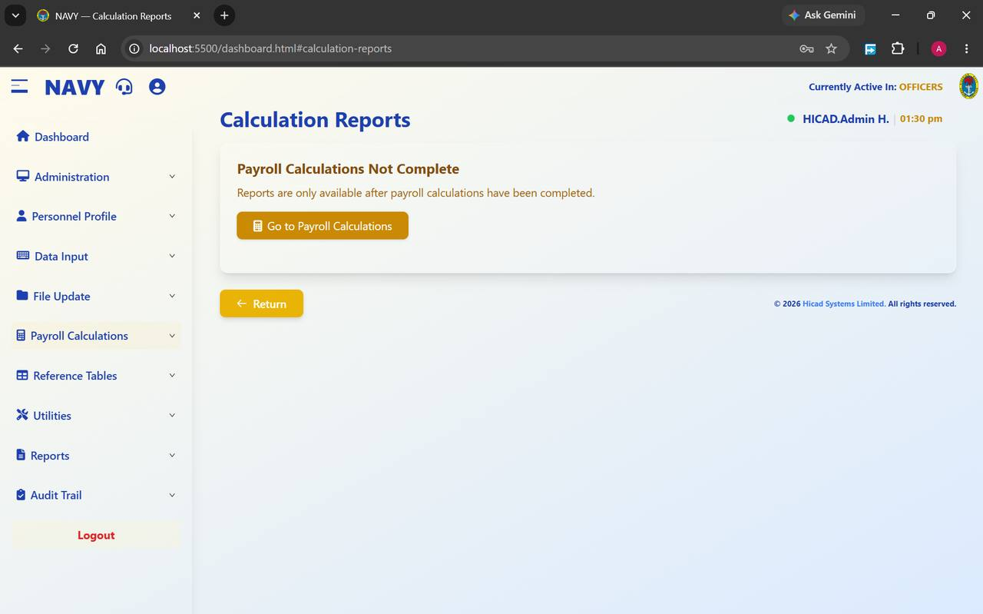
Figure 30.1 Calculation Reports before the calculation has run. Reports are only available once the calculation is complete.
The screen shows Payroll Calculations Not Complete — reports are only available after payroll calculations have been completed, with a Go to Payroll Calculations button, until the calculation has run. Afterwards it gives access to the reports describing what the calculation produced.

30.1 What to check
- The number of records calculated against the number of active personnel in the class.
- The gross, deduction and net totals against the previous period. A movement is normal; a large unexplained movement is not.
- Any records the calculation could not complete.
- The exception reports listed in Chapter 5.4 — reconciliation, variance, overpayment, out-of-range and duplicate accounts.
CAUTION
This is the last comfortable point at which a mistake can be corrected. After the reports have been distributed and month-end has run, a correction becomes an adjustment in a later period, with everything that implies for the person concerned.

31. Overtime Information
Reference Tables > Overtime Information · dashboard.html#overtime-information
The multipliers applied to overtime, and whether overtime is taxed.
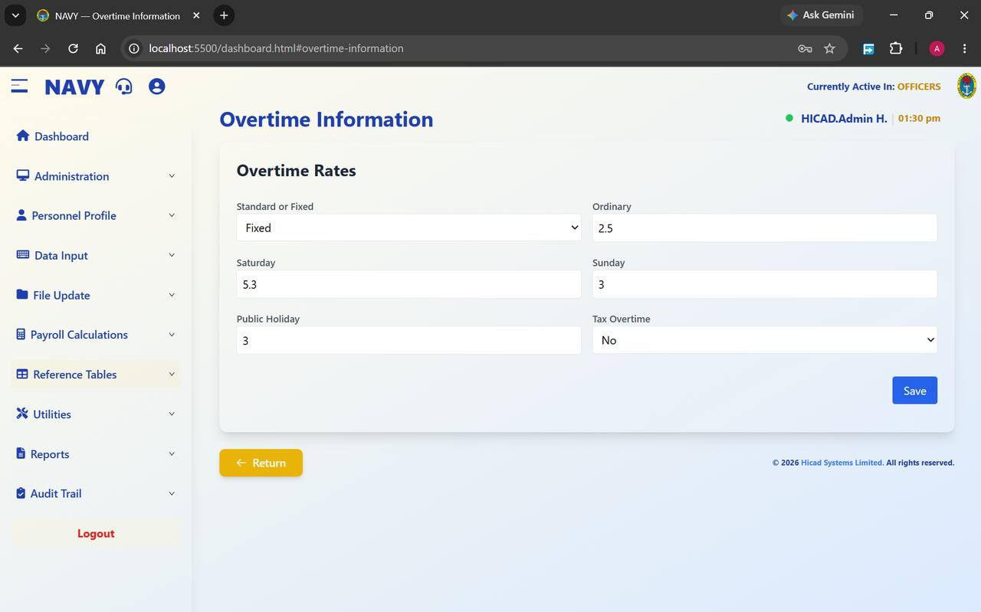
Figure 31.1 Overtime Information. Six settings, one Save button.
Field / control | What it is for
Standard or Fixed | How the overtime rate is derived. Fixed applies the multipliers below to a fixed base; Standard derives them from the salary scale.
Ordinary | The multiplier for ordinary overtime. Shown as 2.5.
Saturday | The multiplier for Saturday working. Shown as 5.3.
Sunday | The multiplier for Sunday working. Shown as 3.
Public Holiday | The multiplier for public holidays. Shown as 3.
Tax Overtime | Whether overtime is subject to tax. Shown as No.

- Amend the values you need to change.
- Press Save.
- Confirm by re-opening the screen and reading the values back.
CAUTION
These multipliers apply to every overtime record calculated afterwards. Change them only on written authority, and only between pay runs — changing them part-way through a period will produce two different rates within the same month.

32. Commands
Reference Tables > Command · dashboard.html#command
The commands under which ships and establishments sit.
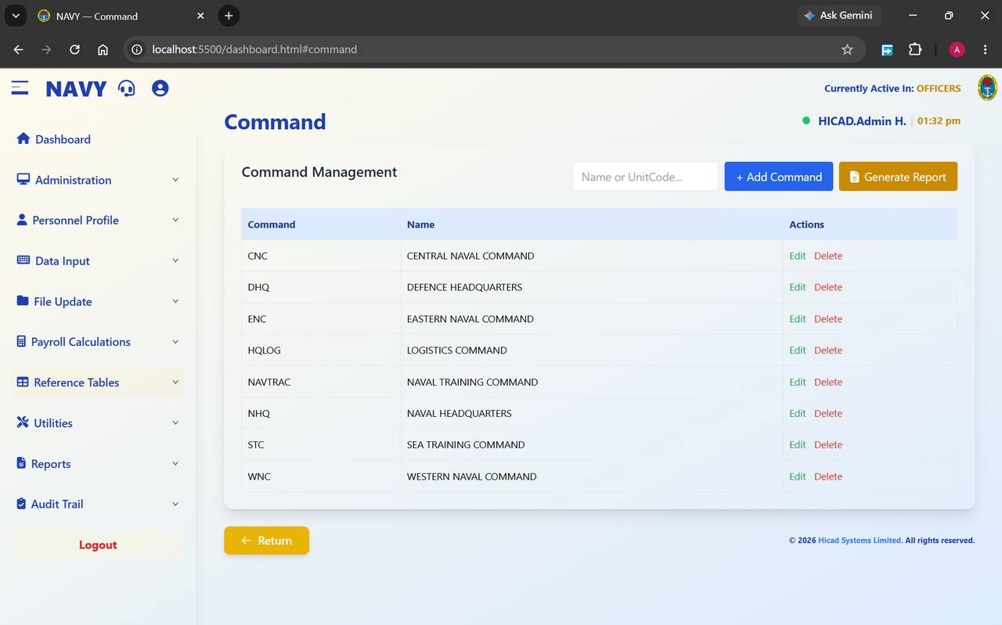
Figure 32.1 Command Management, showing the eight commands configured in this installation.
Field / control | What it is for
Name or UnitCode… | Filters the list.
+ Add Command | Adds a command.
Generate Report | Prints the list.
Command | The short code — CNC, DHQ, ENC, HQLOG, NAVTRAC, NHQ, STC, WNC.
Name | The full name — Central Naval Command, Defence Headquarters, Eastern Naval Command, Logistics Command, Naval Training Command, Naval Headquarters, Sea Training Command, Western Naval Command.
Actions | Edit and Delete.

Command appears on Step 3 of the personnel record (Chapter 14.4) and is used to group several reports. Keeping this table correct is what makes command-level reporting possible.
NOTE
Deleting a command that personnel records still point to will leave those records without a command and drop them out of command-level reports. Reassign the personnel first.

33. Overpayment Percentage Alarm
Reference Tables > Cash Payment · dashboard.html#cash-payment
The tolerance that decides what counts as an overpayment.
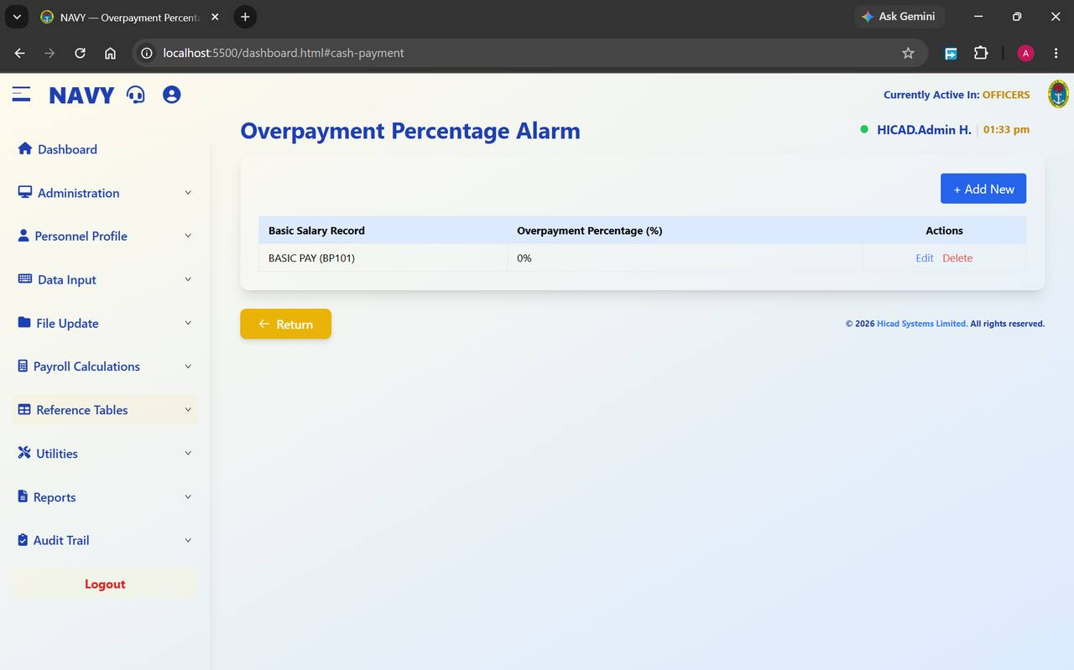
Figure 33.1 Overpayment Percentage Alarm. One row per basic salary record, each with its own tolerance.
Field / control | What it is for
Basic Salary Record | The pay element the tolerance applies to — in the figure, BASIC PAY (BP101).
Overpayment Percentage (%) | How far a payment may exceed the expected figure before it is flagged. Shown as 0%.
+ Add New | Adds a tolerance for another element.
Actions | Edit and Delete.

This setting drives the Overpayment report in Chapter 64. A tolerance of zero means any excess at all is reported — which produces a longer report but misses nothing. A higher tolerance produces a shorter report and relies on the tolerance having been set correctly.
GOOD PRACTICE
Start at zero and read the report for a month or two before deciding whether a tolerance is justified. It is easier to explain a report that flagged too much than one that flagged too little.

34. Tax Table Information
Reference Tables > Tax Table Information · dashboard.html#tax-table-information
The PAYE bands the calculation applies.
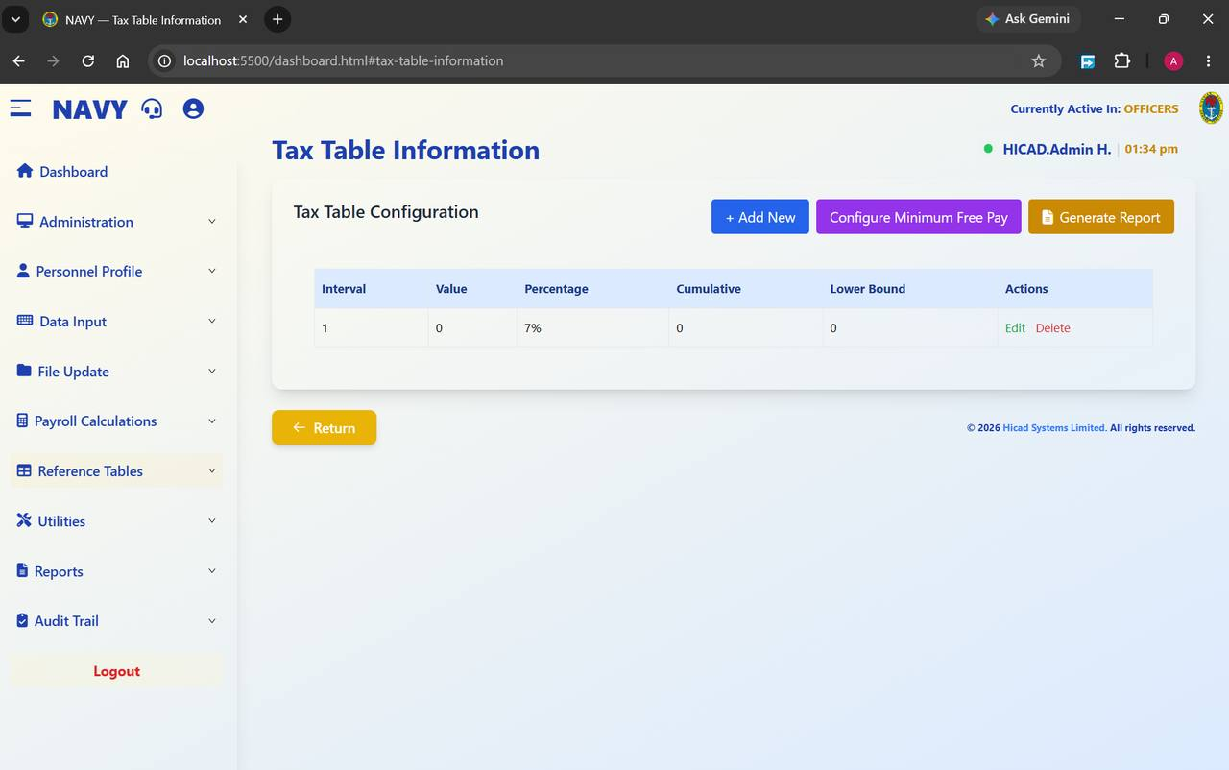
Figure 34.1 Tax Table Configuration. Each row is one band; the buttons above add bands, configure minimum free pay and print the table.
Field / control | What it is for
Interval | The band number, in ascending order.
Value | The width of the band.
Percentage | The rate applied within it — 7% in the figure.
Cumulative | The cumulative amount at the top of the band.
Lower Bound | The income at which the band starts.
+ Add New | Adds a band.
Configure Minimum Free Pay | Sets the tax-free allowance applied before the bands are reached.
Generate Report | Prints the table for checking and for the file.

34.1 Maintaining the tax table
- Obtain the authority — a Finance Act, a circular, or a direction from the appropriate authority.
- Press Generate Report and keep a copy of the table as it stands before you change anything.
- Amend or add the bands.
- Check Configure Minimum Free Pay.
- Press Generate Report again and check the new table line by line against the authority.
- File both printouts with the authority.
CAUTION
The tax table applies to every person in every payroll class. An error here is not a single wrong payslip; it is a wrong deduction for the entire Service, and it will be discovered by the tax authority rather than by you. Have every change checked by a second person before the next calculation runs.
NOTE
Whether tax is calculated month by month or cumulatively is governed by Independent Monthly Tax on the Company Profile (Chapter 12.3), not on this screen.

35. Salary Scale Information
Reference Tables > Salary Scale Information · dashboard.html#salary-scale-information
The consolidated salary scales, and the groups and grades within them.
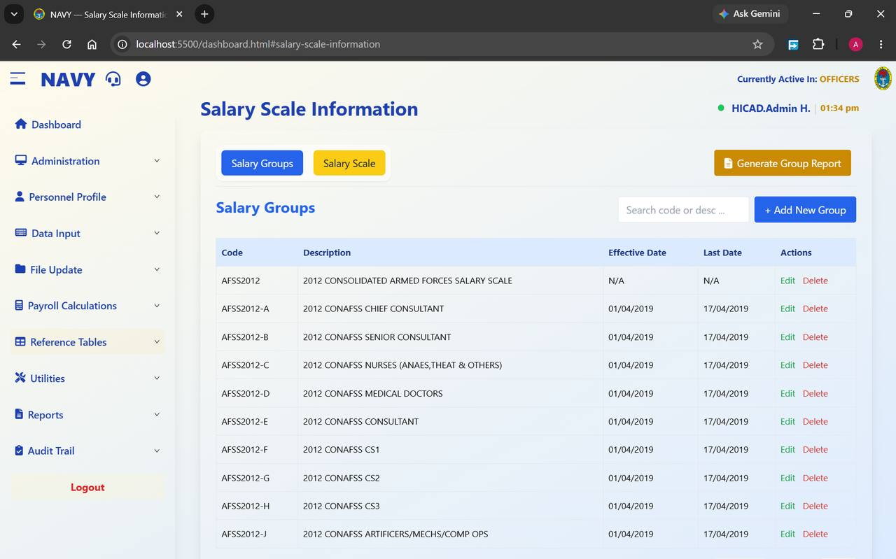
Figure 35.1 Salary Scale Information with the Salary Groups tab selected. The Salary Scale tab beside it holds the amounts.

35.1 Salary Groups
Field / control | What it is for
Code | The group code — AFSS2012, AFSS2012-A, AFSS2012-B and so on.
Description | What the group is — 2012 CONSOLIDATED ARMED FORCES SALARY SCALE, 2012 CONAFSS CHIEF CONSULTANT, 2012 CONAFSS MEDICAL DOCTORS, and so on.
Effective Date / Last Date | The period the group is in force. N/A on the parent scale means it is not time-bounded.
Actions | Edit and Delete.
Search code or desc… | Filters the list.
+ Add New Group | Adds a salary group.
Generate Group Report | Prints the groups.

35.2 Salary Scale
The Salary Scale tab holds the amounts themselves — the figure payable at each grade and step within a group. This is what the calculation reads when Shall Use Standard Salary Scale? is set to Yes on the Company Profile (Chapter 12.3).

35.3 Applying a salary review
- Print the existing groups and scale.
- Create a new group with the effective date of the review, rather than overwriting the existing one. The old scale is what makes historical pay explicable.
- Enter the new amounts against the new group.
- Move personnel onto the new Salary Group and Salary Grade on Step 2 of their records (Chapter 14.3), or by batch update (Chapter 15.4).
- Where the review is retrospective, calculate the arrears in Chapter 21.
- Print the new scale and file it with the authority.
GOOD PRACTICE
Never edit a historical salary group in place. Once you do, the pay a person received last year can no longer be reconciled to a scale, and any query about it becomes unanswerable.

36. Pay Element Description
Reference Tables > Pay Element Description · dashboard.html#pay-element-description
The master list of every payment and deduction the system knows about.
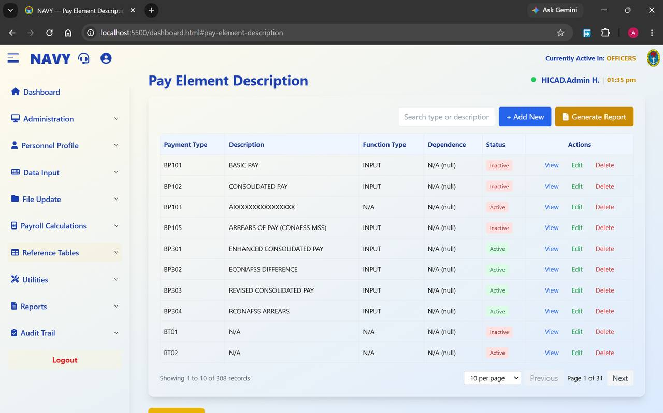
Figure 36.1 Pay Element Description. 308 elements in this installation, ten to a page.
Field / control | What it is for
Payment Type | The code. The prefix tells you what kind of element it is — see the table below.
Description | The plain-language name, as it will appear on payslips and reports — BASIC PAY, CONSOLIDATED PAY, ARREARS OF PAY (CONAFSS MSS), ENHANCED CONSOLIDATED PAY.
Function Type | How the element is arrived at. INPUT means the amount is captured; other function types derive it.
Dependence | Whether this element depends on another. N/A (null) means it stands alone.
Status | Active elements are available for use; Inactive ones are retained for history but cannot be selected for new input.
Actions | View, Edit, Delete.
Search type or description | Filters the list — the fastest way to find an element among several hundred.
+ Add New | Creates an element.
Generate Report | Prints the list.

36.1 The code prefixes
Prefix | Meaning | Examples
BP | Basic pay elements | BP101 Basic Pay · BP102 Consolidated Pay · BP301 Enhanced Consolidated Pay · BP304 RCONAFSS Arrears
PT | Payments — allowances and other credits | PT301 Diving Allowance · PT302 Staff Grant · PT306 Rent Subsidy · PT313 NYSC Allowance · PT366 SBS Active Allowance · PT372 Special Forces Active Allowance
PR | Deductions and recoveries | PR301 PAYE Tax · PR302 Rent · PR303 Mess Bills · PR306 Overpayment Recovery · PR307 Electricity Bill
BT | Reserved / system elements | BT01, BT02

36.2 Retiring an element
When an allowance is withdrawn, set its status to Inactive rather than deleting it. The element then cannot be selected for new input, but every historical record that refers to it still resolves to a description. Deleting it leaves those records pointing at nothing.
CAUTION
Elements marked AXXXXXXXXXXXXXXXX or with a description of N/A are placeholders. Do not use them for live input, and tidy them out of the way by marking them inactive.

37. Pay Element Rules
Reference Tables > Fixed Amount Rank · Reference Tables > Mutually Exclusive
Two tables that constrain how pay elements behave: what they are worth at each rank, and which of them cannot be paid together.

37.1 Fixed Amount per Rank
Some elements are worth a fixed amount that depends on rank rather than on salary. Those amounts are held here.
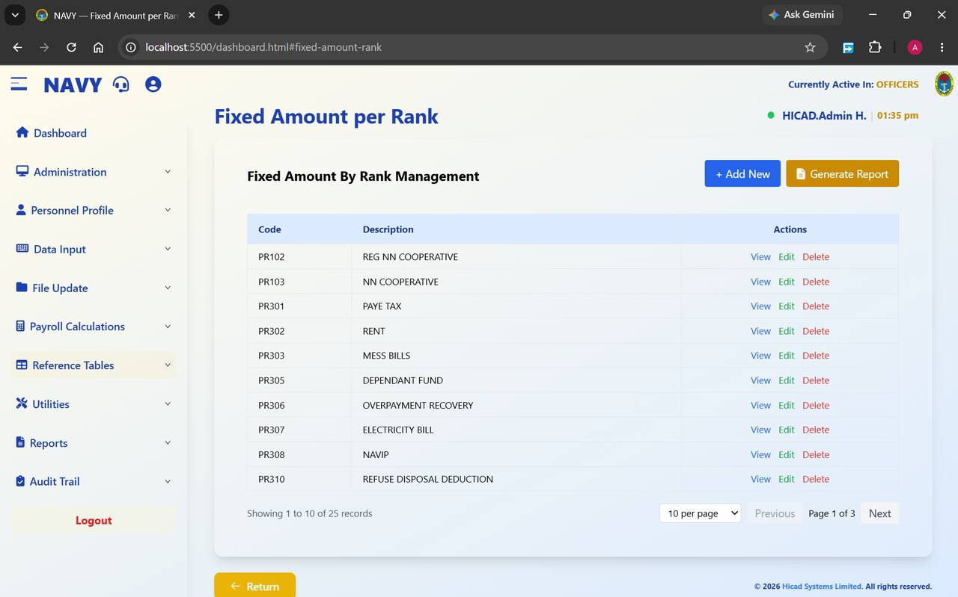
Figure 37.1 Fixed Amount By Rank Management, listing 25 elements across three pages.
Field / control | What it is for
Code | The element — PR102 REG NN Cooperative, PR301 PAYE Tax, PR302 Rent, PR303 Mess Bills, PR305 Dependant Fund, PR306 Overpayment Recovery, PR307 Electricity Bill, PR308 NAVIP, PR310 Refuse Disposal Deduction.
Description | The element name.
Actions | View opens the rank schedule read-only; Edit opens it for amendment; Delete removes the element from this table.
+ Add New | Brings another element under rank-based amounts.
Generate Report | Prints the schedule.

- Find the element and press Edit.
- Enter the amount payable or deductible at each rank.
- Save.
- Press Generate Report and check the printed schedule against the authority before the next calculation.
NOTE
This table is the reference-data equivalent of One-Off Fixed Amount by Rank in Chapter 11.2. This one governs recurring elements; that one governs a single one-off cycle.

37.2 Mutually Exclusive Pay Elements
Some allowances cannot be paid at the same time as others — an active and an inactive version of the same allowance, for instance. This table records those pairs and tells the calculation which one wins.
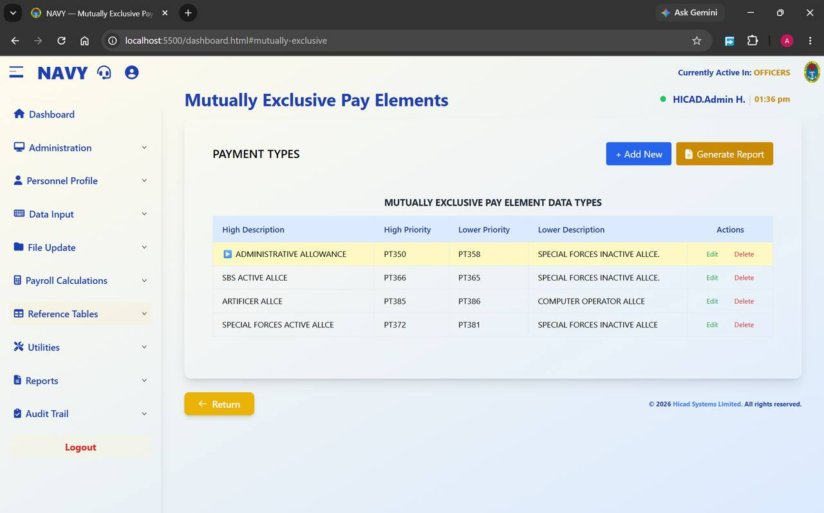
Figure 37.2 Mutually Exclusive Pay Elements. Each row pairs a high-priority element with a lower-priority one.
Field / control | What it is for
High Description / High Priority | The element that takes precedence, and its code.
Lower Priority / Lower Description | The element that is suppressed when both would otherwise be paid, and its code.
Actions | Edit and Delete.
+ Add New | Adds a pair.
Generate Report | Prints the table.

The pairs configured in the figure read as follows:
Takes precedence | Suppresses
PT350 Administrative Allowance | PT358 Special Forces Inactive Allowance
PT366 SBS Active Allowance | PT365 Special Forces Inactive Allowance
PT385 Artificer Allowance | PT386 Computer Operator Allowance
PT372 Special Forces Active Allowance | PT381 Special Forces Inactive Allowance

GOOD PRACTICE
When somebody queries an allowance that appears on their input but not on their payslip, look here first. A mutual exclusion is the usual explanation, and it is working as intended.

38. Pension Fund Administrators
Reference Tables > Pension Fund Administrator · dashboard.html#pension-fund-administrator
The PFAs personnel contribute to, and the custodians behind them.
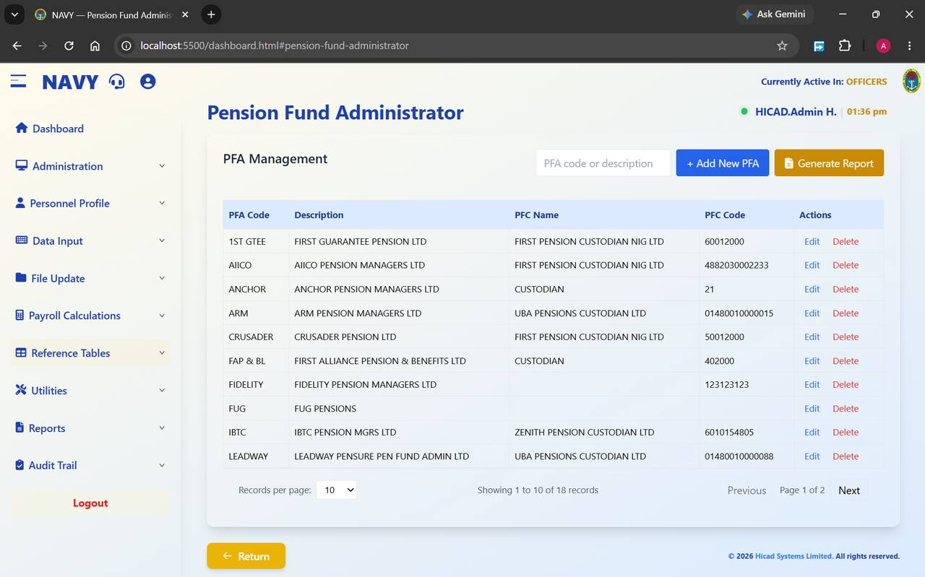
Figure 38.1 PFA Management. Eighteen administrators in this installation, each with its pension fund custodian.
Field / control | What it is for
PFA Code | The short code — 1ST GTEE, AIICO, ANCHOR, ARM, CRUSADER, FIDELITY, IBTC, LEADWAY.
Description | The administrator's full registered name.
PFC Name | The pension fund custodian holding the assets — First Pension Custodian Nig Ltd, UBA Pensions Custodian Ltd, Zenith Pension Custodian Ltd.
PFC Code | The custodian's account or identifying code, used on remittance.
Actions | Edit and Delete.
PFA code or description | Filters the list.
+ Add New PFA | Adds an administrator.
Generate Report | Prints the list.

Each person's PFA is recorded on Step 2 of their personnel record (Chapter 14.3), together with their RSA number. The pairing drives the pension return in Chapter 58 and the By PFA personnel reports in Chapters 15.5 and 16.3.
CAUTION
Two entries in the figure have no PFC Name recorded. A missing custodian will produce an incomplete remittance schedule. Complete every entry before the next pension return is produced.

39. Bank Details
Reference Tables > Bank Details · dashboard.html#bank-details
Every bank and branch that salaries can be paid into.
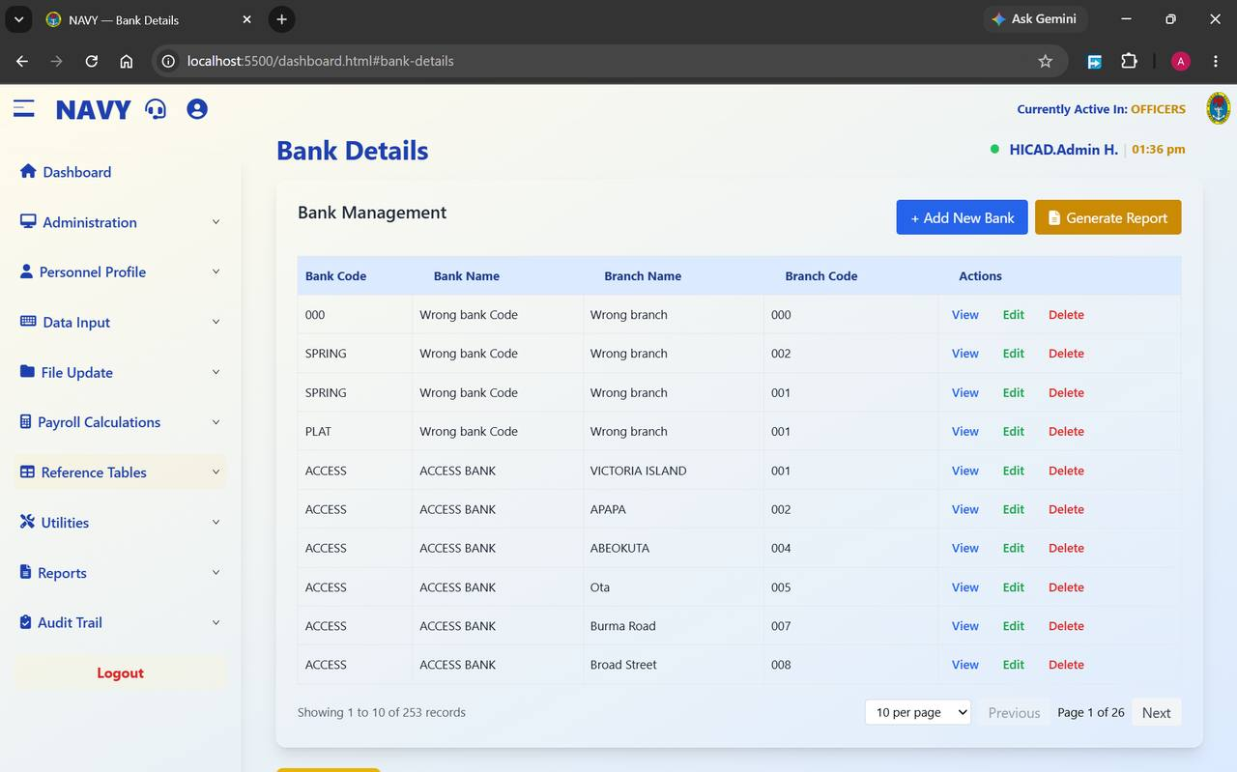
Figure 39.1 Bank Management. 253 bank and branch records, ten to a page.
Field / control | What it is for
Bank Code | The short code for the bank — ACCESS, SPRING, PLAT.
Bank Name | The bank's name.
Branch Name | The branch — VICTORIA ISLAND, APAPA, ABEOKUTA, Ota, Burma Road, Broad Street.
Branch Code | The branch code, used on the bank payment schedule.
Actions | View, Edit, Delete.
+ Add New Bank | Adds a bank or branch.
Generate Report | Prints the list.

39.1 Keeping the table clean
Several rows in Figure 39.1 read Wrong bank Code / Wrong branch. These are placeholder records created when a bank could not be identified, and they are a real risk: a personnel record pointing at one of them will appear on the bank payment schedule under a bank that does not exist.
- Run the By Bank Branch personnel report (Chapter 15.5) to find everybody attached to a placeholder record.
- Correct each personnel record to the real bank and branch.
- When no personnel record refers to the placeholder any more, delete it.
- Re-run the report to confirm.
CAUTION
Branch names in the table are inconsistently capitalised — APAPA beside Ota and Broad Street. This does not affect payment, but it does make the bank schedule harder to read and sort. Standardise on upper case as you touch each record.
GOOD PRACTICE
Whenever a bank merges or renames, add the new entry rather than editing the old one, move the personnel across, and only then remove the old entry. That way there is always a moment at which you can see how many records are still to be moved.

40. Departments, Locations and Branches
Reference Tables > Department · dashboard.html#department
Where people serve, and which professional branch they belong to. Two tables on one screen.

40.1 Locations
The Location tab holds every ship and establishment.
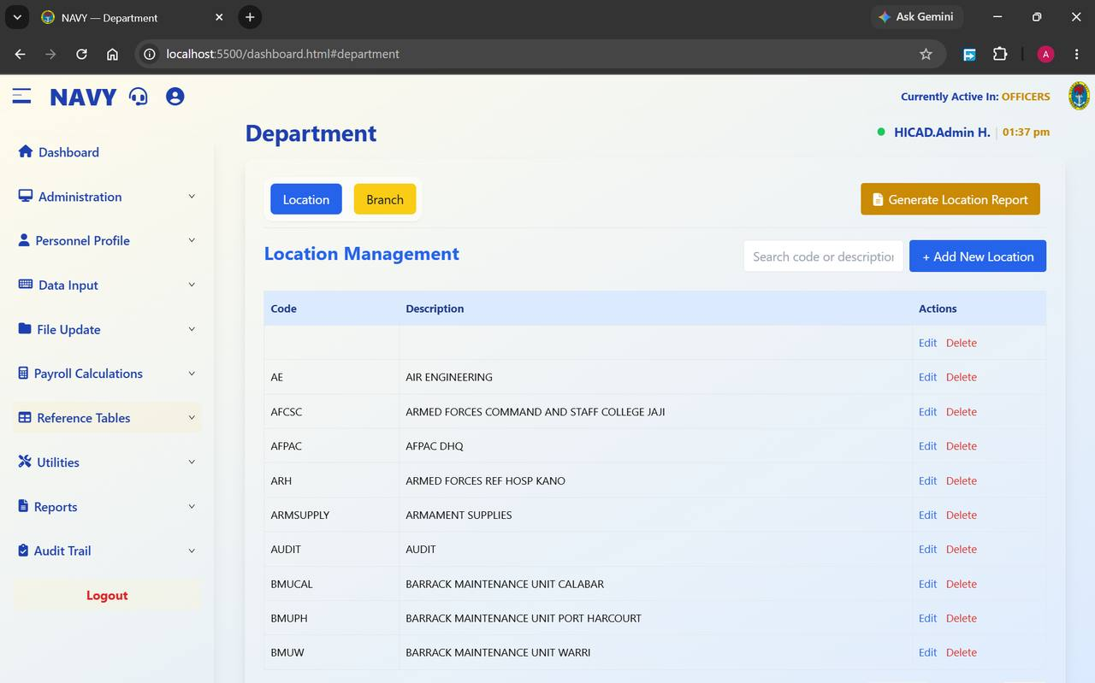
Figure 40.1 Location Management. Ships and establishments with their codes.
Field / control | What it is for
Code | The short code — AE, AFCSC, AFPAC, ARH, ARMSUPPLY, AUDIT, BMUCAL, BMUPH, BMUW.
Description | The full name — Air Engineering, Armed Forces Command and Staff College Jaji, AFPAC DHQ, Armed Forces Ref Hosp Kano, Armament Supplies, Audit, Barrack Maintenance Unit Calabar, Barrack Maintenance Unit Port Harcourt, Barrack Maintenance Unit Warri.
Actions | Edit and Delete.
Search code or description | Filters the list.
+ Add New Location | Adds a location.
Generate Location Report | Prints the list.

CAUTION
The first row in the figure has neither a code nor a description. A blank location record will collect personnel records that were saved without a location and hide them from location reporting. Find it, identify the personnel attached to it, and remove it.

40.2 Branches
The Branch tab holds the professional branches.
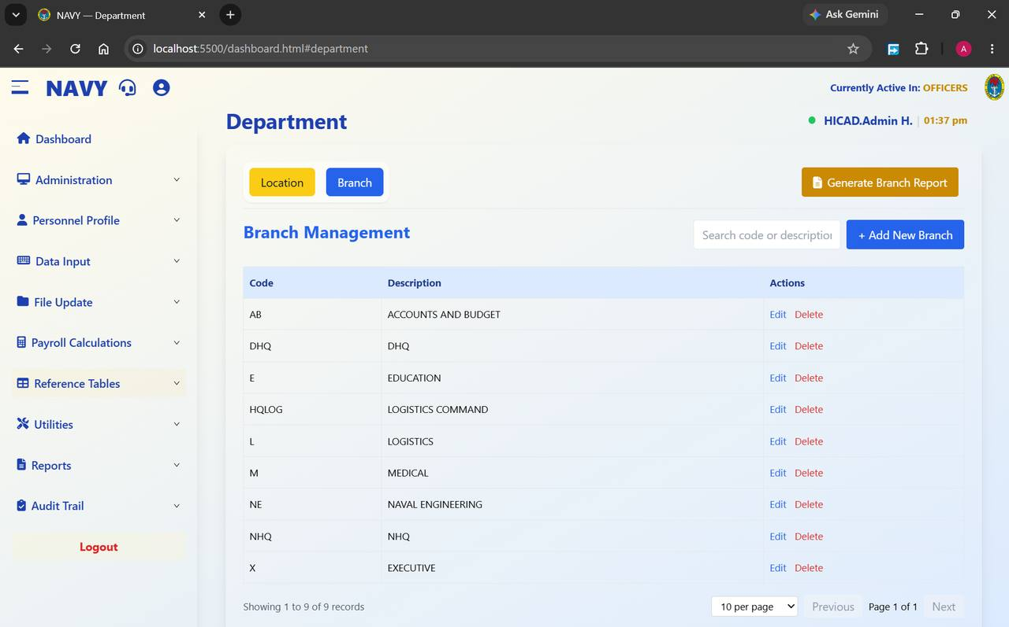
Figure 40.2 Branch Management. Nine branches in this installation.
Code | Description
AB | Accounts and Budget
DHQ | DHQ
E | Education
HQLOG | Logistics Command
L | Logistics
M | Medical
NE | Naval Engineering
NHQ | NHQ
X | Executive

Branch appears on Step 3 of the personnel record (Chapter 14.4) and is used for grouping in reports. The controls mirror the Location tab: + Add New Branch, Generate Branch Report, Edit and Delete.

41. State Codes
Reference Tables > State Codes · dashboard.html#state-codes
The states, their capitals and their geopolitical zones.
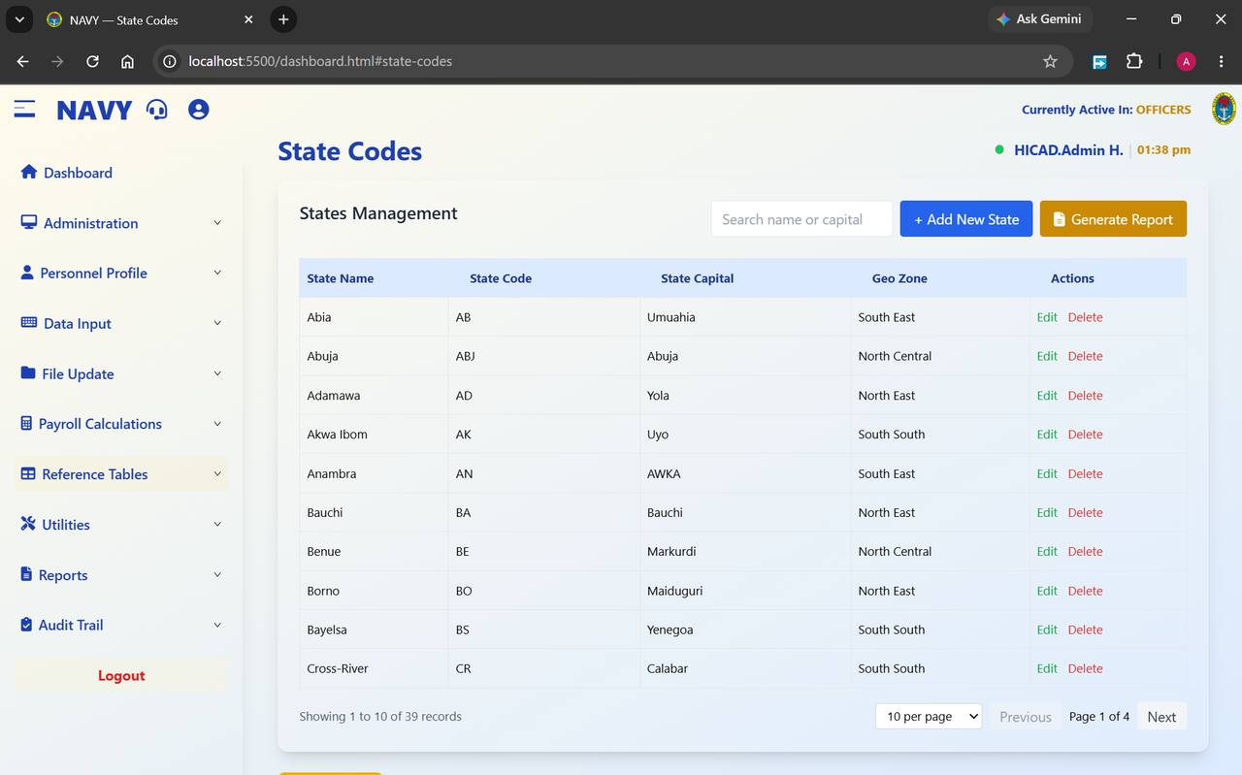
Figure 41.1 States Management. Thirty-nine records covering the states, the Federal Capital Territory and additional entries.
Field / control | What it is for
State Name | The state — Abia, Abuja, Adamawa, Akwa Ibom, Anambra, Bauchi, Benue, Borno, Bayelsa, Cross-River.
State Code | The short code — AB, ABJ, AD, AK, AN, BA, BE, BO, BS, CR.
State Capital | The capital — Umuahia, Abuja, Yola, Uyo, AWKA, Bauchi, Markurdi, Maiduguri, Yenegoa, Calabar.
Geo Zone | The geopolitical zone — South East, North Central, North East, South South.
Actions | Edit and Delete.
Search name or capital | Filters the list.
+ Add New State | Adds a state.
Generate Report | Prints the list.

State appears twice on the personnel record — as State Of Origin on Step 1 and as Tax State on Step 2 — and they are not the same thing. State of origin is biographical; tax state determines which state internal revenue service receives the PAYE deduction reported in Chapter 55.
NOTE
Two capitals in the figure are misspelt — Markurdi for Makurdi and Yenegoa for Yenagoa — and one is capitalised inconsistently (AWKA). These appear on printed reports. Correcting them is a five-minute job that improves every report the table feeds.

42. Local Government Areas
Reference Tables > Local Government · dashboard.html#local-government
The local government areas within each state.
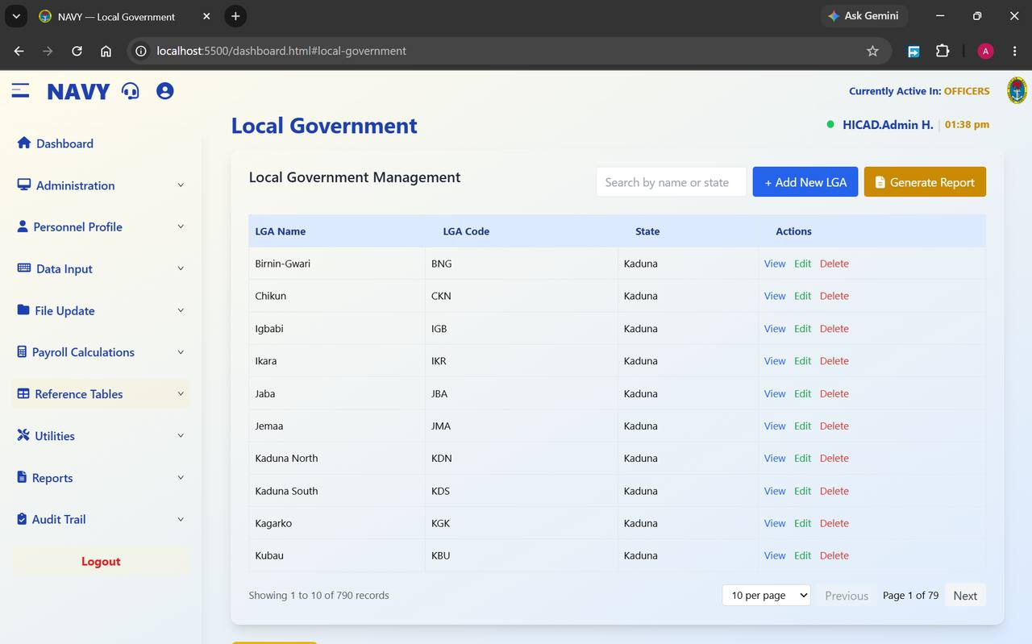
Figure 42.1 Local Government Management. 790 records across 79 pages; use the search rather than paging.
Field / control | What it is for
LGA Name | The local government area — Birnin-Gwari, Chikun, Igbabi, Ikara, Jaba, Jemaa, Kaduna North, Kaduna South, Kagarko, Kubau.
LGA Code | The short code — BNG, CKN, IGB, IKR, JBA, JMA, KDN, KDS, KGK, KBU.
State | The state the LGA belongs to.
Actions | View, Edit, Delete.
Search by name or state | Filters the list — with 790 records this is the only practical way to navigate.
+ Add New LGA | Adds an LGA.
Generate Report | Prints the list.

The Local Government field on Step 1 of the personnel record is populated from this table, and it will not offer any options until a state has been chosen — the field reads Select State First until then. That dependency is why the State column here matters: an LGA attached to the wrong state will not appear where the user expects it.

43. Emolument Form Processing
Utilities > Emolument Form Processing · dashboard.html#emolument-form-processing
The link between the payroll and the emolument exercise.
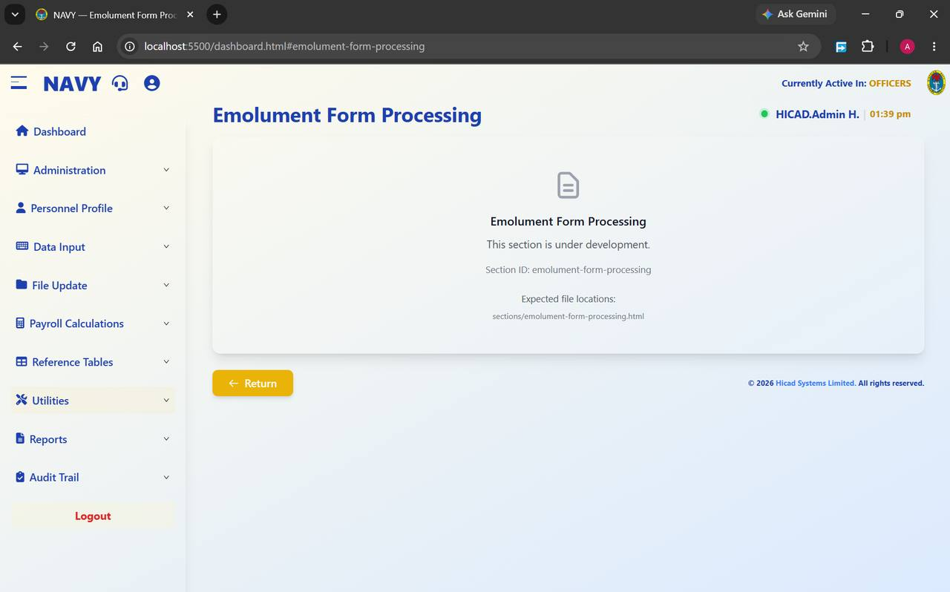
Figure 43.1 Emolument Form Processing. At the time of capture this section was under development.

43.1 Current status
This menu item is present but the screen behind it shows This section is under development, together with its section identifier emolument-form-processing. Nothing can be processed here at present.
NOTE
Check with your administrator whether the section has since been released. If it has, this chapter will not describe it accurately, and the release note for that version should be read instead.

43.2 What the emolument exercise is
The emolument exercise is the annual collection of personal, family and financial details from every member of the Service — the information the payroll ultimately depends on. It runs in a separate portal, in which each person completes a form that is then authenticated by their Duty Officer, approved by the ship's Finance Officer, confirmed by the Central Pay Officer and finally accepted by the Emolument Administrator.
Only at the last stage does the data reach payroll. Until this screen is released, that hand-over is managed outside this system.

43.3 What the payroll system holds today
- Emolument Form Received? on Step 3 of the personnel record (Chapter 14.4) records whether a person's form has come back.
- The Emolument Form scope on the Current Personnel Reports screen (Chapter 15.5) produces the chasing list from that flag.
GOOD PRACTICE
Run the Emolument Form report weekly while an exercise is open. It is the single most useful management figure during the exercise, and it needs no development work to produce.

44. Pull IPPIS Payments
Utilities > IPPIS Payments · dashboard.html#ippis-payments
Importing payment data from the Integrated Personnel and Payroll Information System.
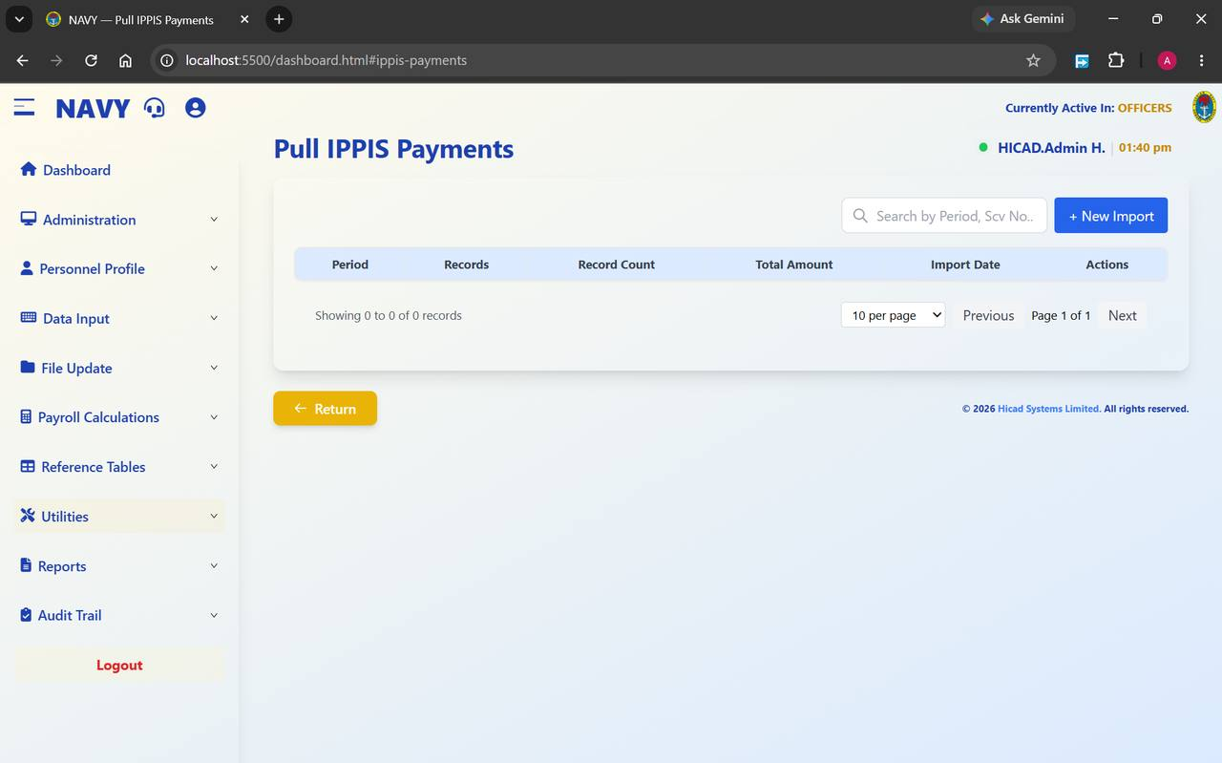
Figure 44.1 Pull IPPIS Payments before any import has been made.
IPPIS is the Federal Government's central personnel and payroll platform. This screen imports payment data from it, period by period, so that the two systems can be compared and reconciled.
Field / control | What it is for
Search by Period, Scv No.. | Filters the imports by period or by service number.
+ New Import | Starts an import.
Period | The month and year the import covers.
Records | The number of personnel records in the import.
Record Count | The number of individual payment lines.
Total Amount | The value of the import.
Import Date | When it was brought in.
Actions | View opens the detail; Summary gives the totals.

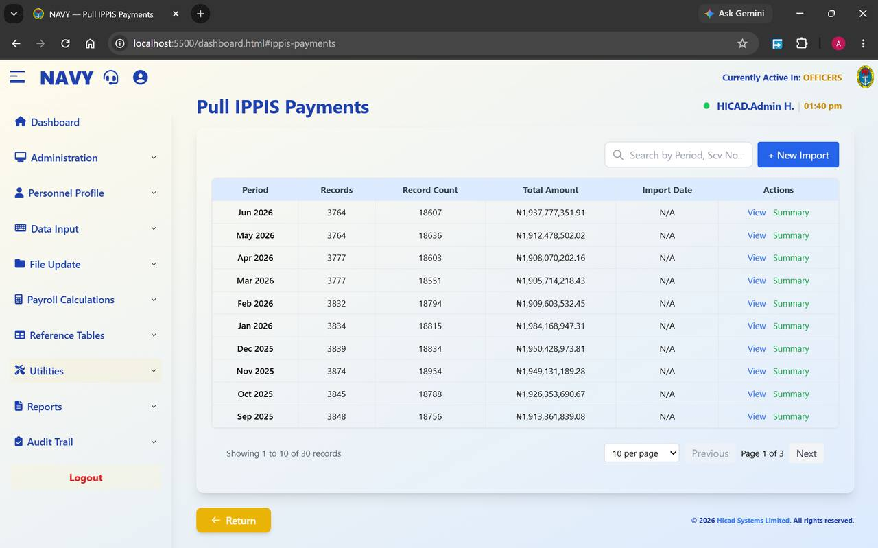
Figure 44.2 Pull IPPIS Payments with thirty periods imported. Reading the columns across a run of months is a quick check on continuity.

44.1 Reading the import history
The history is a useful control in itself. In Figure 44.2 the record count runs between 18,551 and 18,954 across ten months, and the total between ₦1.90 and ₦1.98 billion. Both move gently, month to month, which is what a stable payroll looks like.
- Press + New Import and load the period.
- Check Records and Record Count against the previous month. A step change of more than a few hundred needs an explanation.
- Check Total Amount against the previous month on the same basis.
- Press Summary to see the totals, and View to examine individual records where something needs investigating.
NOTE
A period showing N/A under Import Date was loaded without a recorded date. It is not an error, but it does mean you cannot tell when the data arrived — worth noting if you are relying on the import for a reconciliation.
GOOD PRACTICE
Reconcile the IPPIS totals against the payroll register (Chapter 53) every month. Two independent systems agreeing to the naira is the strongest assurance available that neither has gone wrong.

45. Payroll Class Backup
Utilities > Database Backup · dashboard.html#database-backup
Taking a copy of a payroll class. The cheapest insurance in the system.
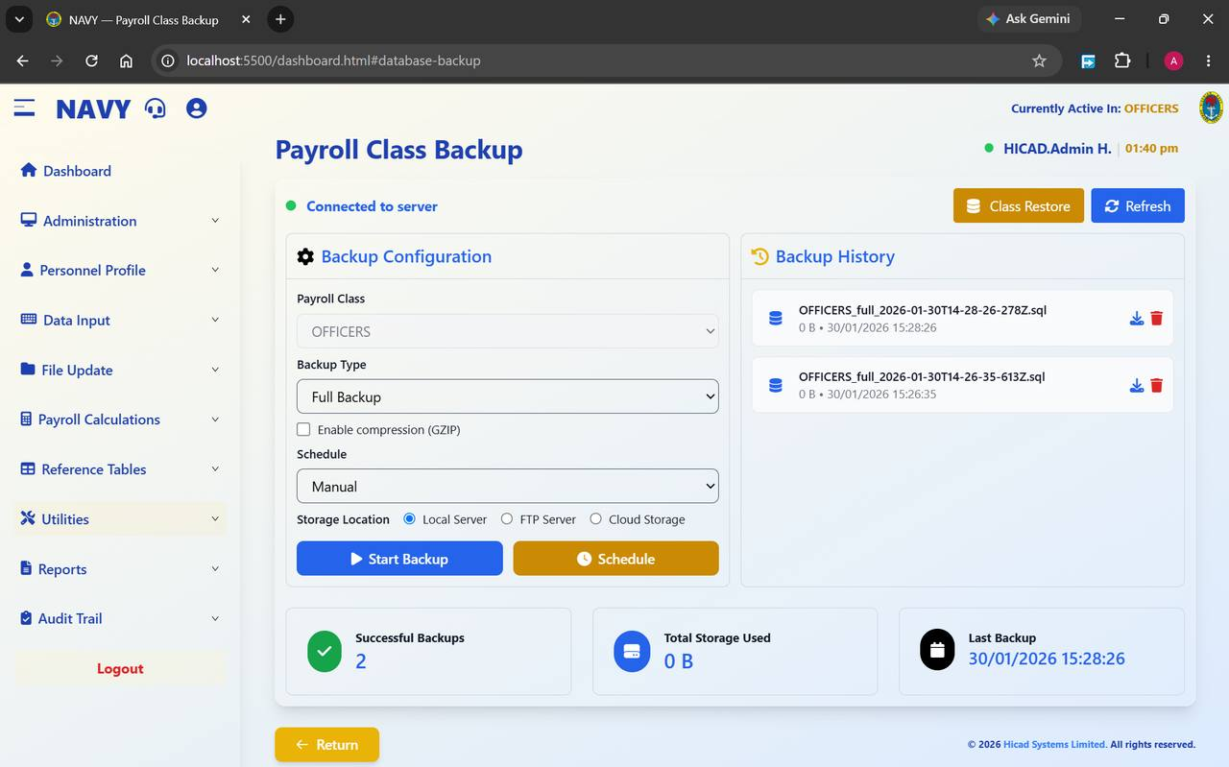
Figure 45.1 Payroll Class Backup. Configuration on the left, history on the right, summary figures beneath.

45.1 The screen
A green indicator at the top left reads Connected to server when the backup service is reachable. If it does not, no backup can be taken and that is the first thing to resolve.
Field / control | What it is for
Payroll Class | The class being backed up. It follows the active class.
Backup Type | Full Backup takes everything. Use it unless you have a specific reason not to.
Enable compression (GZIP) | Compresses the backup file. Slower to produce, smaller to keep.
Schedule | Manual takes a backup when you press the button; other settings run it automatically.
Storage Location | Local Server, FTP Server or Cloud Storage.
Start Backup | Takes the backup now.
Schedule | Sets up a recurring backup.
Class Restore | Switches to the restore screen (Chapter 46).
Refresh | Updates the history and the figures.
Backup History | The backups held, each with a name of the form OFFICERS_full_2026-01-30T14-28-26-278Z.sql, its size, its date, and icons to download or delete it.
Successful Backups / Total Storage Used / Last Backup | Summary figures across the foot of the screen.

45.2 When to take a backup
- Before a bulk payroll class migration (Chapter 9.3).
- Before a batch update to personnel records (Chapter 15.4).
- Before running the payroll calculation (Chapter 29).
- Before month-end processing (Chapter 13.1) — this one is not optional.
- Before year-end processing (Chapter 13.2).
- On a schedule, so that a routine copy exists even when nobody remembers to take one.
CAUTION
The Total Storage Used figure in the figure reads 0 B against two backups. A backup showing no size has not captured anything. Check the size of every backup you take before relying on it — an untested backup is not a backup.
GOOD PRACTICE
Keep at least one backup off the payroll server itself, using the FTP or cloud storage option. A backup that lives only on the machine it protects will not survive the failure of that machine.

46. Payroll Class Restore
Utilities > Database Restore · dashboard.html#database-restore
Putting a backup back. Rare, deliberate, and never done in a hurry.
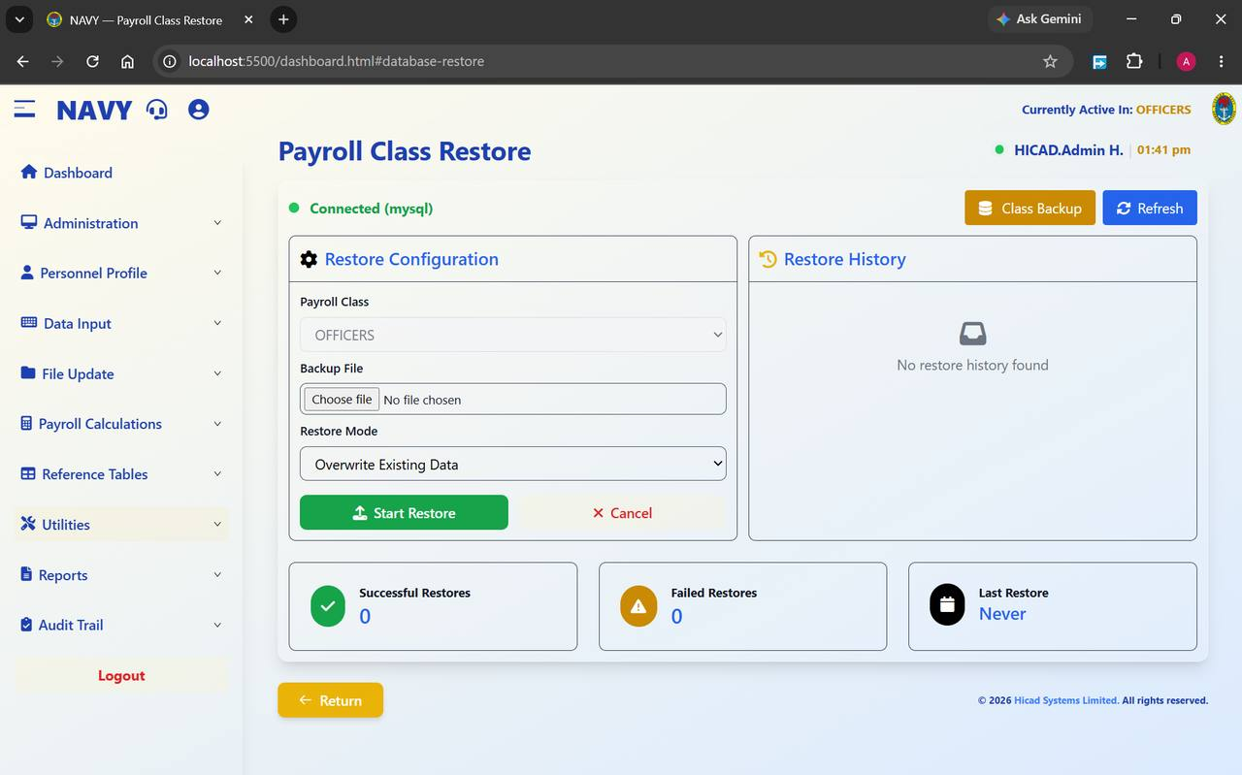
Figure 46.1 Payroll Class Restore. The connection indicator confirms the database; the history panel records every restore.
Field / control | What it is for
Connected (mysql) | Confirms the database the restore will be written to. Read it before you start.
Payroll Class | The class being restored.
Backup File / Choose file | The backup to restore from.
Restore Mode | Overwrite Existing Data replaces what is there now.
Start Restore | Runs the restore. Cancel abandons.
Restore History | Previous restores.
Successful Restores / Failed Restores / Last Restore | Summary figures.
Class Backup | Switches back to the backup screen.

46.1 Before you restore
- Establish exactly what went wrong and confirm that a restore is the right remedy. Most problems are better fixed by correcting the data.
- Identify the backup that predates the problem, and check its size and date.
- Take a fresh backup of the current state first. However bad the current data is, you may need to refer to it.
- Establish what has happened since the backup was taken. All of it will be lost.
- Get authority. A restore is not a routine operator action.
- Confirm the Payroll Class and the Backup File, then press Start Restore.
- Check the result thoroughly before allowing anybody to resume work.
CAUTION
Overwrite Existing Data does exactly that. Every change made to the class since the backup was taken — every payment captured, every personnel record amended, every calculation run — is discarded. This is the most destructive action available anywhere in this system.

47. Consolidated Payslips
Utilities > Consolidated Payslip · dashboard.html#consolidated-payslip
One payslip covering several periods, rather than one per month.
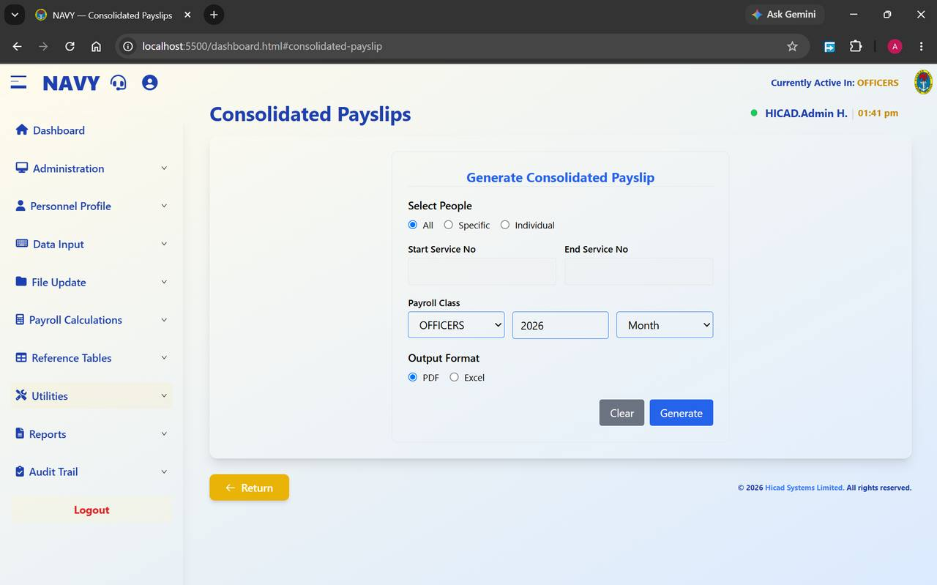
Figure 47.1 Consolidated Payslips. Choose who, choose the class and period, choose the format, generate.
Field / control | What it is for
Select People | All covers the whole class; Specific takes a range of service numbers; Individual takes one person.
Start Service No / End Service No | The range, used with Specific.
Payroll Class | The class to report on.
Year / Month | The period the consolidation covers.
Output Format | PDF to issue or file, Excel to analyse.
Generate | Produces the payslips. Clear resets the form.

Consolidated payslips are most often needed for a loan or mortgage application, for a pension claim, or in support of a query covering several months. For the ordinary monthly payslip, use Chapter 48 instead.
GOOD PRACTICE
Generate consolidated payslips as PDF when they are going to a third party such as a bank. A PDF is a fixed document; a spreadsheet is not, and an institution receiving one may reasonably ask for something that cannot be edited.

48. Payslips
Reports > Pay Slips · dashboard.html#pay-slips
The Reports menu at a glance, and the report everybody recognises.

48.1 The Reports menu
The Reports menu holds the full reporting suite. It also provides a second route to two reports already described in Part III, because they are as often wanted by a reporting user as by somebody maintaining records.
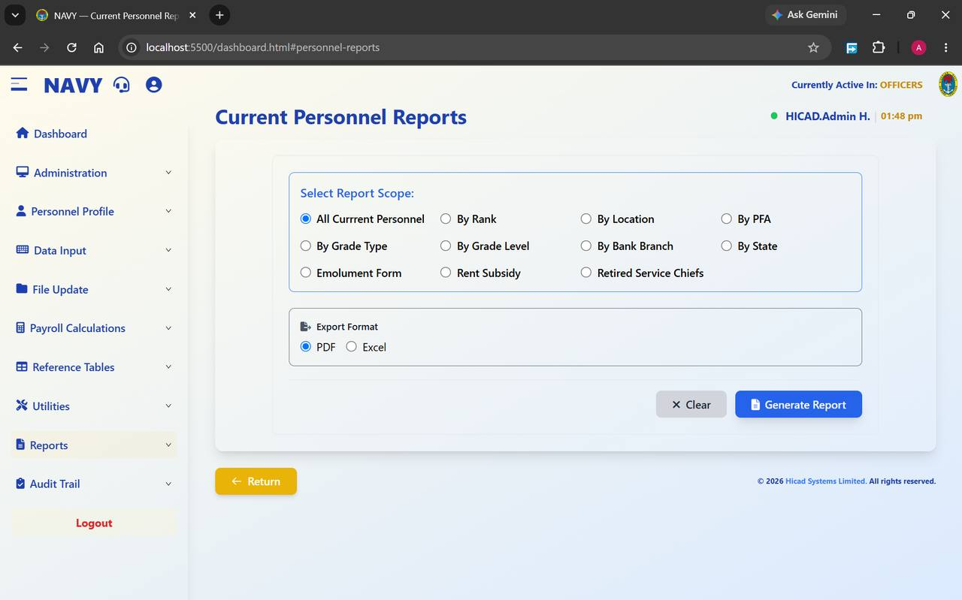
Figure 48.1 Current Personnel Reports, reached from the Reports menu. The same screen is described in Chapter 15.5.
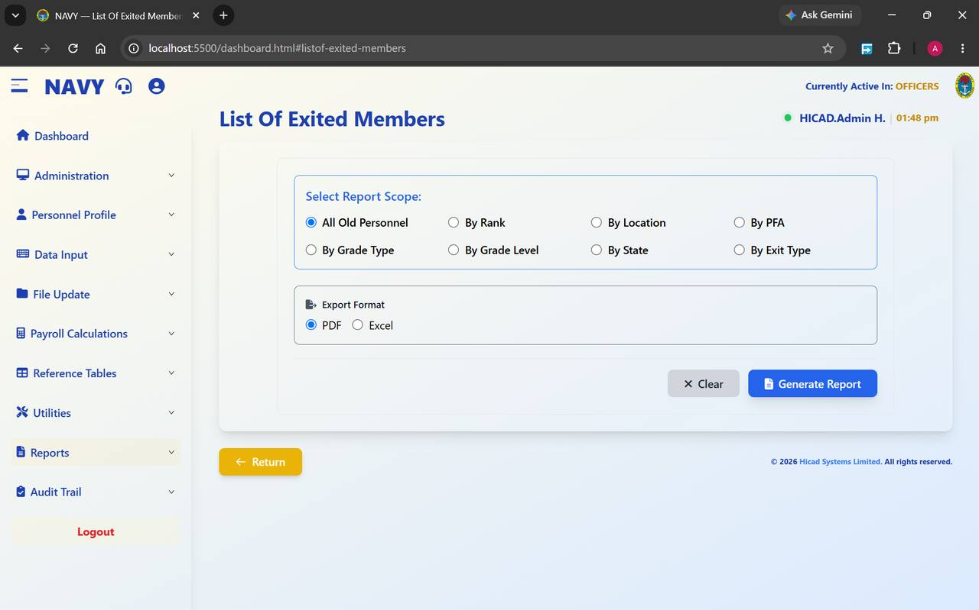
Figure 48.2 List Of Exited Members, reached from the Reports menu. The same screen is described in Chapter 16.3.
The remaining chapters of this Part take the reports in the order the menu presents them. Nearly all of them share the same four controls, so they are described once here and not repeated:
Control | Behaviour
Select People — All / Specific / Individual | All covers the whole class. Specific takes a Start Service No and an End Service No and covers the range between them. Individual takes one person.
Processing Month / Processing Year | The period reported on. These default to the current processing period; check them before generating.
Output Format — PDF / Excel | PDF produces a fixed document suitable for issue, signature or filing. Excel produces a workbook suitable for further analysis. Where a report offers only PDF, it is because it is a formal return.
Generate / Clear | Generate produces the report; Clear resets the choices without producing anything.
Summary Report | Where offered, produces totals only instead of the full detail. Run the summary first to check the figures, then the detail.

48.2 Payslips
Open Reports > Pay Slips to produce individual payslips.
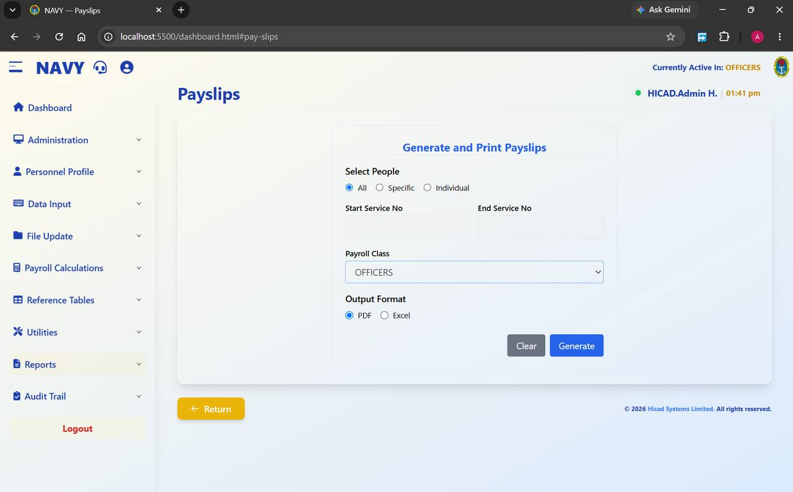
Figure 48.3 Generate and Print Payslips.
- Choose All, Specific or Individual under Select People.
- Where you chose Specific, enter the Start Service No and End Service No.
- Confirm the Payroll Class.
- Choose PDF or Excel.
- Press Generate.
CAUTION
Payslips carry personal financial data. Produce them for the narrowest population that meets the need, and handle the resulting file accordingly — a full-class PDF is a document containing several thousand people's pay.
GOOD PRACTICE
For a single query, use Individual rather than generating the whole class and searching within it. It is faster, and it produces a document you can send to the person who asked.

49. Payments by Bank (Branch)
Reports > Payments by Bank · dashboard.html#payments-by-bank
The schedule that tells each bank what to pay into which account. Handle it with care.
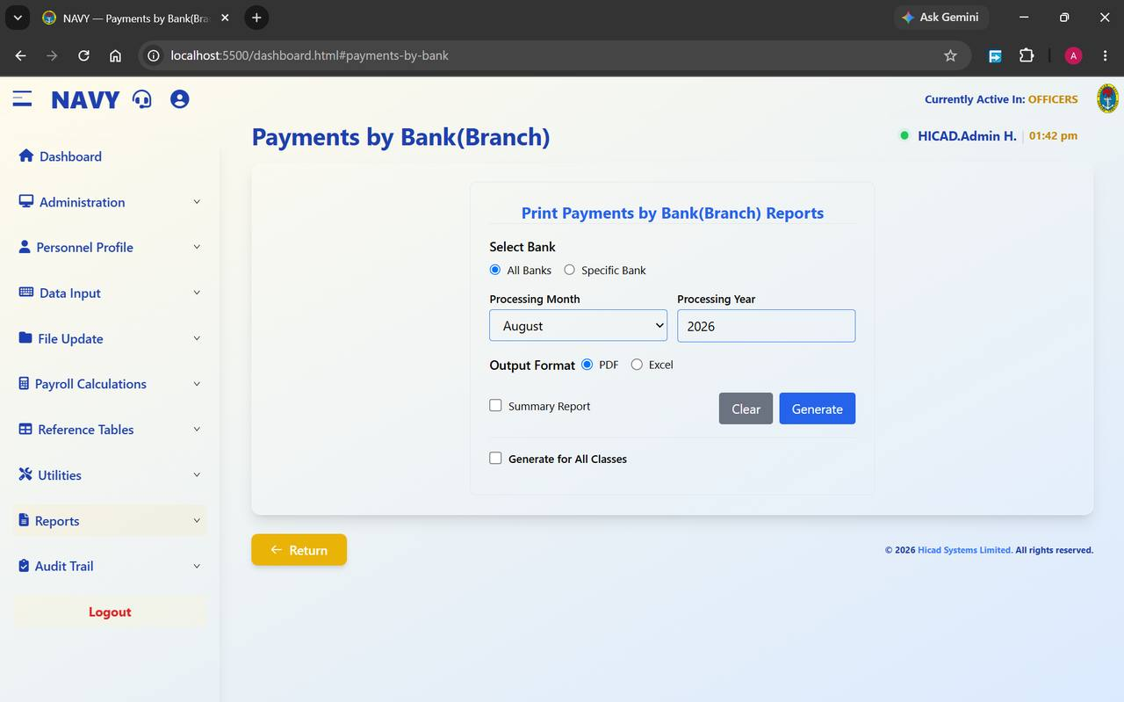
Figure 49.1 Print Payments by Bank(Branch) Reports.
Field / control | What it is for
Select Bank — All Banks / Specific Bank | Produce one schedule covering every bank, or a schedule for a single bank.
Processing Month / Processing Year | The period.
Output Format | PDF or Excel. Banks normally require a fixed document; check what yours accepts.
Summary Report | Totals by bank rather than the full account-level detail. Use it to check before producing the detail.
Generate for All Classes | Covers every payroll class in one schedule instead of the active class only.

- Produce the Summary Report first and agree the total against the payroll register (Chapter 53).
- When the totals agree, produce the detailed schedule.
- Check that no bank in the schedule is a placeholder record of the kind described in Chapter 39.2.
- Have the schedule authorised before it is transmitted.
CAUTION
This report initiates the movement of money. It should never be produced, and certainly never transmitted, by one person acting alone.

50. Analysis of Earnings and Deductions
Reports > Analysis of Earnings · dashboard.html#analysis-of-earnings
What was paid and deducted, broken down by payment type.
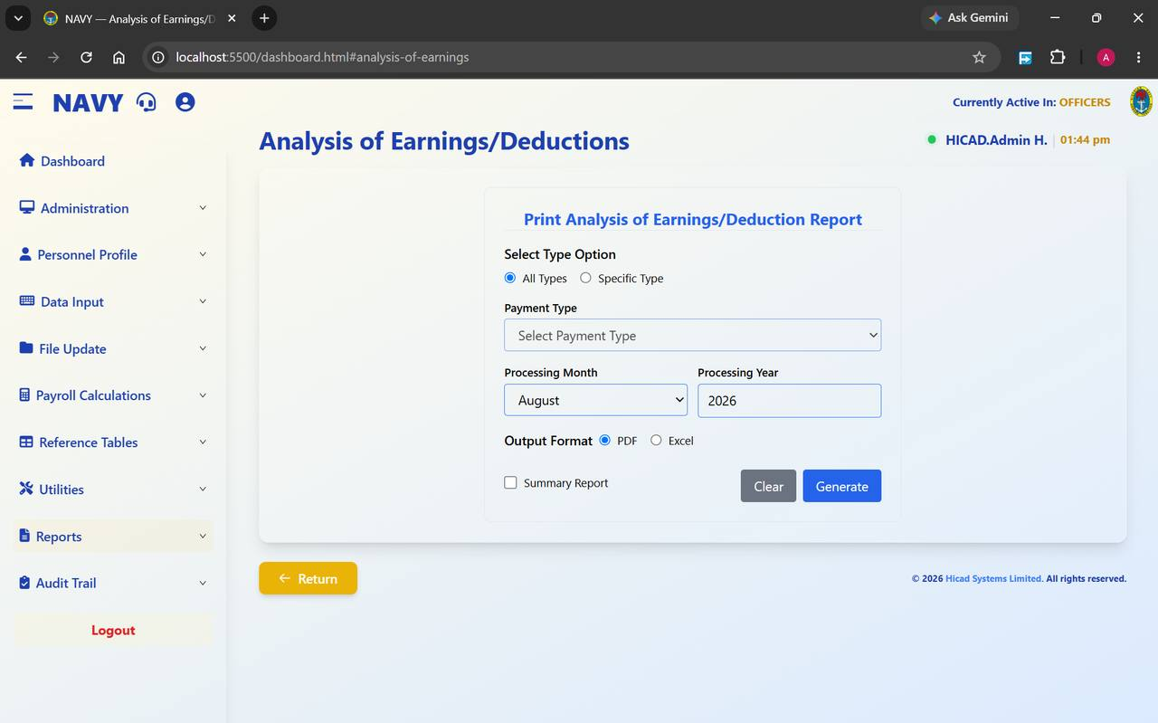
Figure 50.1 Print Analysis of Earnings/Deduction Report.
Field / control | What it is for
Select Type Option — All Types / Specific Type | Report on every pay element, or on one.
Payment Type | The element, used with Specific Type. Drawn from the list in Chapter 36.
Processing Month / Processing Year | The period.
Output Format | PDF or Excel.
Summary Report | Totals by element rather than person-by-person detail.

This is the natural report for answering “how much did we pay in rent subsidy last month?” or “what did the SBS allowance cost across the year?”. Run it with All Types and Summary Report ticked and you have a one-page picture of the whole payroll by element.
GOOD PRACTICE
Produce this summary every month and keep the series. A single month tells you what was paid; twelve months side by side tell you what is changing, which is a far more useful thing to know.

51. Loan Analysis
Reports > Loan Analysis · dashboard.html#loan-analysis
Outstanding loans and recoveries.
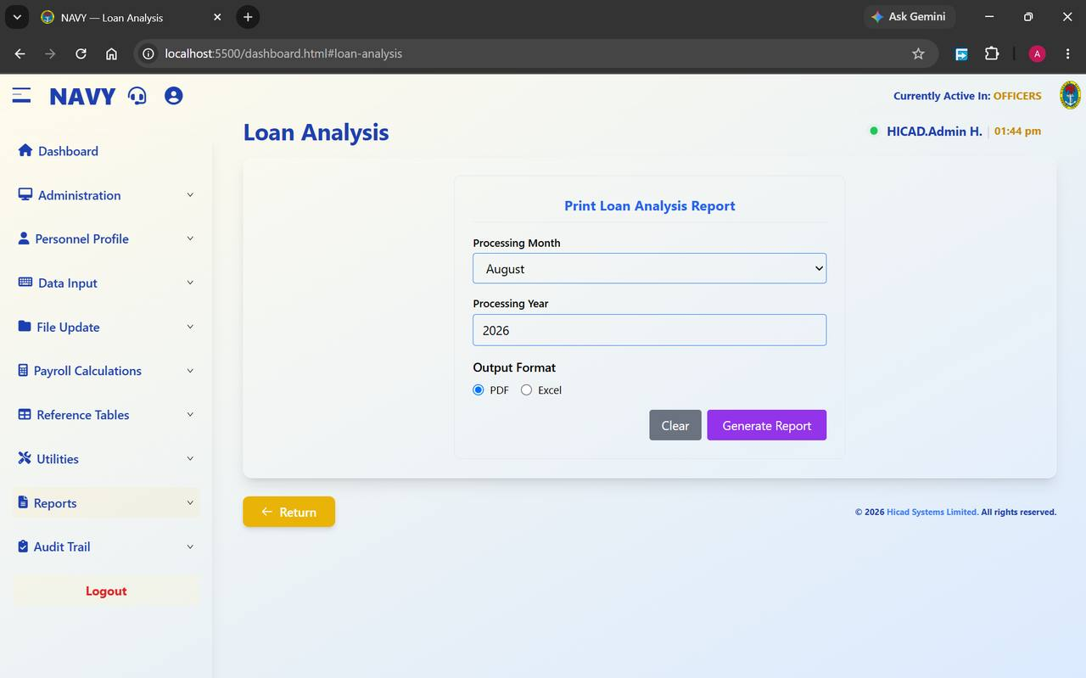
Figure 51.1 Print Loan Analysis Report. The simplest report screen in the system: period, format, generate.
Field / control | What it is for
Processing Month / Processing Year | The period.
Output Format | PDF or Excel.
Generate Report | Produces the report; Clear resets.

The report shows loans and recoveries in force, what has been deducted and what remains outstanding. Those balances come from the Amount To Date field on the payment and deduction records described in Chapter 17.1.
- Check that no loan has a remaining balance below zero — that indicates over-recovery, which must be refunded.
- Check that recoveries scheduled to end have ended. A deduction that continues past its term is money taken without authority.
- Reconcile the total outstanding against the lending body's own records.
GOOD PRACTICE
Run this in Excel and sort by remaining balance. Loans about to complete and loans that should already have completed both stand out immediately.

52. Analysis of Payments and Deductions by Bank
Reports > Analysis of Payments · dashboard.html#analysis-of-payments
Payment types crossed with banks.
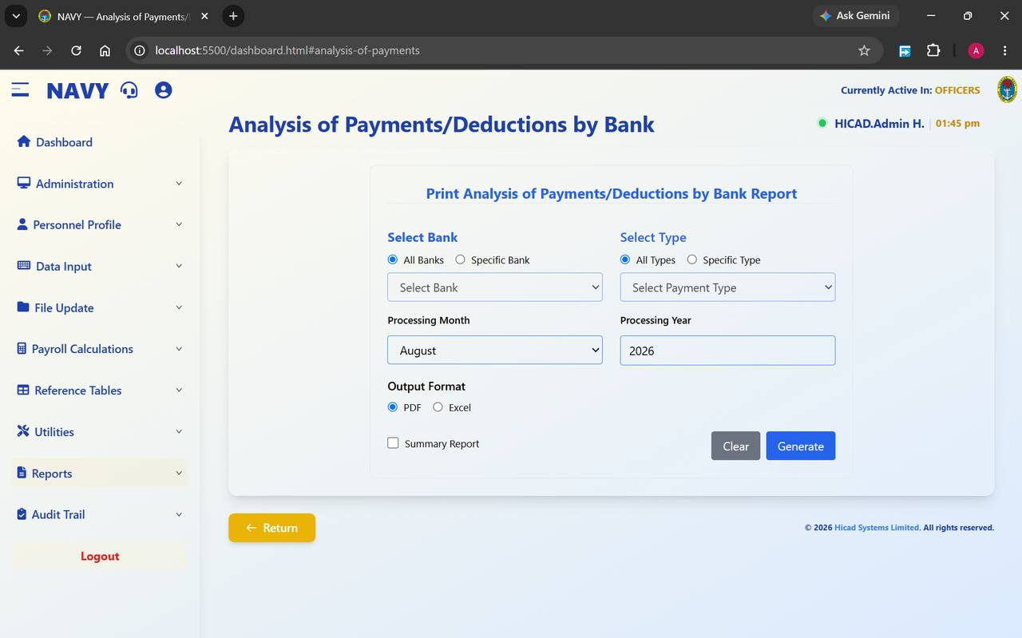
Figure 52.1 Print Analysis of Payments/Deductions by Bank Report. Bank on the left, payment type on the right.
Field / control | What it is for
Select Bank — All Banks / Specific Bank | Which bank or banks to cover.
Select Bank dropdown | The bank, used with Specific Bank.
Select Type — All Types / Specific Type | Which pay elements to cover.
Select Payment Type dropdown | The element, used with Specific Type.
Processing Month / Processing Year | The period.
Output Format | PDF or Excel.
Summary Report | Totals only.

Use this report when a bank raises a query about a particular payment, or when a payment type needs to be traced through to the accounts it was paid into. It is the intersection of Chapters 49 and 50.

53. Payroll Register
Reports > Payroll Register · dashboard.html#payroll-register
The definitive record of a pay run.
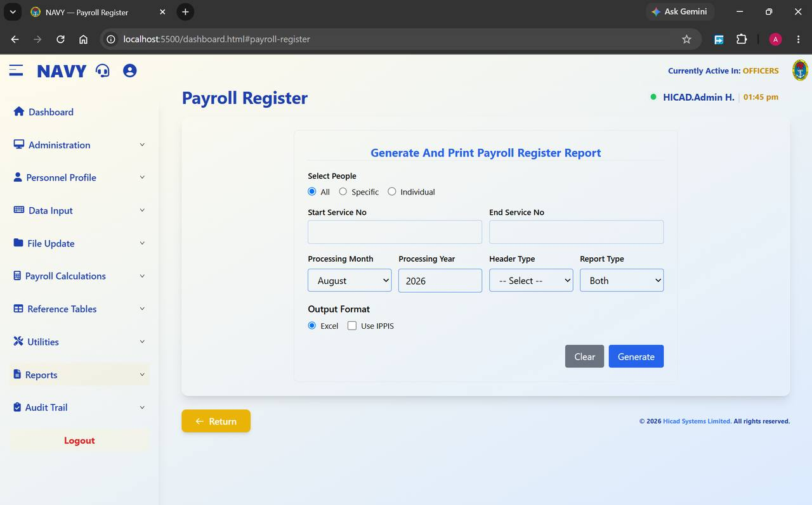
Figure 53.1 Generate And Print Payroll Register Report.
Field / control | What it is for
Select People — All / Specific / Individual | The population.
Start Service No / End Service No | The range, with Specific.
Processing Month / Processing Year | The period.
Header Type | The heading applied to the report.
Report Type — Both | Whether the register shows payments, deductions, or Both.
Output Format — Excel | The register is produced in Excel.
Use IPPIS | Produces the register on the IPPIS basis, for comparison with the imports described in Chapter 44.

The payroll register is the report against which everything else is reconciled. Its totals should agree with the bank payment schedule (Chapter 49), with the analysis of earnings and deductions (Chapter 50), and — where Use IPPIS is ticked — with the IPPIS import for the same period.
- Produce the register for the whole class with Report Type set to Both.
- Agree its total to the bank payment schedule.
- Agree its total to the analysis of earnings and deductions.
- Produce it again with Use IPPIS ticked and agree it to the IPPIS import.
- File it. This is the report an auditor will ask for.

54. Salary Summary
Reports > Salary Summary · dashboard.html#salary-summary
The one-page management view of the payroll.
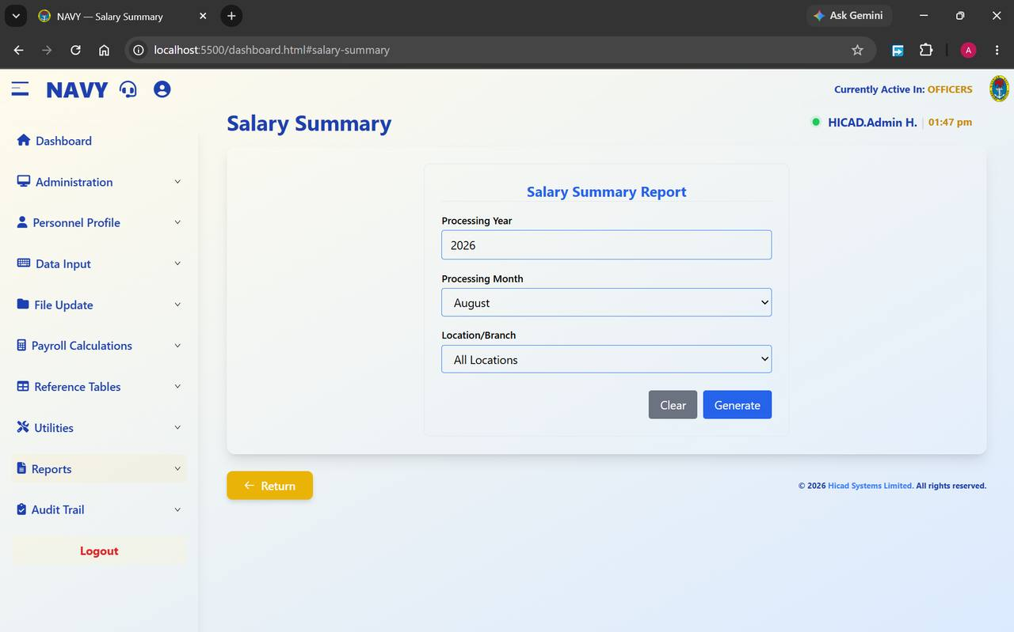
Figure 54.1 Salary Summary Report. Period, location and generate.
Field / control | What it is for
Processing Year / Processing Month | The period.
Location/Branch — All Locations | Covers the whole payroll, or narrows to a single ship, establishment or branch from the tables in Chapter 40.
Generate | Produces the summary; Clear resets.

This is the report to take to a meeting. It gives the totals without the detail, and narrowing it by location answers the question a commanding officer is most likely to ask: what does my ship cost?

55. Tax Payments by State
Reports > Tax Payments by State · dashboard.html#tax-payments-by-state
The PAYE return, broken down by the state each deduction is remitted to.
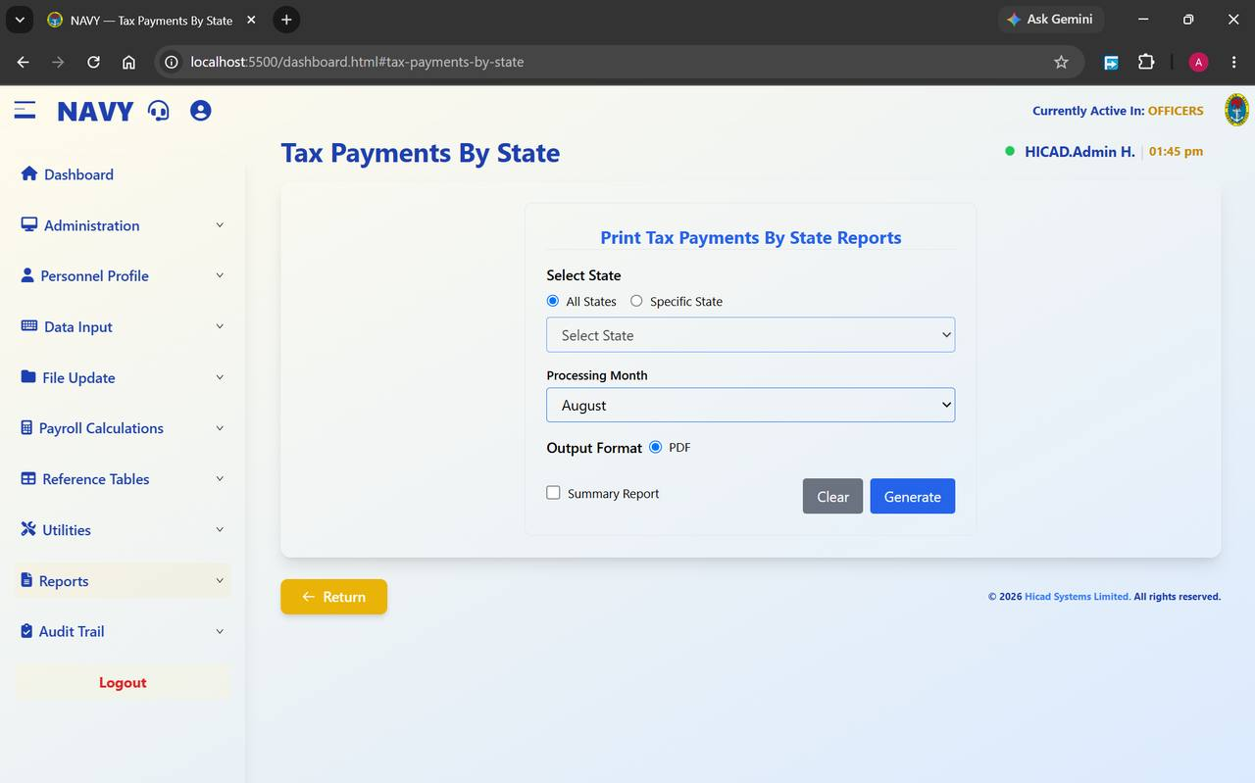
Figure 55.1 Print Tax Payments By State Reports. Note that this report is produced as PDF only.
Field / control | What it is for
Select State — All States / Specific State | Every state, or one.
Select State dropdown | The state, used with Specific State.
Processing Month | The period.
Output Format — PDF | PDF only. This is a formal return, and the fixed format is deliberate.
Summary Report | Totals by state rather than the person-by-person detail.

Each person's Tax State is set on Step 2 of their personnel record (Chapter 14.3), and it is that field — not their state of origin — which determines where their PAYE is remitted.
- Produce the Summary Report for All States and agree the total to the PAYE deduction total on the payroll register (Chapter 53).
- Produce the detail for each state that is to receive a return.
- Check for personnel with no tax state recorded; their deductions will not appear against any state.
- Remit and file.
CAUTION
A wrong Tax State sends a person's PAYE to the wrong state internal revenue service. Correcting it afterwards means recovering money from one state and paying it to another, which is slow. Check new personnel records at the point of entry.

56. Control Sheet / Journal
Reports > Control Sheet · dashboard.html#control-sheet
The accounting summary of the pay run, for posting to the ledger.
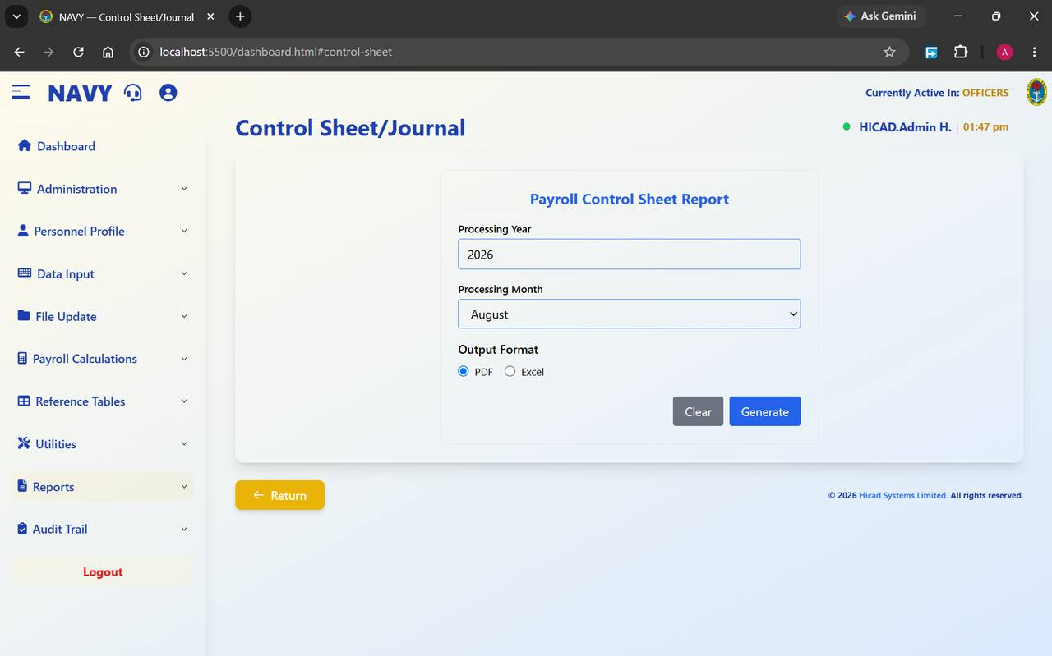
Figure 56.1 Payroll Control Sheet Report.
Field / control | What it is for
Processing Year / Processing Month | The period.
Output Format | PDF or Excel.
Generate | Produces the control sheet; Clear resets.

The control sheet summarises the pay run in accounting terms — the totals to be posted, by category. It is the document that passes from the pay office to the accounts branch, and it should be produced and agreed before month-end processing runs.

57. National Housing Fund
Reports > National Housing Funds · dashboard.html#national-housing-funds
The NHF return.
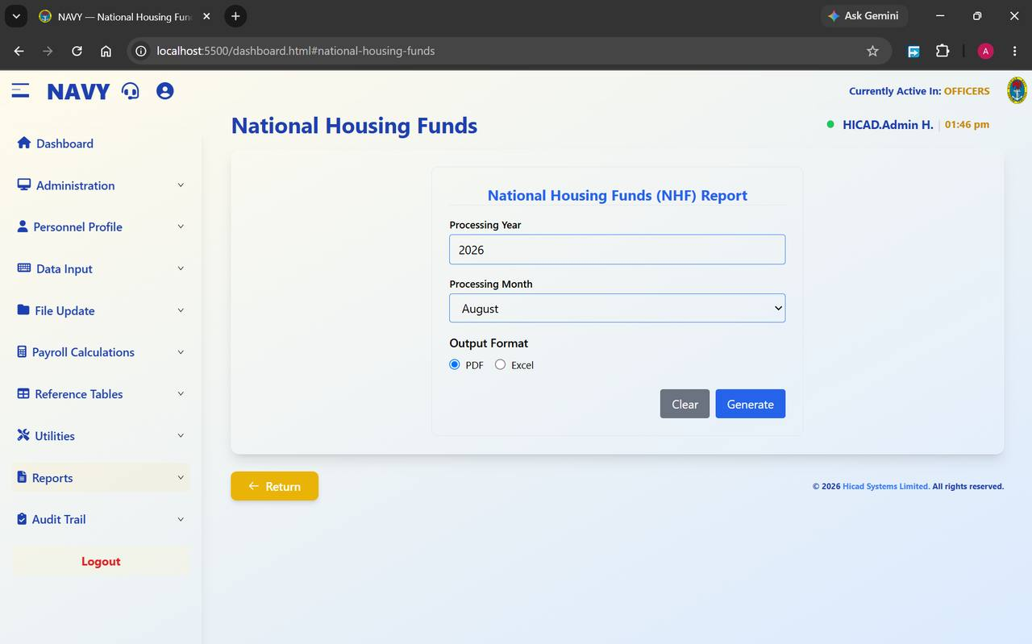
Figure 57.1 National Housing Funds (NHF) Report.
Field / control | What it is for
Processing Year / Processing Month | The period.
Output Format | PDF or Excel.
Generate | Produces the return; Clear resets.

The return lists NHF contributions for the period. It draws on the NHF Code held on Step 3 of each personnel record (Chapter 14.4); a person without an NHF code will not appear on it.
GOOD PRACTICE
Before producing the return, run the current personnel report in Excel and check for blank NHF codes among those who should be contributing. A missing code is the usual reason a contribution fails to reach the Fund.

58. Pension Fund Scheme
Reports > NSITF · dashboard.html#nsitf
The pension return, by administrator.
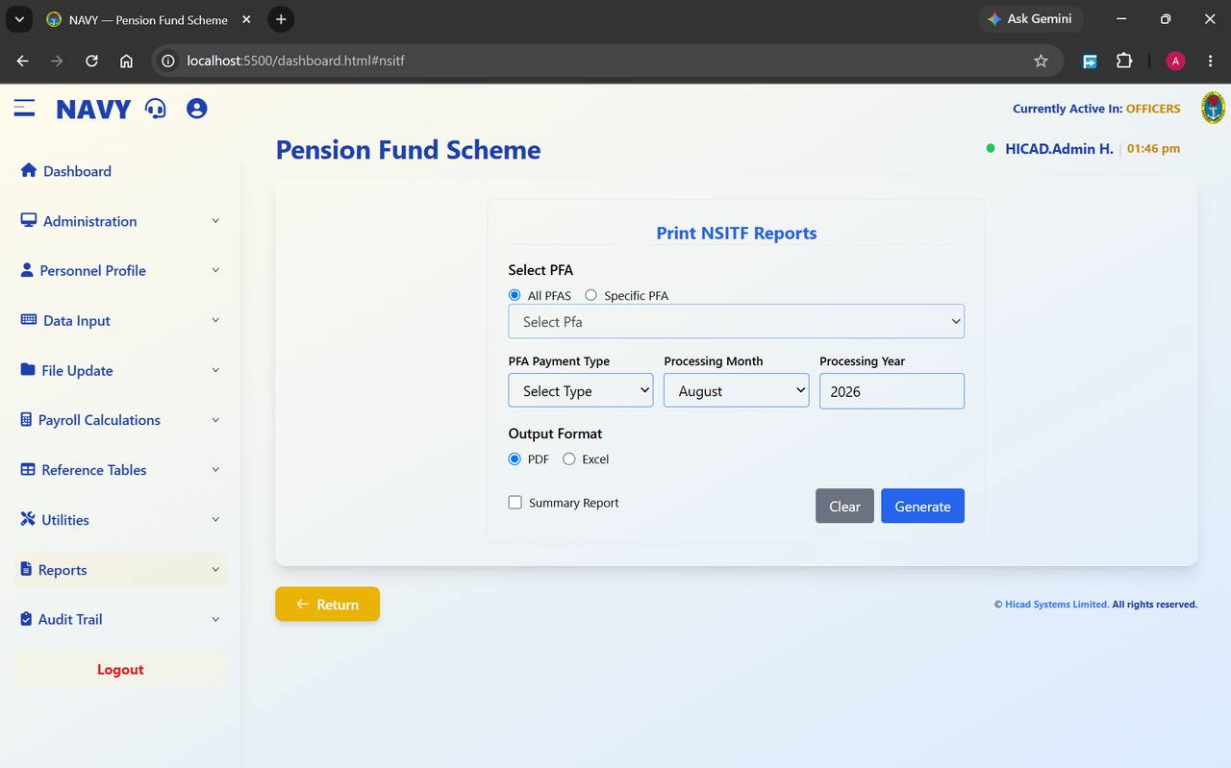
Figure 58.1 Print NSITF Reports. Filter by PFA and by PFA payment type.
Field / control | What it is for
Select PFA — All PFAS / Specific PFA | Every administrator, or one.
Select Pfa dropdown | The administrator, used with Specific PFA. Drawn from the list in Chapter 38.
PFA Payment Type | Which pension element to report on.
Processing Month / Processing Year | The period.
Output Format | PDF or Excel.
Summary Report | Totals by administrator.

- Produce the Summary Report for All PFAS and agree the total to the pension deduction total on the payroll register.
- Produce a detailed return for each administrator.
- Check that every administrator on the return has a pension fund custodian recorded (Chapter 38) — a missing custodian produces an incomplete remittance schedule.
- Remit and file.

59. Salary History
Reports > Salary History · dashboard.html#salary-history
Payslips and pay history across periods rather than for a single month.
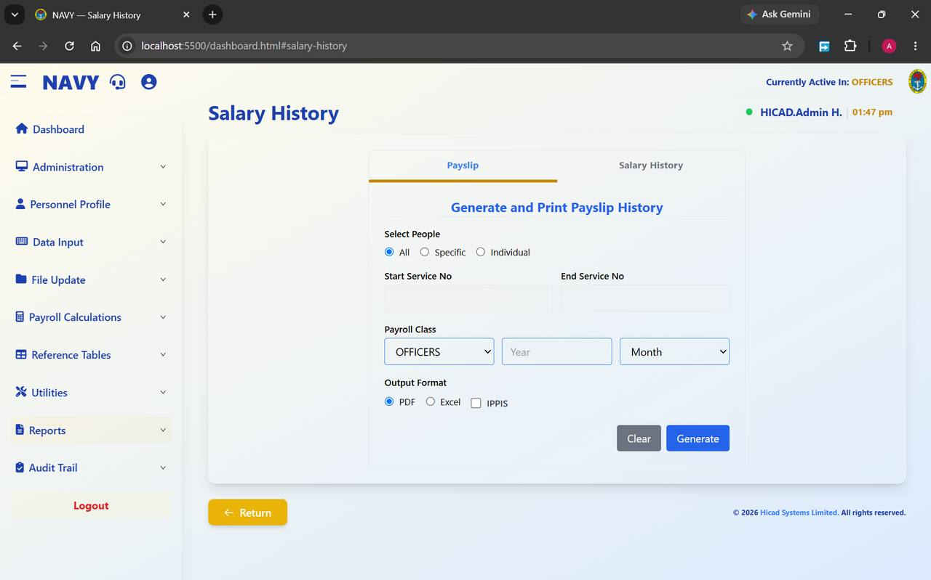
Figure 59.1 Salary History, with the Payslip tab selected. The Salary History tab beside it gives the history view.
Field / control | What it is for
Payslip / Salary History tabs | Switch between reproducing historical payslips and producing a history of pay.
Select People — All / Specific / Individual | The population.
Start Service No / End Service No | The range, with Specific.
Payroll Class, Year, Month | The class and period.
Output Format | PDF, Excel, or IPPIS for the IPPIS-format equivalent.

This is the report to use when somebody needs a payslip they did not keep, or when a query concerns a period that has already been closed. It reads the history rather than the current period, so it can be run at any time without disturbing the current cycle.

60. Salary Reconciliation
Reports > Salary Reconciliation · dashboard.html#salary-reconciliation
The first of the five exception reports. Run it every month.
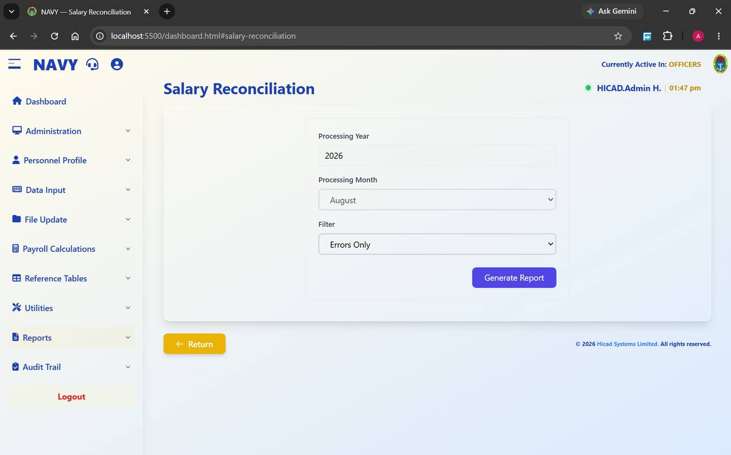
Figure 60.1 Salary Reconciliation with the filter set to Errors Only.
Field / control | What it is for
Processing Year / Processing Month | The period.
Filter — Errors Only | Restricts the report to records that do not reconcile. Other filter settings widen it.
Generate Report | Produces the report.

The report compares this period against the last and reports records whose figures do not reconcile. With Errors Only selected it should, in a clean month, return nothing — and a nil return is a meaningful result worth filing.
- Run it with Errors Only immediately after the calculation completes.
- Investigate every record it returns. There is no such thing as an acceptable reconciliation error.
- Correct the cause, re-run the calculation, and run the report again.
- File the clean report as evidence that the period reconciled.

61. Changes in Personal Details Record
Reports > Changes in Personal Details · dashboard.html#changes-in-personal-details
What changed on personnel records, over a range of periods.
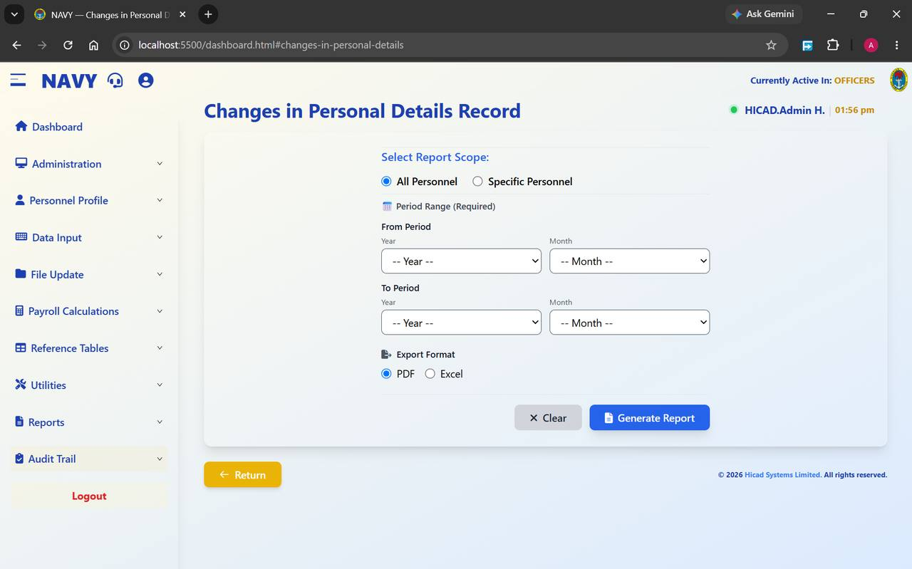
Figure 61.1 Changes in Personal Details Record. The period range is required; both From and To must be set.
Field / control | What it is for
Select Report Scope — All Personnel / Specific Personnel | Everybody, or a named individual.
From Period — Year, Month | The start of the range. Both must be set.
To Period — Year, Month | The end of the range. Both must be set.
Export Format | PDF or Excel.
Generate Report | Produces the report; Clear resets.

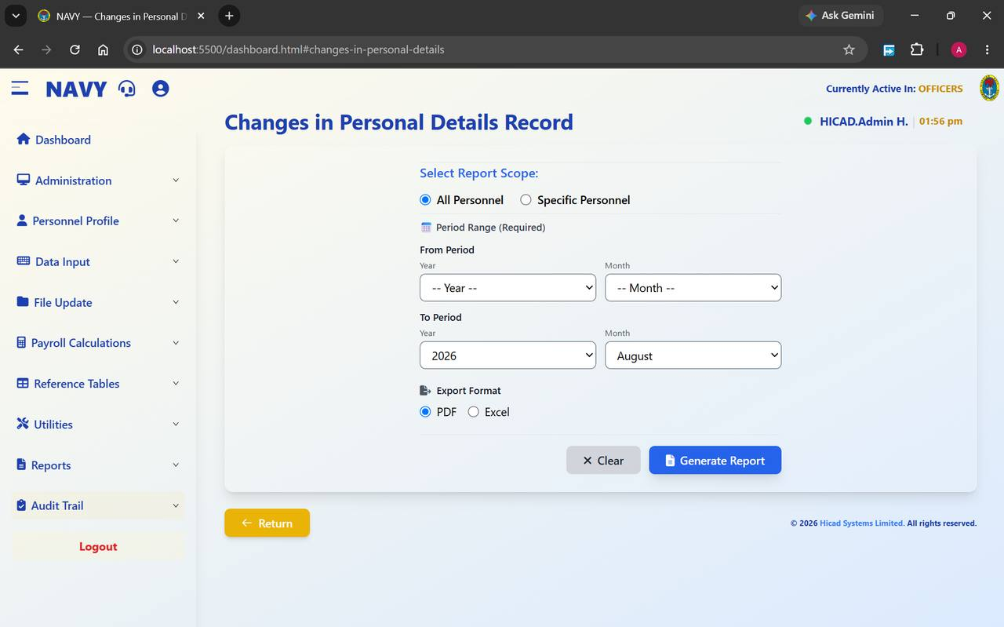
Figure 61.2 The same screen with the To Period set to August 2026. The From Period must also be completed before the report will generate.
This report differs from Changes in Personnel Data in Chapter 25 in one important respect: that one is a control report for a single cycle and is part of the mandatory sequence, while this one looks across a range of periods and can be run at any time. Use this one when investigating a query — “when did this person's bank account change, and who changed it?”
NOTE
The period range is marked (Required). If the report does not generate, the usual reason is that only one of the four year and month fields has been set.

62. Variation Input Listings
Reports > Variation Input Listings · dashboard.html#variation-input-listings
The control report for the variations captured in Chapter 18.
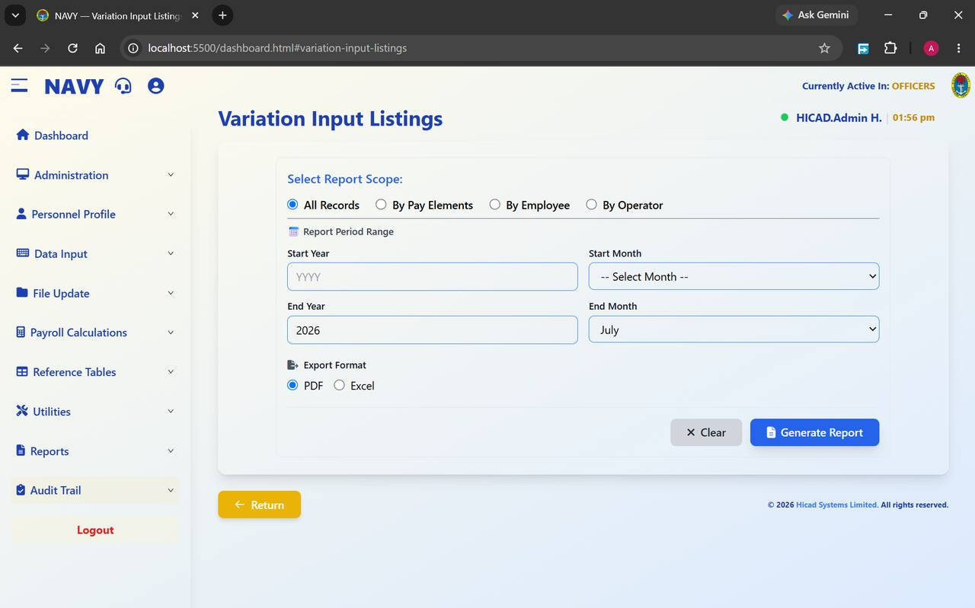
Figure 62.1 Variation Input Listings. Four scopes, including By Operator.
Field / control | What it is for
All Records | Every variation in the period range.
By Pay Elements | Grouped by the element varied.
By Employee | Grouped by the person affected.
By Operator | Grouped by the user who keyed the variation.
Start Year / Start Month / End Year / End Month | The period range.
Export Format | PDF or Excel.

By Operator deserves particular attention. It is the report that shows what each member of staff has changed, and it is the natural companion to the audit trail in Chapter 67 — the audit trail records everything, while this report presents the variations in a form a supervisor can read and sign.
GOOD PRACTICE
Run By Operator monthly and have each operator's listing initialled by their supervisor. It takes minutes, and it turns the system's record-keeping into an actual control.

63. Salary Variance Analysis
Reports > Salary Variance Analysis · dashboard.html#salary-variance-analysis
Where has pay moved, and why?
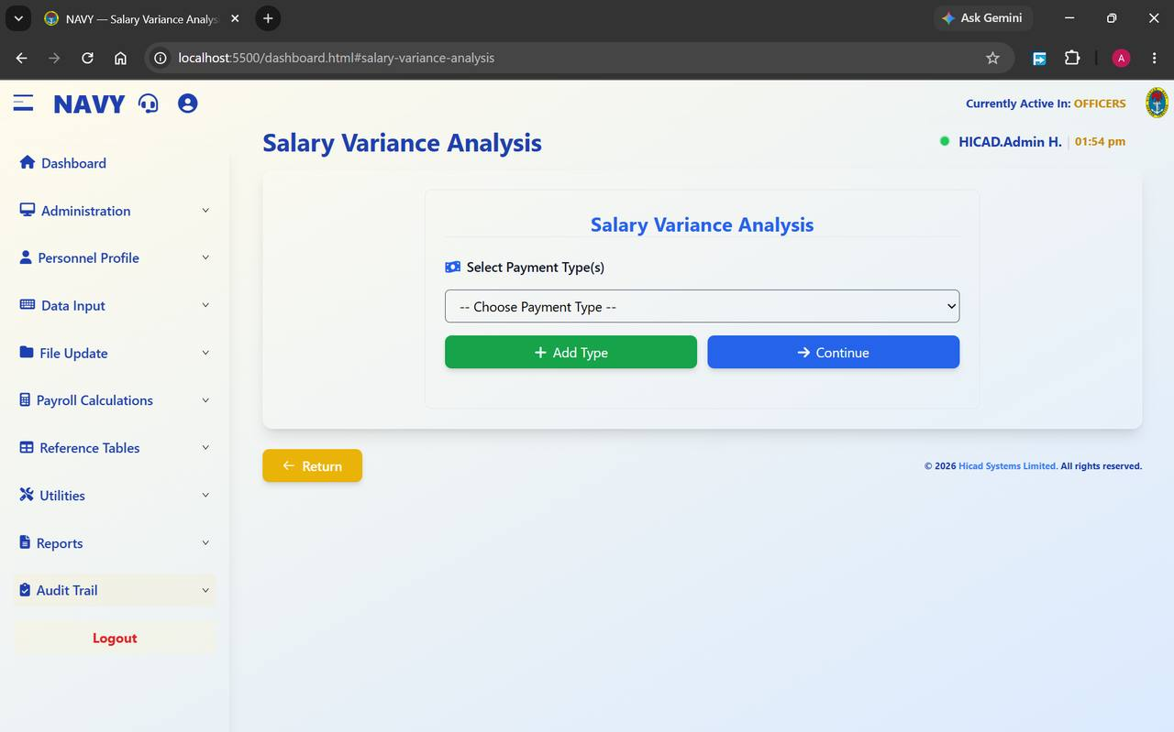
Figure 63.1 Salary Variance Analysis. Choose one or more payment types, then continue.
Field / control | What it is for
Select Payment Type(s) | The elements to analyse, drawn from Chapter 36.
+ Add Type | Adds another element to the analysis. Several can be analysed together.
Continue | Moves to the analysis itself.

Variance analysis compares pay between periods and reports the movements. It is the second of the five exception reports, and the one most likely to catch a mistake that is individually plausible — a single person moved to the wrong salary grade, for instance, which no total-level check will find.
- Add the pay elements you want to analyse. Basic Pay and the larger allowances are the usual starting point.
- Press Continue.
- Read the movements. Anything unexpected should be traceable to a specific authority — a promotion, a posting, a change of entitlement.
- Investigate anything that is not.

64. Overpayment
Reports > Overpayment · dashboard.html#overpayment
Payments that breach the tolerance set in Chapter 33.
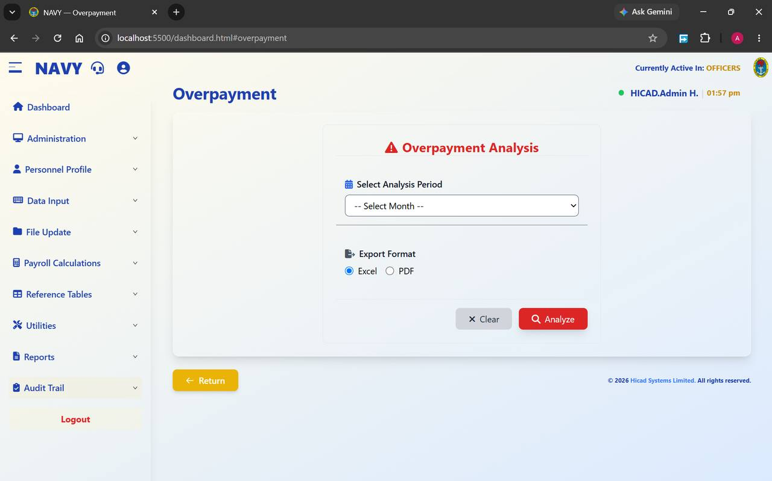
Figure 64.1 Overpayment Analysis. Select a period, choose a format, and analyse.
Field / control | What it is for
Select Analysis Period | The month to analyse.
Export Format | Excel or PDF. Excel is the more useful of the two here, because the output is a working list.
Analyze | Runs the analysis; Clear resets.

The report identifies payments exceeding the overpayment percentage set for the element on the Overpayment Percentage Alarm screen (Chapter 33). With a tolerance of zero, any excess at all is reported.
- Run the analysis for the period immediately after the calculation.
- Work through the list and establish the cause of each item.
- Where an overpayment is confirmed, correct the underlying record and set up a recovery using the PR306 Overpayment Recovery element (Chapter 36).
- Re-run the analysis after the correction.
CAUTION
An overpayment recovered promptly is an administrative matter. An overpayment discovered a year later is a hardship for the person concerned and a difficult conversation for everybody. Run this report every month.

65. Duplicate Account Number
Reports > Duplicate Account Number · dashboard.html#duplicate-account-number
Two people, one bank account. Almost always an error, occasionally something worse.
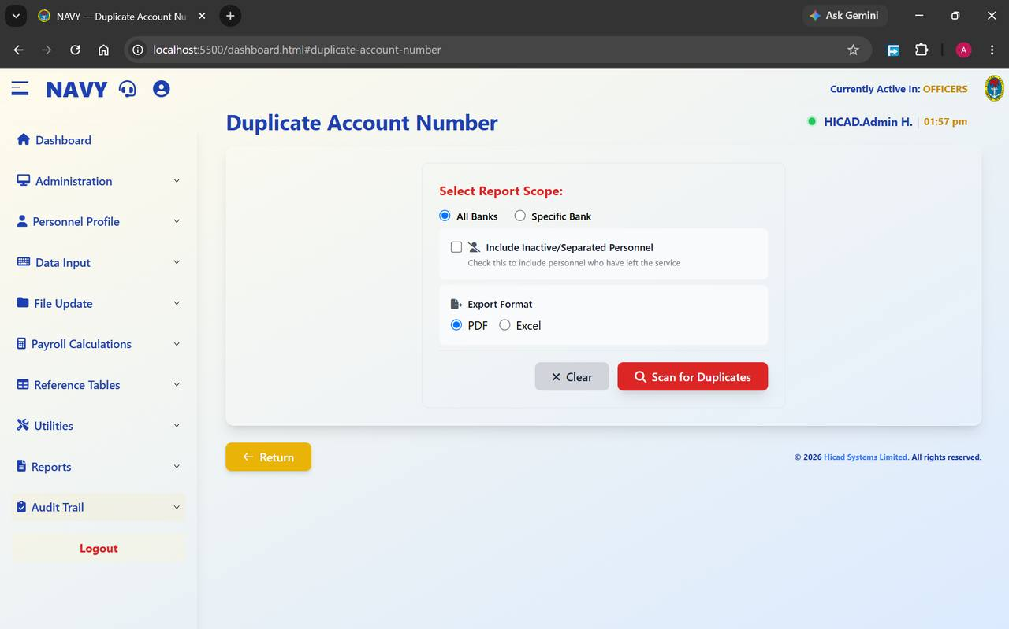
Figure 65.1 Duplicate Account Number. The scan can be restricted to one bank and can optionally include personnel who have left.
Field / control | What it is for
Select Report Scope — All Banks / Specific Bank | Scan every bank, or one.
Include Inactive/Separated Personnel | Extends the scan to personnel who have left the Service. Worth ticking periodically — a live account sharing a number with a departed member is exactly the pattern worth understanding.
Export Format | PDF or Excel.
Scan for Duplicates | Runs the scan; Clear resets.

- Run the scan across All Banks each month.
- For every pair returned, obtain the bank documentation for both individuals.
- Correct whichever record is wrong.
- Where the duplication cannot be explained by a keying error, report it through the appropriate channel rather than simply correcting it.
CAUTION
Most duplicates are transcription errors. Some are not. Do not quietly correct a duplicate that you cannot explain — record what you found and refer it.

66. Out-of-Range Payments
Reports > Out of Range Payments · dashboard.html#outof-range-payments
Payments outside the limits you would expect. The last of the five exception reports.
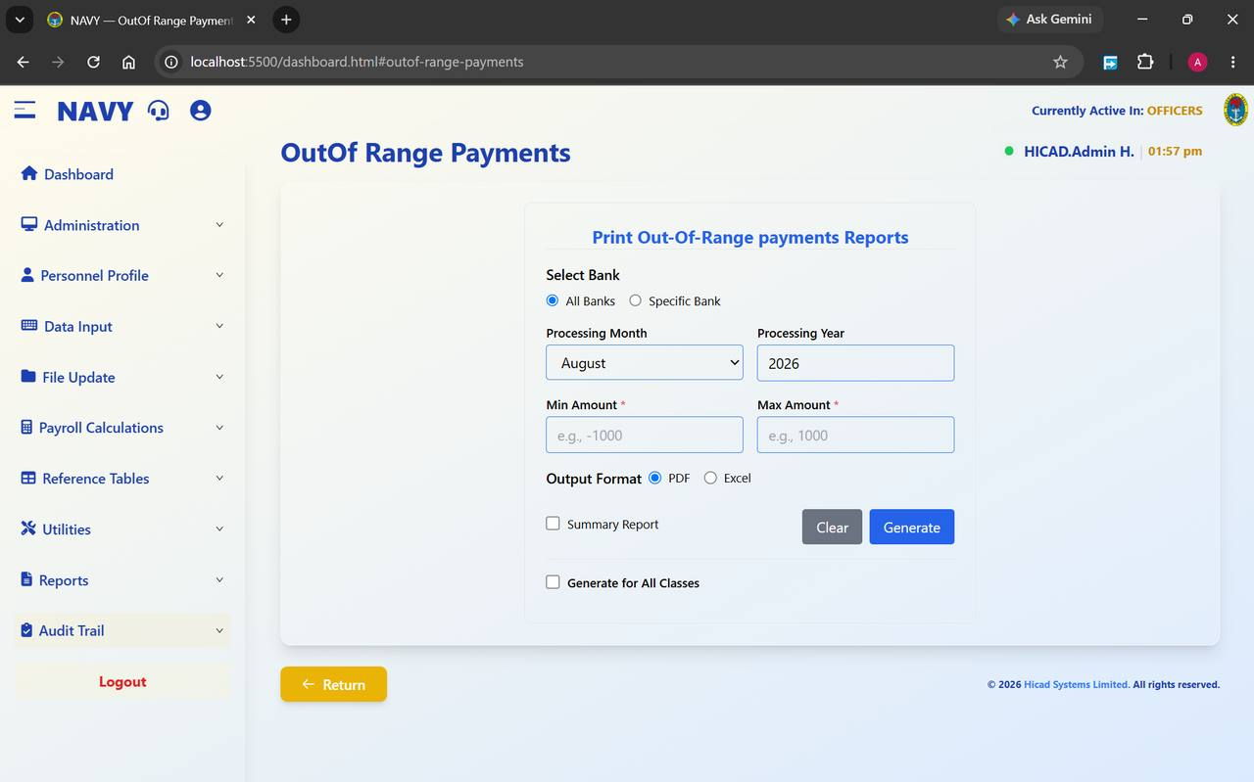
Figure 66.1 Print Out-Of-Range payments Reports. Both Min Amount and Max Amount are required.
Field / control | What it is for
Select Bank — All Banks / Specific Bank | The scope of the scan.
Processing Month / Processing Year | The period.
Min Amount * | The lower limit. The example on screen is -1000 — a negative minimum catches negative net pay, which should never occur.
Max Amount * | The upper limit. Set it above the highest legitimate net pay in the class and anything above it is by definition worth looking at.
Output Format | PDF or Excel.
Summary Report | Totals only.
Generate for All Classes | Scans every payroll class rather than the active one.

- Set Min Amount to a small negative figure to catch negative and zero net pay.
- Set Max Amount just above the highest net pay you would expect in the class.
- Tick Generate for All Classes to cover the whole payroll in one pass.
- Run it, and investigate everything it returns.
GOOD PRACTICE
Zero and negative net pay is the single most important thing this report finds. A person whose deductions exceed their gross pay will receive nothing at all that month, and they will find out on pay day unless you find out first.

67. Audit Trail
Audit Trail — the last item on the left-hand menu
The record of who did what. The reason the rest of the controls in this manual mean anything.

67.1 What the audit trail is
The audit trail records changes of consequence made anywhere in the system: which table was affected, which record, what action was taken, who took it, when, and what the value was before and after. It is not a report you run to get work done — it is the record you go to when a question arises months later and nobody remembers.

67.2 When to use it
- A payment is queried. Establish what the record held at the time and when it changed.
- A figure has moved unexpectedly. Find the change that caused it, and the authority for it.
- A service number was changed. Chapter 10 records the old value, the new value, and who made the change.
- A permission question arises. Changes to roles and users are recorded here.
- An audit. This is what an auditor will ask to see.

67.3 Filtering
The audit trail is filtered by table, by action and by date range. Start with the date range — you will almost always know roughly when something happened — then narrow by table or action. Individual entries can be expanded to show the before-and-after values.

67.4 Why it matters
Everything else in this manual depends on this chapter being true. The separation of duties recommended in Chapter 6.5, the control reports in Chapters 25 and 26, the operator listing in Chapter 62 — each of them works because the system keeps an independent record of what was done and by whom.
CAUTION
Nothing in this system should be changed outside it. A correction applied directly to the database leaves no audit entry, and the record then no longer explains the data. If a change cannot be made through the application, it needs a decision at a level above the pay office, and it needs to be documented.
NOTE
At the time of writing, no screen capture of the Audit Trail was available, so this chapter describes it without a figure. The filters and columns are as described above; if your version differs, the release note for that version takes precedence.

Appendix A · Payroll Class Reference
The classes configured in the system, as shown on Administration > Payroll Class Setup (Chapter 9.1).
Code | Class | Covers | Notes
1 | OFFICERS | Commissioned officers | Approximately 4,646 personnel in the installation shown in this manual.
2 | W/OFFICERS | Warrant officers | Approximately 4,519 personnel.
3 | RATE A | Ratings, band A | Approximately 8,134 personnel.
4 | RATE B | Ratings, band B | Approximately 6,595 personnel.
5 | RATE C | Ratings, band C | Approximately 11,111 personnel — the largest class.
6 | TRAINEE | Personnel under training | Population varies with the training cycle.
— | Z | Holding | Not a payroll class for processing. Records here are not attached to a live class and will not be paid. Approximately 2,496 records.

NOTE
The population figures are those shown in the figures in this manual and are illustrative. Use the live Payroll Class Statistics panel (Chapter 9.4) for current numbers.

A.1 Class-by-class checklist for a monthly cycle
Every step of the cycle in Chapter 5 is run per class. Use this grid to keep track.
Step | OFFICERS | W/OFFICERS | RATE A | RATE B | RATE C | TRAINEE
Input captured
Validation locked
Payroll files saved
Personnel changes printed
Input variable report printed
Master file updated
Calculated
Exception reports run
Register reconciled
Backup taken
Month-end processed

Appendix B · Pay Element Code Reference
Pay elements are defined on Reference Tables > Pay Element Description (Chapter 36). The prefix of the code tells you what kind of element it is.

B.1 Prefixes
Prefix | Kind of element
BP | Basic pay — the salary elements from which everything else is derived.
PT | Payments — allowances, grants, subsidies and other credits.
PR | Deductions and recoveries — tax, rent, mess bills, cooperative contributions, recoveries.
BT | Reserved and system elements.

B.2 Elements referred to in this manual
Code | Description | Notes
BP101 | Basic Pay | The element the overpayment alarm is configured against (Chapter 33).
BP102 | Consolidated Pay
BP105 | Arrears of Pay (CONAFSS MSS)
BP301 | Enhanced Consolidated Pay
BP302 | ECONAFSS Difference
BP303 | Revised Consolidated Pay
BP304 | RCONAFSS Arrears
PT116 | A.F.H.A. | Function type DIVISION (D).
PT129 | Plain Cloth Allowance | Fixed amount by rank.
PT301 | Diving Allowance
PT302 | Staff Grant
PT306 | Rent Subsidy | Linked to the rent subsidy entitlement on the personnel record.
PT313 | NYSC Allowance
PT321 | Salary Arrears
PT330 | NYSC Allowance Arrears
PT350 | Administrative Allowance | Takes precedence over PT358.
PT358 | Special Forces Inactive Allowance | Suppressed by PT350.
PT365 | SBS Inactive Allowance | Suppressed by PT366.
PT366 | SBS Active Allowance | Takes precedence over PT365.
PT372 | Special Forces Active Allowance | Takes precedence over PT381.
PT381 | Special Forces Inactive Allowance | Suppressed by PT372.
PT385 | Artificer Allowance | Takes precedence over PT386.
PT386 | Computer Operator Allowance | Suppressed by PT385.
PR102 | REG NN Cooperative | Fixed amount by rank.
PR103 | NN Cooperative
PR301 | PAYE Tax | Reported by state in Chapter 55.
PR302 | Rent
PR303 | Mess Bills
PR305 | Dependant Fund
PR306 | Overpayment Recovery | The element to use when recovering an overpayment found in Chapter 64.
PR307 | Electricity Bill
PR308 | NAVIP
PR310 | Refuse Disposal Deduction

NOTE
This is not the full list. The installation shown in this manual holds 308 elements. Use the search box on the Pay Element Description screen to find any element by code or description.

Appendix C · Troubleshooting
The messages and situations most likely to bring work to a halt, and what to do about each.

C.1 Screens that refuse to open
What you see | What it means | What to do
Validation Required — lock and verify Payment/Deduction records in Validation before payroll files can be saved | Payments and deductions for the period have not been locked and validated. | Press Go to Validation and complete Chapter 23.
Personnel Details Report Not Available Yet | The payroll files have not been saved. | Press Save Payroll Files and complete Chapter 24.
Input Variable Report Not Available Yet | The personnel data changes have not been printed. | Press Personnel Changes and complete Chapter 25.
Waiting for Input Variable Report | The input variable report has not been printed. | Press Input Variable Report and complete Chapter 26.
Payroll Calculations Not Complete | The calculation has not been run. | Press Go to Payroll Calculations and complete Chapter 29.
This section is under development | The feature has not yet been released in your version. | Nothing to do in the system. See Chapter 43.

C.2 Things that look wrong but are not
Situation | Explanation
A payroll class shows null / undefined for year and month. | The class has never been processed. The values populate on the first cycle. Chapter 9.1.
Showing 0 to 0 of 0 records on a data input screen. | Normal at the start of a period, before capture begins. Chapter 17.2.
Two classes are in different months. | Classes are processed independently. Chapter 9.1.
An allowance on the input does not appear on the payslip. | A mutual exclusion is suppressing it. Chapter 37.2.
A row is missing after a batch upload. | Duplicates are rejected by design — either a duplicate service number, or a duplicate service number and payment type pair. Chapters 14.7 and 22.
Local Government shows Select State First. | The field is dependent on the state. Choose a state and it populates. Chapter 42.
A menu described in this manual is not on your screen. | Your role does not have access to it. Chapter 7.

C.3 Things that are wrong
Situation | What to do
The green status dot is missing or the clock has stopped. | Your session has dropped. Sign in again before entering anything further. Chapter 3.4.
A backup shows a size of 0 B. | The backup captured nothing. Do not rely on it. Investigate the backup service before proceeding with anything that needs one. Chapter 45.
A bank record reads Wrong bank Code / Wrong branch. | A placeholder. Find the personnel attached to it, correct them, then delete it. Chapter 39.2.
A location record has no code and no description. | A blank record collecting personnel saved without a location. Identify and reassign them, then remove it. Chapter 40.1.
A PFA has no pension fund custodian. | The remittance schedule will be incomplete. Complete the record before the next return. Chapter 38.
The same payment type appears twice on the one-off setup list. | A duplicated payment is possible. Remove the repetition before running the one-off calculation. Chapter 11.1.
Net pay is zero or negative for a person. | Deductions exceed gross pay. Find these with the out-of-range report before pay day. Chapter 66.
A reconciliation error is reported. | There is no acceptable reconciliation error. Investigate, correct, re-calculate, re-run. Chapter 60.

C.4 Escalation
- Data question — a figure looks wrong. Start with Input Documentation (Chapter 20) and the Audit Trail (Chapter 67).
- Access question — a menu is missing or a user cannot sign in. Your system administrator, Chapters 7 and 8.
- System question — a screen errors, a backup fails, the connection indicator is red. Support, using the headset icon in the header.
- Policy question — a rate, a band or an entitlement is in doubt. This is not a system question. Obtain the authority before changing anything.

Appendix D · Glossary
Term | Meaning
Active class | The payroll class every screen currently reads and writes, shown as Currently Active In in the header. Chapter 4.
Amount To Date | The cumulative amount paid or deducted against a payment or deduction record. What makes it possible to see how much of a loan remains. Chapter 17.1.
Arrears | Back pay owed when a change of grade or rate is applied retrospectively. Chapter 21.
Batch upload | Loading many records at once from a spreadsheet instead of keying them. Chapters 14.7, 15.4, 17.3, 22.
CONAFSS | Consolidated Armed Forces Salary Scale — the salary structure the scales are built on. Chapter 35.
Cumulative | A year-to-date figure — taxable, tax, gross or net. Maintained by the system; entered manually only on transfer in. Chapter 19.
Function type | How a pay element's amount is arrived at — captured as INPUT, derived by DIVISION (D), or taken from a rank table as FIXED AMOUNT BY RANK (R). Chapters 11.1 and 36.
HICAD | Hicad Systems Limited, the supplier of the system; also the name of the full-access role. Chapters 2.2 and 6.
IPPIS | Integrated Personnel and Payroll Information System — the Federal Government platform this system reconciles against. Chapter 44.
Master file update | Writing validated input into the master records, after which the data for the calculation is fixed. Chapter 27.
Month-end processing | Finalising a period and rolling forward. Cannot be undone. Chapter 13.1.
Mutually exclusive elements | Two pay elements that cannot both be paid; the higher-priority one suppresses the other. Chapter 37.2.
NHF | National Housing Fund. Chapter 57.
NSITF | The pension return screen. Chapter 58.
Pay element | Any payment or deduction the system recognises, identified by a code such as PT306. Chapter 36 and Appendix B.
Pay indicator | A setting on a payment or deduction record governing how it recurs and how the calculation treats it. Chapter 17.1.
Payroll class | A group of personnel processed as a separate pay run — OFFICERS, W/OFFICERS, RATE A, RATE B, RATE C, TRAINEE. Chapter 4 and Appendix A.
PFA / PFC | Pension Fund Administrator, which manages the retirement savings account; Pension Fund Custodian, which holds the assets. Chapter 38.
Role | A named bundle of menu permissions assigned to a user account. Chapters 6 and 7.
RSA | Retirement Savings Account. Recorded on Step 2 of the personnel record. Chapter 14.3.
Salary group / salary grade | The scale a person is paid on, and their position within it. Chapters 14.3 and 35.
Service number | The identifier that ties a person to every record in the system, and the credential they sign in with. Chapter 10.
Tax state | The state to which a person's PAYE is remitted. Distinct from state of origin. Chapters 14.3 and 55.
Validation lock | Freezing payment and deduction data for a period so it can be verified. The gate between capture and processing. Chapter 23.
Variation | A recorded change to a payment or deduction already running. Chapter 18.
Year-end processing | Closing the payroll year and resetting annual cumulatives. Chapter 13.2.

Appendix E · Training Exercises
These exercises follow the order of the manual. Work them in a training or test installation only — never against live data.
CAUTION
Do not use live personnel records for training. Service numbers, bank account numbers and pay data are restricted, and a trainee working in a live system can close a period or migrate a class by accident.

E.1 Exercise 1 — Orientation (Chapters 3 – 4)
- Sign in and identify, without scrolling: the active payroll class, the current payroll period, and the number of active personnel.
- Collapse and expand the left-hand menu.
- Name the ten menu groups and say, for each, one thing it is used for.
- Switch the active payroll class to RATE A and back to OFFICERS. Confirm the header changes both times.

E.2 Exercise 2 — Access (Chapters 6 – 8)
- Create a role called TRAINEE_CLERK with an appropriate description.
- Grant it access to Data Input and Reports only.
- Create a user account with that role and an expiry date one week from today.
- Sign in as that account and confirm which menus appear.
- Explain why the account cannot reach Administration.

E.3 Exercise 3 — A personnel record (Chapter 14)
- Add a new person, completing all three steps.
- Add one next of kin and one child.
- Find the record again through Current Personnel.
- Say which field on the record determines where their PAYE is remitted, and which determines their entitlement to rent subsidy.

E.4 Exercise 4 — A cycle (Chapters 17 – 30)
- Capture three payment or deduction records.
- Lock validation for the period.
- Work down the File Update menu in order, and note at each screen what the previous step released.
- Run the calculation.
- Open the calculation reports and state the number of records calculated.

E.5 Exercise 5 — Exceptions (Chapters 60, 63 – 66)
- Run the salary reconciliation with Errors Only.
- Run the out-of-range report with a minimum of -1000.
- Run the duplicate account number scan across all banks.
- Run the overpayment analysis.
- For any item returned, describe how you would establish its cause.

E.6 Exercise 6 — An investigation (Chapters 20, 61, 62, 67)
A member of the Service reports that an allowance they expected is missing from their payslip. Using the system only, establish:
- What was captured for them this period (Input Documentation).
- Whether the allowance was varied or removed (Variation Input Listings, Changes in Personal Details Record).
- Whether another allowance is suppressing it (Mutually Exclusive Pay Elements).
- Who made the last change to their record, and when (Audit Trail).
- Write two sentences you would send in reply.

E.7 Assessment
A trainee is ready to work unsupervised on live data when they can, without reference to this manual:
- State the active class and period before doing anything else.
- Recite the eleven steps of the monthly cycle in order.
- Explain what each of the five exception reports finds.
- Name the three actions in the system that cannot be undone.
- Say what they would do before running any of them.

Appendix F · Figure and Capture Index
Every figure in this manual, with the original screen capture it was taken from. The captures are held in the folder Navy-Pay-shots-Img.

F.1 Figures
Figure | Screen | Capture file
Figure 3.1 | The dashboard, showing the greeting, the three headline figures, Quick Access and Notifications. The left-h… | Screenshot 2026-08-11 125341.png
Figure 6.1 | Role Management with the five roles supplied as standard. Each row can be edited or deleted; the buttons at… | Screenshot 2026-08-11 125445.png
Figure 6.2 | The Add New Role form. Both fields are marked with an asterisk and are required. | Screenshot 2026-08-11 125633.png
Figure 7.1 | Role Permissions before a role is chosen. The Configure Permissions button is greyed out until a selection … | Screenshot 2026-08-11 125659.png
Figure 7.2 | DATA_ENTRY selected. The blue information panel repeats the role description so you can confirm you are wor… | Screenshot 2026-08-11 125721.png
Figure 7.3 | HICAD — full system access. This is the administrator role; treat any change to its permissions with partic… | Screenshot 2026-08-11 125744.png
Figure 7.4 | MANAGER — processor tasks plus user and payment type management. | Screenshot 2026-08-11 125758.png
Figure 7.5 | OPERATOR — data entry, input reports and utilities. | Screenshot 2026-08-11 125817.png
Figure 7.6 | PROCESSOR — operator tasks plus payroll processing and reports. | Screenshot 2026-08-11 125924.png
Figure 8.1 | Create Payroll User. Fields marked with an asterisk are required; the rest may be left blank. | Screenshot 2026-08-11 130045.png
Figure 8.2 | Control Payroll Users. Each account shows its service number, name, role and status, with View, Edit and De… | Screenshot 2026-08-11 130107.png
Figure 9.1 | Payroll Class Setup. The Add New Record strip creates a class; the table below lists those that exist, with… | Screenshot 2026-08-11 130152.png
Figure 9.2 | Switch Active Payroll Class. OFFICERS is active — shown by the green highlight, the tick and the Active bad… | Screenshot 2026-08-11 130228.png
Figure 9.3 | Change Personnel Payroll Class set to bulk migration. Only a target class need be chosen; the Payroll Class… | Screenshot 2026-08-11 130430.png
Figure 9.4 | Individual migration. Search for the person by name or service number, then choose the class they are movin… | Screenshot 2026-08-11 130551.png
Figure 9.5 | Range migration. Set a From and a To personnel record and the system moves everybody in between. | Screenshot 2026-08-11 130958.png
Figure 10.1 | Change Service Number. Find the person, enter the new number, save. | Screenshot 2026-08-11 131030.png
Figure 11.1 | One-Off Requirement Setup. Each row pairs a payment type with the function used to calculate it. | Screenshot 2026-08-11 131059.png
Figure 11.2 | The same screen scrolled down. The list is longer than one screen; scroll to review every entry before runn… | Screenshot 2026-08-11 131147.png
Figure 11.3 | One-Off Fixed Amount By Rank Management. Each code is opened with View or Edit to reach the rank-by-rank am… | Screenshot 2026-08-11 131208.png
Figure 11.4 | Individual One-Off Payment Input, showing entries against two service numbers. The record count at the foot… | Screenshot 2026-08-11 131300.png
Figure 11.5 | One-Off Calculations. Choose the payroll class, decide whether to calculate for everybody or for named pers… | Screenshot 2026-08-11 131424.png
Figure 11.6 | One-Off Reports. Four report types, a payroll class, an output format, and an option to cover all classes a… | Screenshot 2026-08-11 131330.png
Figure 12.1 | Company Profile. The Edit button at the top right opens every field for amendment. | Screenshot 2026-08-11 131523.png
Figure 13.1 | Month End Processing. The current status, the period to be processed, an explicit warning, and — on the rig… | Screenshot 2026-08-11 131549.png
Figure 13.2 | Year End Processing. The panel confirms the current and previous periods before the year is closed. | Screenshot 2026-08-11 131607.png
Figure 14.1 | Add New Personnel, Step 1. The three step buttons run across the top; the record tabs sit at the top right. | Screenshot 2026-08-11 131648.png
Figure 14.2 | Add New Personnel, Step 2. Service dates on the left, tax and pension in the middle, salary and bank detail… | Screenshot 2026-08-11 132026.png
Figure 14.3 | Add New Personnel, Step 3. Posting, branch, specialisation and entitlement fields. | Screenshot 2026-08-11 132052.png
Figure 14.4 | The Next of Kin tab on a new record, before any next of kin has been added. | Screenshot 2026-08-11 131740.png
Figure 14.5 | The Children tab, showing the empty state before any child is added. | Screenshot 2026-08-11 131753.png
Figure 14.6 | The Batch Upload panel, reached from the button at the top left of the Add New Personnel screen. | Screenshot 2026-08-11 131703.png
Figure 15.1 | Current Personnel. The list is filtered to the active payroll class; the record count at the foot shows 4,6… | Screenshot 2026-08-11 131905.png
Figure 15.2 | Current Personnel, from which Batch Update and Generate Report are launched. Always note the record count b… | Screenshot 2026-08-11 132141.png
Figure 15.3 | Current Personnel Reports. Choose a scope, choose PDF or Excel, and generate. | Screenshot 2026-08-11 131940.png
Figure 16.1 | Old Personnel. Every record shows Inactive; the list runs to 8,332 records in this installation. | Screenshot 2026-08-11 132213.png
Figure 16.2 | Exited Members. The scopes mirror the current personnel report, with By Exit Type added. | Screenshot 2026-08-11 132258.png
Figure 17.1 | Payments/Deductions at the start of a period, before any records have been captured. | Screenshot 2026-08-11 132512.png
Figure 17.2 | Payments/Deductions (Batch Upload). The Batch List tab keeps a record of previous uploads. | Screenshot 2026-08-11 132551.png
Figure 18.1 | Variation to Payments/Deductions, before any variation has been recorded. | Screenshot 2026-08-11 132613.png
Figure 19.1 | Cumulative Payroll Transfer, showing the four year-to-date figures the system holds. | Screenshot 2026-08-11 132633.png
Figure 20.1 | Input Documentation. Search for a person to see and print their input form. | Screenshot 2026-08-11 132648.png
Figure 21.1 | Arrears Calculations. The REGULAR block handles grade changes; the OTHERS block handles any other retrospec… | Screenshot 2026-08-11 132740.png
Figure 22.1 | NHQ Allowances. A single upload panel, with the rules stated above it. | Screenshot 2026-08-11 132758.png
Figure 23.1 | Payments/Deductions Validation with data entry still open. The lower panel stays empty until the data is lo… | Screenshot 2026-08-11 132842.png
Figure 24.1 | Save Payroll Files, refused because validation has not been completed. The Go to Validation button takes yo… | Screenshot 2026-08-11 132901.png
Figure 25.1 | Changes in Personnel Data, locked until the payroll files have been saved. The button at the top right take… | Screenshot 2026-08-11 132919.png
Figure 26.1 | Input Variable Report, locked until the personnel data changes have been printed. | Screenshot 2026-08-11 132937.png
Figure 27.1 | Master File Update, waiting on the Input Variable Report. The button reads Waiting for Input Variable Repor… | Screenshot 2026-08-11 132952.png
Figure 28.1 | Recall Payment Files. A single action, described plainly on the screen. | Screenshot 2026-08-11 133006.png
Figure 29.1 | Payroll Calculations. The month and year are shown for confirmation; the button is greyed until the master … | Screenshot 2026-08-11 133022.png
Figure 30.1 | Calculation Reports before the calculation has run. Reports are only available once the calculation is comp… | Screenshot 2026-08-11 133035.png
Figure 31.1 | Overtime Information. Six settings, one Save button. | Screenshot 2026-08-11 133059.png
Figure 32.1 | Command Management, showing the eight commands configured in this installation. | Screenshot 2026-08-11 133306.png
Figure 33.1 | Overpayment Percentage Alarm. One row per basic salary record, each with its own tolerance. | Screenshot 2026-08-11 133331.png
Figure 34.1 | Tax Table Configuration. Each row is one band; the buttons above add bands, configure minimum free pay and … | Screenshot 2026-08-11 133440.png
Figure 35.1 | Salary Scale Information with the Salary Groups tab selected. The Salary Scale tab beside it holds the amou… | Screenshot 2026-08-11 133508.png
Figure 36.1 | Pay Element Description. 308 elements in this installation, ten to a page. | Screenshot 2026-08-11 133541.png
Figure 37.1 | Fixed Amount By Rank Management, listing 25 elements across three pages. | Screenshot 2026-08-11 133608.png
Figure 37.2 | Mutually Exclusive Pay Elements. Each row pairs a high-priority element with a lower-priority one. | Screenshot 2026-08-11 133623.png
Figure 38.1 | PFA Management. Eighteen administrators in this installation, each with its pension fund custodian. | Screenshot 2026-08-11 133650.png
Figure 39.1 | Bank Management. 253 bank and branch records, ten to a page. | Screenshot 2026-08-11 133708.png
Figure 40.1 | Location Management. Ships and establishments with their codes. | Screenshot 2026-08-11 133733.png
Figure 40.2 | Branch Management. Nine branches in this installation. | Screenshot 2026-08-11 133753.png
Figure 41.1 | States Management. Thirty-nine records covering the states, the Federal Capital Territory and additional en… | Screenshot 2026-08-11 133807.png
Figure 42.1 | Local Government Management. 790 records across 79 pages; use the search rather than paging. | Screenshot 2026-08-11 133829.png
Figure 43.1 | Emolument Form Processing. At the time of capture this section was under development. | Screenshot 2026-08-11 133956.png
Figure 44.1 | Pull IPPIS Payments before any import has been made. | Screenshot 2026-08-11 134009.png
Figure 44.2 | Pull IPPIS Payments with thirty periods imported. Reading the columns across a run of months is a quick che… | Screenshot 2026-08-11 134030.png
Figure 45.1 | Payroll Class Backup. Configuration on the left, history on the right, summary figures beneath. | Screenshot 2026-08-11 134103.png
Figure 46.1 | Payroll Class Restore. The connection indicator confirms the database; the history panel records every rest… | Screenshot 2026-08-11 134120.png
Figure 47.1 | Consolidated Payslips. Choose who, choose the class and period, choose the format, generate. | Screenshot 2026-08-11 134132.png
Figure 48.1 | Current Personnel Reports, reached from the Reports menu. The same screen is described in Chapter 15.5. | Screenshot 2026-08-11 134813.png
Figure 48.2 | List Of Exited Members, reached from the Reports menu. The same screen is described in Chapter 16.3. | Screenshot 2026-08-11 134846.png
Figure 48.3 | Generate and Print Payslips. | Screenshot 2026-08-11 134158.png
Figure 49.1 | Print Payments by Bank(Branch) Reports. | Screenshot 2026-08-11 134212.png
Figure 50.1 | Print Analysis of Earnings/Deduction Report. | Screenshot 2026-08-11 134429.png
Figure 51.1 | Print Loan Analysis Report. The simplest report screen in the system: period, format, generate. | Screenshot 2026-08-11 134449.png
Figure 52.1 | Print Analysis of Payments/Deductions by Bank Report. Bank on the left, payment type on the right. | Screenshot 2026-08-11 134514.png
Figure 53.1 | Generate And Print Payroll Register Report. | Screenshot 2026-08-11 134548.png
Figure 54.1 | Salary Summary Report. Period, location and generate. | Screenshot 2026-08-11 134705.png
Figure 55.1 | Print Tax Payments By State Reports. Note that this report is produced as PDF only. | Screenshot 2026-08-11 134528.png
Figure 56.1 | Payroll Control Sheet Report. | Screenshot 2026-08-11 134718.png
Figure 57.1 | National Housing Funds (NHF) Report. | Screenshot 2026-08-11 134634.png
Figure 58.1 | Print NSITF Reports. Filter by PFA and by PFA payment type. | Screenshot 2026-08-11 134649.png
Figure 59.1 | Salary History, with the Payslip tab selected. The Salary History tab beside it gives the history view. | Screenshot 2026-08-11 134756.png
Figure 60.1 | Salary Reconciliation with the filter set to Errors Only. | Screenshot 2026-08-11 134732.png
Figure 61.1 | Changes in Personal Details Record. The period range is required; both From and To must be set. | Screenshot 2026-08-11 135621.png
Figure 61.2 | The same screen with the To Period set to August 2026. The From Period must also be completed before the re… | Screenshot 2026-08-11 135644.png
Figure 62.1 | Variation Input Listings. Four scopes, including By Operator. | Screenshot 2026-08-11 135657.png
Figure 63.1 | Salary Variance Analysis. Choose one or more payment types, then continue. | Screenshot 2026-08-11 135437.png
Figure 64.1 | Overpayment Analysis. Select a period, choose a format, and analyse. | Screenshot 2026-08-11 135722.png
Figure 65.1 | Duplicate Account Number. The scan can be restricted to one bank and can optionally include personnel who h… | Screenshot 2026-08-11 135735.png
Figure 66.1 | Print Out-Of-Range payments Reports. Both Min Amount and Max Amount are required. | Screenshot 2026-08-11 135757.png

F.2 Captures not reproduced
The following captures were reviewed but are not reproduced as figures, either because they duplicate a screen already shown or because the capture itself carries no usable content. They are listed here so that the set is fully accounted for.
Capture file | Reason
Screenshot 2026-08-11 125905.png | Duplicate of Figure 7.5 — Role Permissions with OPERATOR selected.
Screenshot 2026-08-11 132009.png | Duplicate of Figure 14.1 — Add New Personnel, Step 1.
Screenshot 2026-08-11 132109.png | Duplicate of Figure 14.6 — Add New Personnel, Batch Upload.
Screenshot 2026-08-11 135204.png | Duplicate of Figure 48.2 — List Of Exited Members.
Screenshot_20260121-122725.jpg | Blank mobile screen capture; no content.

F.3 Screens not captured
A small number of screens reachable from the menu were not available at the time of capture. They are described in the text without a figure:
Screen | Menu | Covered in
Audit Trail | Audit Trail | Chapter 67
Overtime Analysis by Dept | Reports | Not covered — see note below
Analysis of Normal Hours by Dept. | Reports | Not covered — see note below
Listing of Payroll Files | Reports | Not covered — see note below
Payment Staff List | Reports | Not covered — see note below
Payment Statistics | Reports | Not covered — see note below

NOTE
The five Reports screens listed above appear in the left-hand menu but were not captured, and are therefore not described. They follow the same pattern as the reports in Part IX — a scope, a period, an output format and a Generate button. Where they are used routinely in your office, capture them and add them to this manual at the next revision.

End of manual

